

Software Design Document
Smart Cafe Management System
Project Code: SCMS
Document Code: Version 03

– Hanoi, October 2026 –

Table of contents
1 Introduction 3
1.1 Purpose 3
1.2 Definitions, Acronyms and Abbreviations 3
1.3 References 4
2 System Architecture 5
2.1 System Overview 5
2.2 Assumptions 5
2.3 Design Constraints 6
3 Software Architecture Design 7
3.1 Architectural Representation 7
3.2 Software Architecture 9
4 Detailed Component Design 25
4.1 Common Design 25
4.2 Login/Logout 32
4.3 Manage Roles & Permissions 38
4.4 Check In 42
4.5 Check Out 48
4.6 Manage Branch 52
4.7 Manage Branch Manager 59
4.8 Manage Employee Profiles 65
4.9 Manage Work Shifts 73
4.10 Manage Menu Categories 79
4.11 Raw Material Inventory Management Subsystem 87
5. Database Design 102
5.1 Database Design 102
5.2 Data File Design 124

1 Introduction

1.1 Purpose
This Software Design Description (SDD) provides the definitive technical specification and architectural blueprint for the Smart Cafe Management System (SCMS) - Group 2. Conforming to IEEE Std 1016-2009, this document translates the functional requirements and business rules (BR-01 through BR-51) defined in the Software Requirements Specification (SRS) into robust, modular, and maintainable software architectures.
The document defines the system's 4+1 architectural views (Process, Logical, Development, Deployment, and Use-Case scenarios), common cross-cutting infrastructure (exception handling, centralized logging, audit trails, WebSocket messaging, and transaction management), detailed component specifications (screen mockups, 5-column class tables, dynamic sequence diagrams), and complete requirements traceability matrices. It serves as the primary technical guide for developers, quality assurance engineers, system architects, and operations personnel.

1.2 Definitions, Acronyms and Abbreviations
The core operational and technical terms utilized throughout this document are summarized below:
No | Term / Acronym | Definition
1 | SCMS | Smart Cafe Management System: Central multi-branch web management platform for cafe chains.
2 | COO | Chief Operating Officer: Chain-level administrator managing master data, menus, and global reports.
3 | BM | Branch Manager: Store manager responsible for shift schedules, cash control, and raw material inventory.
4 | Cashier | Front-counter sales personnel operating the Point of Sale terminal for order and payment handling.
5 | Staff | General store personnel (baristas, servers) who record attendance at the Kiosk via RFID/PIN.
6 | POS | Point of Sale: Counter touchscreen software interface for order creation, customization, and checkout.
7 | Kiosk | Standalone branch terminal allowing employees to clock in/out in under 0.5s via RFID or 4-digit PIN.
8 | COGS | Cost of Goods Sold: Direct cost of raw ingredients used in preparing menu items, tracked for shrinkage.
9 | RBAC | Role-Based Access Control: Security mechanism restricting API endpoints by user role and branch scope.
10 | JWT | JSON Web Token (RFC 7519): Stateless cryptographically signed token carrying authenticated user claims.
11 | WSS | WebSocket Secure: Encrypted bidirectional protocol pushing instant payment events to POS terminals.
12 | SePay | Third-party payment gateway pushing automated bank balance fluctuation Webhooks to SCMS.
13 | VietQR | National standard dynamic payment QR code (NAPAS 247) rendered for customer mobile banking.
14 | ESC/POS | Standardized thermal printer command protocol driving POS receipt and barista preparation tickets.

1.3 References
This document derives from and complies with the following baseline specifications and industry standards:
No | Document / Standard | Version / Date | Source / Location
1 | Software Requirements Specification (SRS) for SCMS | Version 1.0 (09/2026) | SCMS Group 2, FPT University
2 | SCMS Business Process & Domain Model Specification | Version 1.0 (09/2026) | SCMS Group 2, FPT University
3 | SCMS Database Design & Data Dictionary Document | Version 1.0 (10/2026) | SCMS Group 2, FPT University
4 | IEEE Std 1016-2009: Software Design Descriptions | Standard (2009) | IEEE Computer Society
5 | The '4+1' View Model of Software Architecture | IEEE Software (1995) | Philippe Kruchten
6 | Spring Boot 3.x & React 18 Architecture Guides | Official Specs (2024) | VMware Tanzu & Meta Platforms, Inc.

2 System Architecture

2.1 System Overview
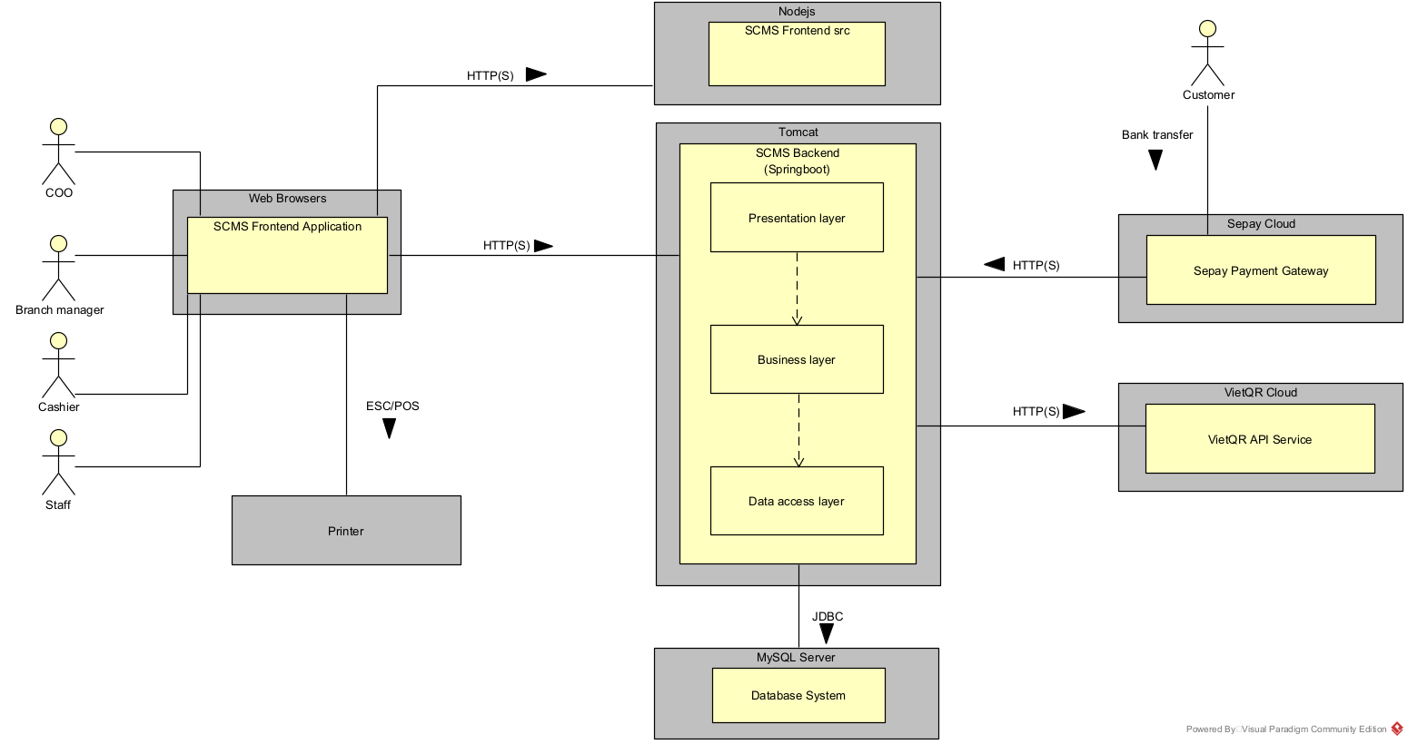
Figure 2-1: System Architectural Overview

As described in Figure 2-1, the system will have the following components:
- User Groups / Actors:
  - COO, Branch Manager, Cashier, and Staff: Internal users who interact with the system via a web browser.
  - Customer: External user who initiates bank transfers to make payments.
- Web Browser: Chrome or Edge used by internal users to access the application.
- SCMS Frontend: Developed as a React Single Page Application (SPA) bundled with Vite, serving the user interface over HTTP.
- SCMS Backend: Deployed on Tomcat, containing a REST controller, service layer, and data access layer, communicating with the browser via REST.
- Database: SQL Server or MySQL database connected to the SCMS backend via JDBC.
- SePay Payment Gateway: A third-party payment service that integrates with the SCMS backend via HTTP Webhook to process customer bank transfers.
- VietQR API Service: An external service that integrates with the SCMS backend via REST.
- Printer: Hardware peripheral connected to the SCMS backend via the ESC/POS protocol.

2.2 Assumptions
This system is designed based on the following assumptions:
- End-users (COO, branch managers, cashiers, staff) access the system using modern web browsers, specifically Chrome or Edge.
- The client-side environment runs a React SPA framework powered by Vite.
- The server-side deployment environment relies on Tomcat as the application server.
- The persistent storage layer relies on either SQL Server or MySQL accessed via JDBC.
- External services such as the SePay Payment Gateway and VietQR API Service are continuously available via network/webhooks.
- Hardware setup includes an ESC/POS-compatible receipt printer connected to the backend.

2.3 Design Constraints
This system should comply with the following items:
- The user interface must communicate with the backend services using HTTP, REST, and WebSocket (WSS) protocols.
- The backend architecture must strictly enforce a layered design pattern consisting of a REST controller layer, a service layer, and a data access layer.
- Database transactions must be executed via JDBC connectivity.
- Payment processing and transaction verification must integrate externally through HTTP Webhooks (SePay) and REST endpoints (VietQR API).
- Receipt and ticket printing functions must strictly support and utilize the ESC/POS communication protocol.

3 Software Architecture Design

3.1 Architectural Representation
Software architecture for the Smart Cafe Management System (SCMS) defines the foundational structure of the system, encompassing its software elements (React SPA frontend, Spring Boot backend RESTful services, and relational database persistence), their externally visible properties, and the mutual relationships between them. It establishes high-level modularity, security boundaries, and communication protocols (HTTPS/REST, WSS, JDBC, and ESC/POS) necessary to ensure high throughput, sub-second POS response times, and multi-branch data consistency.
To provide a clear, comprehensive description for all stakeholders, the system architecture is represented using Philippe Kruchten’s 4+1 View Model. This framework decomposes the system into four complementary architectural views, organized around a central set of critical use case scenarios:
Architectural View | Focus & Architectural Role | Key Model Elements & Artifacts
Use-Case View | Forms the core that drives, validates, and illustrates the entire architectural design from the perspective of end users and external systems. | • Actors: COO, Branch Manager, Cashier, Staff, SePay Gateway, VietQR, Printer.  • UML Use Case Diagrams and specifications for 33 use cases (UC01 through UC33).  • Core operational scenarios: POS sales, cash shift lifecycle, and bulk inventory tracking.
Logical View | Describes the static structural decomposition of the software into functional layers, subsystems, packages, and object-oriented abstractions. | • Three-tier Spring MVC architecture (@RestController -> Service -> Repository -> Entity/DTO).  • Subsystem Class Diagrams, Domain Models, and Entity Relationship Mappings.  • 5-column Class Specifications defining attributes, method signatures, inputs, and outputs.
Process View | Addresses runtime concurrency, execution threads, transactional integrity, and dynamic inter-process communication. | • Dynamic UML Sequence Diagrams capturing end-to-end request-response interactions.  • POS Checkout and automated VietQR / SePay Webhook reconciliation flows.  • Cash Drawer Shift opening/closing lifecycle and physical variance reconciliation.  • Full-duplex WebSocket Secure (WSS / STOMP) pub/sub event broadcasting.
Development View  (Implementation) | Organizes the concrete codebase, internal package structures, dependency management, and software build configurations. | • Java/Spring Boot package hierarchy (controller, service, repository, entity, dto, security, config).  • Frontend React/Vite modular directory structure (components, pages, hooks, services, utils).  • Maven build dependencies (pom.xml) and NPM package manifests (package.json).
Deployment View | Maps software processes and execution artifacts onto physical hardware nodes, network topologies, and store peripherals. | • Host/Cloud Server hosting Tomcat application container and MySQL / SQL Server database.  • Store-level hardware: Touchscreen POS terminals, Attendance Kiosks, and Mobile devices.  • Hardware peripherals: ESC/POS 80mm thermal receipt/bar printers and USB RFID readers.  • Secure network protocols: HTTPS, WebSocket Secure (WSS), JDBC, and Webhook listeners.

3.2 Software Architecture

3.2.1 Process View

3.2.1.1 Frontend Process View – POS Checkout Request Execution
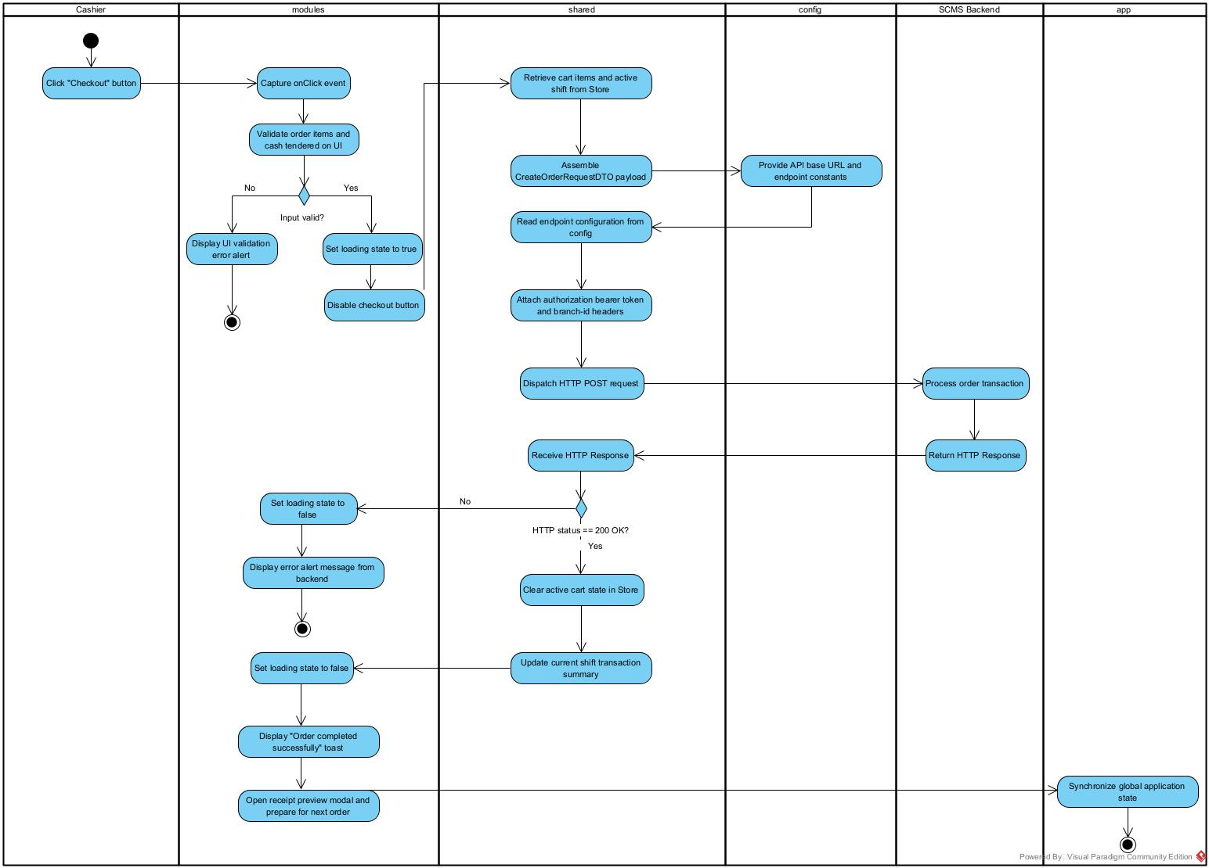

Description:
Step | Participant | Action Name | Detailed Description | Output / Next State
1 | Cashier | Click "Checkout" button | Cashier reviews line items, enters customer cash tender, and clicks the primary checkout action. | Event dispatched to modules.
2 | modules | Capture onClick event | The POS page component (modules/pos) captures the click event and initiates client-side form validation. | Triggers validation flow.
3 | modules | Validate order items and cash tendered on UI | Evaluates basic constraints: verifies cart item count > 0 and confirms cash tendered is greater than or equal to total payable amount. | Decision: Input valid?
4.1 | modules | [Branch: No] Display UI validation error alert | If validation fails, an inline error toast or modal alert is rendered to notify the Cashier of invalid input. | Process Terminated (Final State).
4.2 | modules | [Branch: Yes] Set loading state to true | If valid, sets local component state isLoading = true to display an active loading spinner. | UI enters loading state.
5 | modules | Disable checkout button | Dynamically disables checkout button (disabled=true) to prevent accidental duplicate clicks or race conditions. | Button locked.
6 | shared | Retrieve cart items and active shift from Store | Queries central Zustand store (shared/store) to pull snapshot data of selected items, modifiers, voucher codes, and current shift ID. | Cart snapshot data retrieved.
7 | shared | Assemble CreateOrderRequestDTO payload | Serializes and structures snapshot data into a standardized CreateOrderRequestDTO JSON object. | DTO payload prepared.
8 | config | Provide API base URL and endpoint constants | Exposes environment parameters (VITE_API_BASE_URL) and static route definitions (API_ENDPOINTS.POS_CHECKOUT). | Endpoint URL constants provided.
9 | shared | Read endpoint configuration from config | The Axios HTTP client resolves the full target endpoint URL using constants supplied by config. | Target URL resolved.
10 | shared | Attach authorization bearer token and branch-id headers | Axios request interceptor injects Bearer JWT token from authStore and active Branch-Id into HTTP request headers. | Headers injected.
11 | shared | Dispatch HTTP POST request | Dispatches an asynchronous HTTP POST request containing DTO payload to backend server. | HTTP Request transmitted over network.
12 | SCMS Backend | Process order transaction | Spring Boot backend ingests request, verifies security, evaluates business rules, and commits data to SQL Server. | Backend processing completed.
13 | SCMS Backend | Return HTTP Response | Backend sends back HTTP response containing status code and response payload. | Response sent to client.
14 | shared | Receive HTTP Response | Axios response interceptor intercepts incoming response and evaluates status code. | Decision: HTTP status == 200 OK?
15.1 | modules | [Branch: No] Set loading state to false | On HTTP failure (4xx or 5xx), unlocks UI loading spinner. | Spinner hidden.
15.2 | modules | [Branch: No] Display error alert message from backend | Extracts error message from response envelope (e.g. ApiError.message) and renders error notification on screen. | Process Terminated (Final State).
16 | shared | [Branch: Yes] Clear active cart state in Store | On HTTP 200 OK, dispatches clearCart() action in Zustand store to purge order lines and reset selected voucher. | Store cart state emptied.
17 | shared | Update current shift transaction summary | Updates active register shift totals (increments total cash collected and completed order counter) in local store. | Shift summary updated.
18 | modules | Set loading state to false | Resets component state (isLoading = false) to hide loading overlay. | UI interaction restored.
19 | modules | Display "Order completed successfully" toast | Fires green success toast notification confirming payment completion and order persistence. | Toast displayed to user.
20 | modules | Open receipt preview modal and prepare for next order | Triggers thermal receipt modal for optional customer printing and resets POS cash tender input fields. | Receipt modal opened.
21 | app | Synchronize global application state | Root application container (app) ensures context synchronization across global providers and route listeners. | Process Terminated (Success Final State).

3.2.1.2 Backend Process View – POS Checkout Request Execution
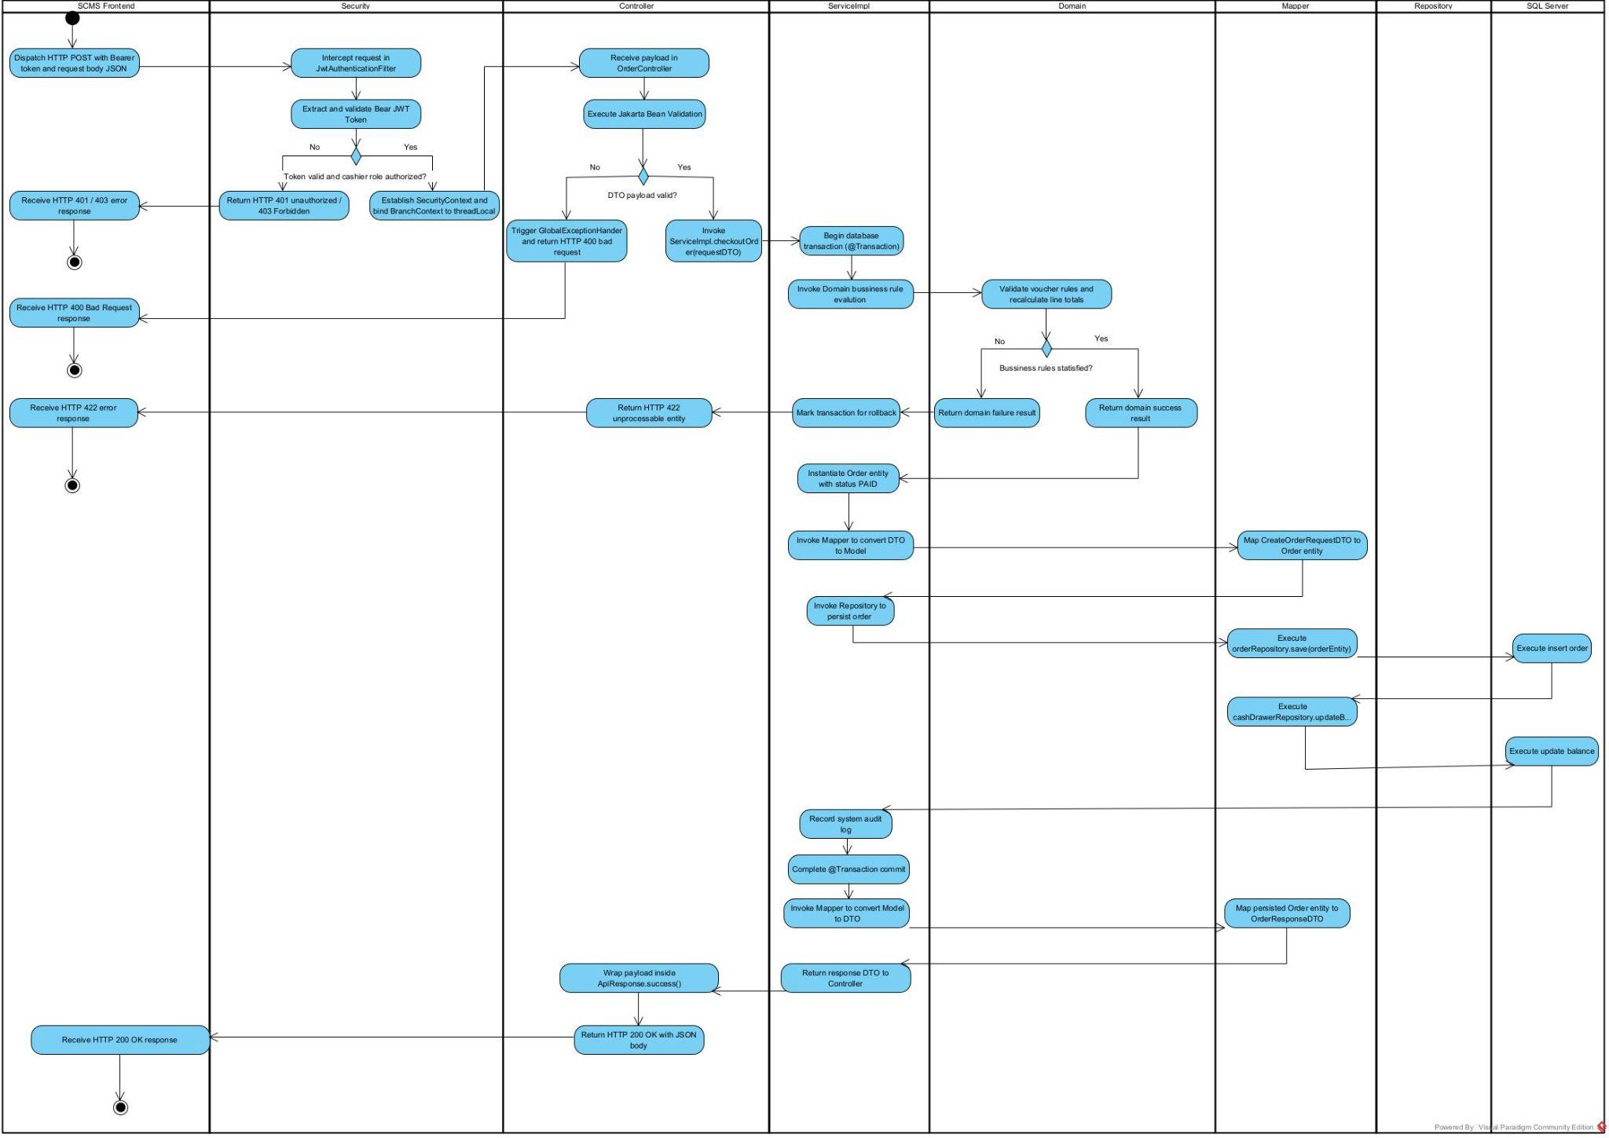

Description:
Step | Participant | Action Name | Detailed Description | Output / Next State
1 | SCMS Frontend | Dispatch HTTP POST with Bearer token and request body JSON | Dispatches an asynchronous HTTP POST request to /api/v1/pos/orders/checkout carrying Bearer JWT token in headers and CreateOrderRequestDTO JSON body. | Request enters Backend filter chain.
2 | Security | Intercept request in JwtAuthenticationFilter | JwtAuthenticationFilter intercepts incoming HTTP request from the filter chain to inspect authorization headers. | Request intercepted for authentication.
3 | Security | Extract and validate Bearer JWT Token | Extracts the Bearer token, verifies digital signature, checks expiration timestamp, and inspects granted user roles. | Decision: Token valid and cashier role authorized?
4.1 | Security | [Branch: No] Return HTTP 401 unauthorized / 403 Forbidden | AuthenticationEntryPoint rejects unauthorized or invalid request, returning HTTP 401 Unauthorized or HTTP 403 Forbidden. | Error response transmitted to Frontend.
4.2 | SCMS Frontend | [Branch: No] Receive HTTP 401 / 403 error response | Client receives 401/403 response, invalidates local session, and prompts user to re-authenticate. | Process Terminated (Error).
5 | Security | [Branch: Yes] Establish SecurityContext and bind BranchContext to threadLocal | Populates SecurityContextHolder with user principal and binds current branch identifier (BranchId) to ThreadLocal context. | Contexts established; flow passed to Controller.
6 | Controller | Receive payload in OrderController | OrderController deserializes JSON request body into CreateOrderRequestDTO instance. | DTO parsed into memory.
7 | Controller | Execute Jakarta Bean Validation | Executes validation annotations (@Valid, @NotNull, @Positive) declared on the DTO fields. | Decision: DTO payload valid?
8.1 | Controller | [Branch: No] Trigger GlobalExceptionHandler and return HTTP 400 bad request | GlobalExceptionHandler intercepts validation constraint violations and emits HTTP 400 Bad Request with field error details. | Error response transmitted to Frontend.
8.2 | SCMS Frontend | [Branch: No] Receive HTTP 400 Bad Request response | Client receives 400 response and highlights invalid form input fields on the POS screen. | Process Terminated (Error).
9 | Controller | [Branch: Yes] Invoke ServiceImpl.checkoutOrder(requestDTO) | Delegates the validated request payload to the application service layer for transactional orchestration. | Service execution initiated.
10 | ServiceImpl | Begin database transaction (@Transactional) | Opens a declarative database transaction boundary (@Transactional) managing rollback and commit boundaries. | Transaction context started.
11 | ServiceImpl | Invoke Domain business rule evaluation | Calls the pure domain logic engine to evaluate enterprise business rules without database dependencies. | Domain engine triggered.
12 | Domain | Validate voucher rules and recalculate line totals | Evaluates voucher eligibility, minimum spend rules, discounts, and recalculates exact payable total and expected change. | Decision: Business rules satisfied?
13.1 | Domain | [Branch: No] Return domain failure result | Domain logic returns a DomainFailureResult containing the business violation reason without throwing unmanaged exceptions. | Failure result passed to Service.
13.2 | ServiceImpl | [Branch: No] Mark transaction for rollback | Service catches domain failure, marks active database transaction for rollback, and throws BusinessException. | Transaction marked for rollback.
13.3 | Controller | [Branch: No] Return HTTP 422 unprocessable entity | GlobalExceptionHandler catches BusinessException and translates it into HTTP 422 Unprocessable Entity response. | Error response transmitted to Frontend.
13.4 | SCMS Frontend | [Branch: No] Receive HTTP 422 error response | Client displays business rule violation alert (e.g., voucher expired or invalid total) to Cashier. | Process Terminated (Error).
14 | Domain | [Branch: Yes] Return domain success result | Domain logic confirms that all business calculations, discounts, and item pricing are valid. | Success result passed to Service.
15 | ServiceImpl | Instantiate Order entity with status PAID | Instantiates the JPA Order entity model, assigns reference invoice code, and sets operational status to PAID. | Model entity initialized.
16 | ServiceImpl | Invoke Mapper to convert DTO to Model | Calls MapStruct mapper component to transform DTO values into the Order entity model hierarchy. | Mapping requested.
17 | Mapper | Map CreateOrderRequestDTO to Order entity | Transforms DTO attributes and nested line items into Order and OrderItem JPA entity objects. | Entity graph populated.
18 | ServiceImpl | Invoke Repository to persist order | Passes the mapped Order entity to the data access repository layer for database insertion. | Persistence requested.
19 | Repository | Execute orderRepository.save(orderEntity) | Spring Data JPA translates the entity graph into parameterized SQL INSERT queries. | SQL commands prepared.
20 | SQL Server | Execute insert order | Physical Microsoft SQL Server database executes INSERT INTO orders and order_items tables, generating primary keys. | Order records committed to disk.
21 | Repository | Execute cashDrawerRepository.update() | Dispatches update query to increment the active shift cash drawer balance by the cash tender received. | Balance update query sent.
22 | SQL Server | Execute update balance | Physical database executes UPDATE query on cash drawer balance and acknowledges successful commit. | Balance updated in database.
23 | ServiceImpl | Record system audit log | Asynchronously records an audit log entry documenting order code, cashier identity, branch, and total value. | Audit entry saved.
24 | ServiceImpl | Complete @Transaction commit | Completes and commits the application transaction boundary; database locks and connections are released. | Transaction committed successfully.
25 | ServiceImpl | Invoke Mapper to convert Model to DTO | Calls mapper to convert persisted Order entity back into an outbound OrderResponseDTO. | Conversion requested.
26 | Mapper | Map persisted Order entity to OrderResponseDTO | Transforms persisted entity properties into client-safe OrderResponseDTO, stripping database internals. | Response DTO constructed.
27 | ServiceImpl | Return response DTO to Controller | Returns the assembled OrderResponseDTO back to OrderController. | DTO handed to Controller.
28 | Controller | Wrap payload inside ApiResponse.success() | Wraps the response DTO into a standardized ApiResponse envelope with success flag and timestamp. | API response envelope constructed.
29 | Controller | Return HTTP 200 OK with JSON body | Sends HTTP 200 OK status code along with JSON response envelope over network to client. | HTTP 200 transmitted.
30 | SCMS Frontend | Receive HTTP 200 OK response | Client receives success response, unlocks UI, and proceeds with cart clearing and receipt modal rendering. | Process Terminated (Success Final State).

3.2.2 Logical View

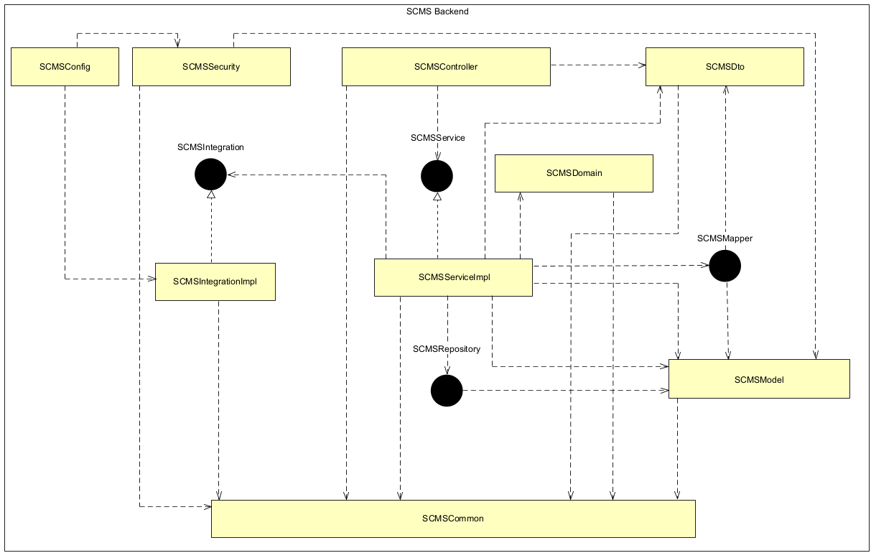
Figure 3-1: SCMS BE Logical Overview
- Controller
- Controller — entry point receiving requests from the UI and returning results. It imports dto, service, security (authorization) and common (error codes); a GlobalExceptionHandler centralizes error handling in one place.
- DTO
- DTO — defines the data entering/leaving the API (Request/Response) so entities are never exposed. A near-pure data layer; it imports only common (for validation annotations / ApiError/ Enum).
- Service
- Service — orchestrates each use case and manages transactions via @Transactional. It imports domain (business rules), repository + model (data), dto, mapper (DTO conversion), integration (external systems) and common.
- Domain
- Domain — holds the pure business rules (cash balance, shrinkage, voucher, webhook matching, order state) in plain Java, independent of any framework. It returns result objects instead of throwing errors (the service decides on errors); it never touches repository, integration, BranchContext or audit.
- Mapper
- Mapper — Converts between entities and DTOs. It imports model and dto.
- Repository
- Repository — Handles database access and applies branch filtering in one central place, preventing data leaks between branches. It imports model and common (like read BranchContext).
- Model
- Model — The JPA entities mapped to database tables according to the ERD. It uses only JPA annotations and It can import common (Enum), making it the most stable foundation.
- Integration
- Integration — Communicates with SePay, VietQR and the ESC/POS printer using the Port/Adapter pattern, so changing a provider only requires replacing the Adapter. It can import common (IntegrationException/ErrorCode)
- Security
- Security — Handles JWT authentication and RBAC authorization, and sets up BranchContext for each request. It imports repository (to load users), common, and model (the single exception, confined to CustomUserDetailsServiceImpl)
- Common
- Common — Shared utilities (exceptions, ErrorCode, annotations, utils, constants, audit, BranchContext) with no business logic. Everyone may import it, but it imports no one, which prevents dependency cycles.
- Config
- Config — Framework configuration and wiring (the composition root). It enables Spring features (security filter chain, JPA, CORS, OpenAPI, async/scheduling) and registers shared beans such as PasswordEncoder. It imports only security (to attach the JWT filter and UserDetailsService to the SecurityFilterChain). no other package imports config;

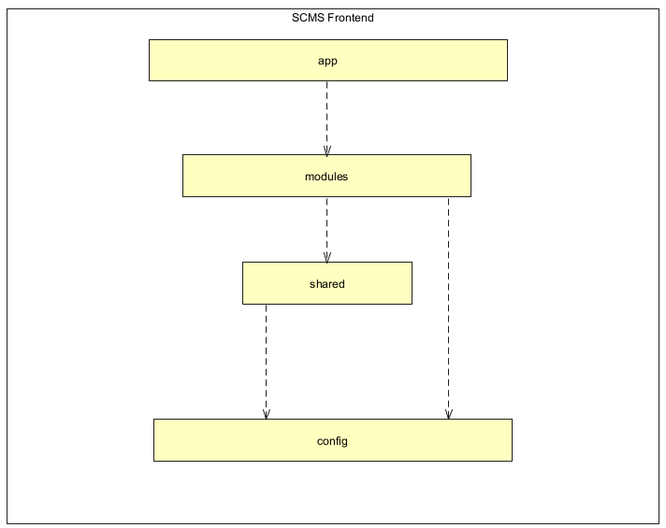
Figure 3-2: SCMS FE Logical Overview

No | Package | Description
01 | app | Houses core application bootstrap logic, global routing (router), top-level context wrappers (providers), and page frame structures (layouts).
02 | modules | Organized by business domains, encapsulating feature-specific pages, domain components, React Query API hooks, custom business hooks, and client-side calculations.
03 | shared | Contains cross-cutting, domain-agnostic components and utilities reusable across all feature modules (such as base UI components, global Zustand stores, custom hooks, and API clients).
04 | config | Stores system-wide configuration files including environment variables (env), static constants, and application route definitions (routes).

3.2.3 Development View

3.2.3.1 Spring Boot Package Diagram
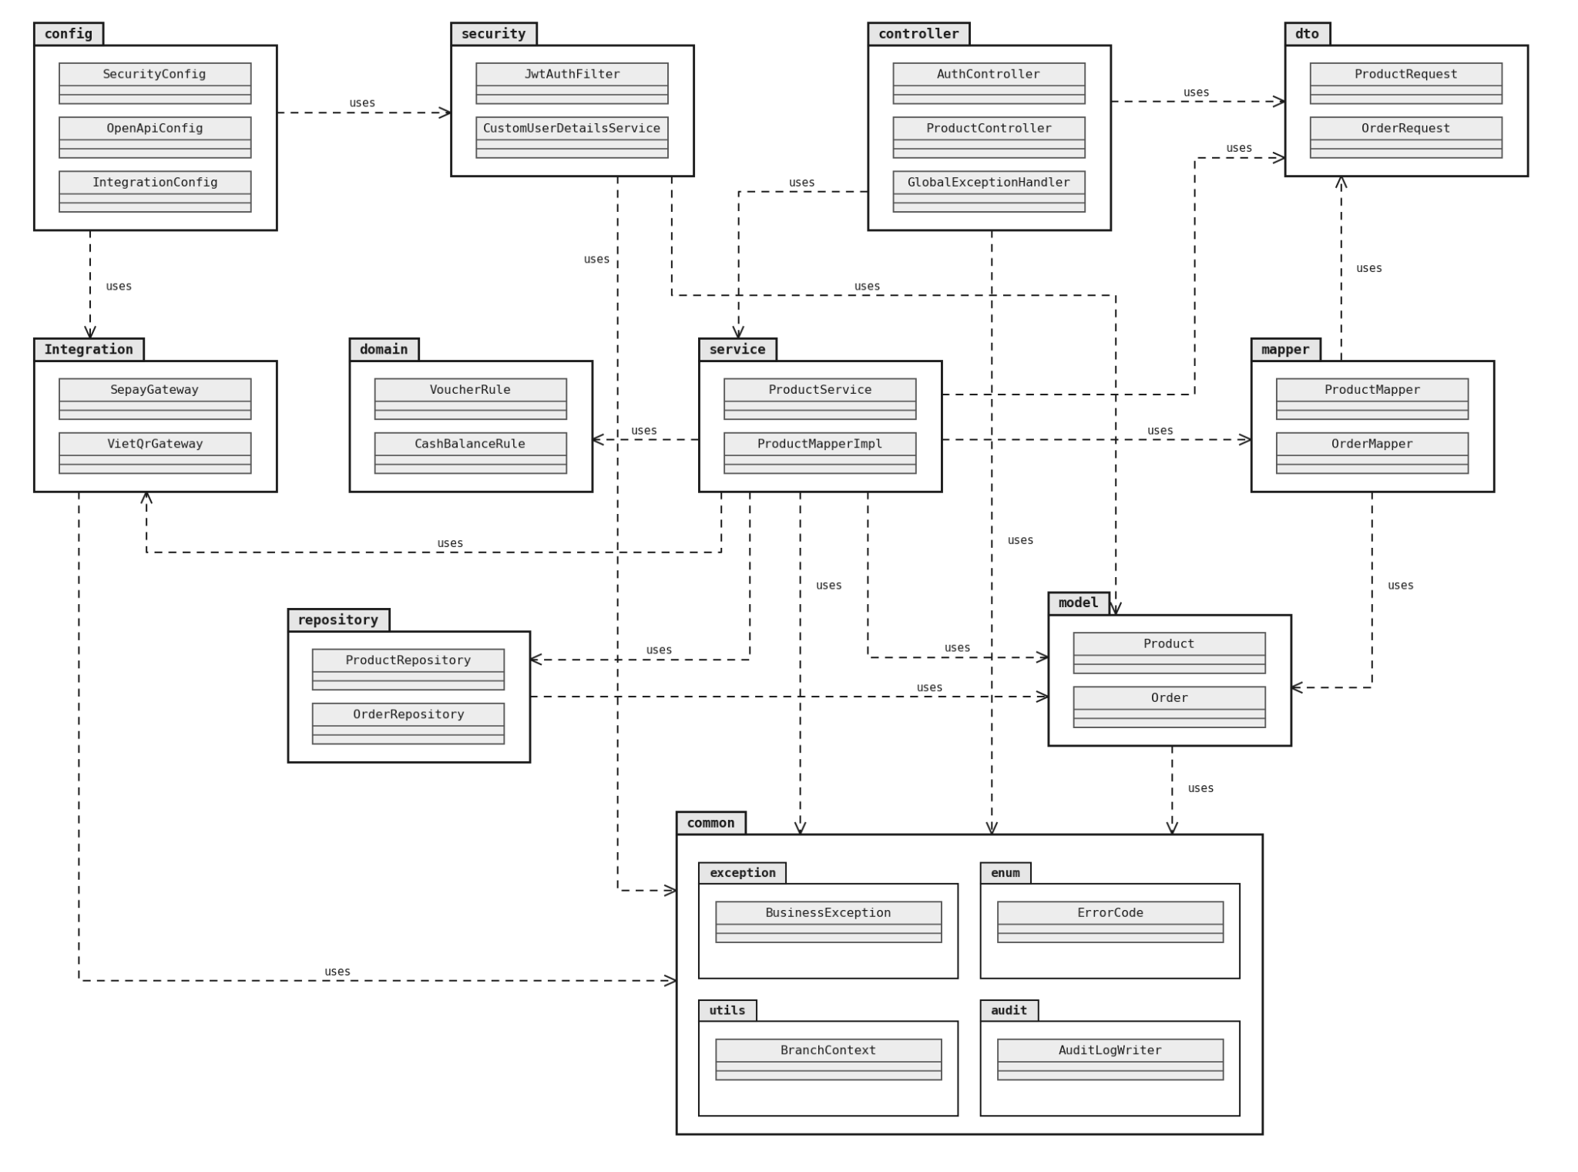

No | Package | Description
01 | config | Contains core Spring Boot configuration classes (e.g., SecurityConfig, AppConfig) for setting up beans, CORS, and system-wide parameters.
02 | security | Manages security mechanisms, authentication filters (e.g., JwtTokenFilter), Role-Based Access Control (RBAC), and user details services (CustomUserDetailsService).
03 | common | Contains system-wide shared components such as centralized exception handling (GlobalExceptionHandler), enums, annotations, and multi-branch context (BranchContext).
04 | controller | The presentation layer (RestController). Receives HTTP requests from clients, coordinates business logic, and returns formatted responses.
05 | dto | Contains Data Transfer Objects (such as request/response models) used to safely transport data between the client and server without exposing database entities directly.
06 | service | The business logic layer. Implements core application workflows and rules, consisting of both service interfaces and implementation classes (ServiceImpl).
07 | domain | Holds the pure business rules (cash balance, shrinkage, voucher, webhook matching, order state) in plain Java, independent of any framework. It returns result objects instead of throwing errors (the service decides on errors); it never touches repository, integration, BranchContext or audit.
08 | mapper | Contains data mapping components (e.g., MapStruct) responsible for converting objects back and forth between Model (Entities) and DTOs.
09 | repository | The data access layer, housing JPA Repository interfaces to interact directly with the database.
10 | model | Contains entity classes mapped directly to relational database tables within the system.
11 | integration | Contains services dedicated to connecting with external third-party systems or hardware peripherals (e.g., SePay payment gateway, VietQR service, ESC/POS receipt printers).

3.2.3.2 React Package Diagram
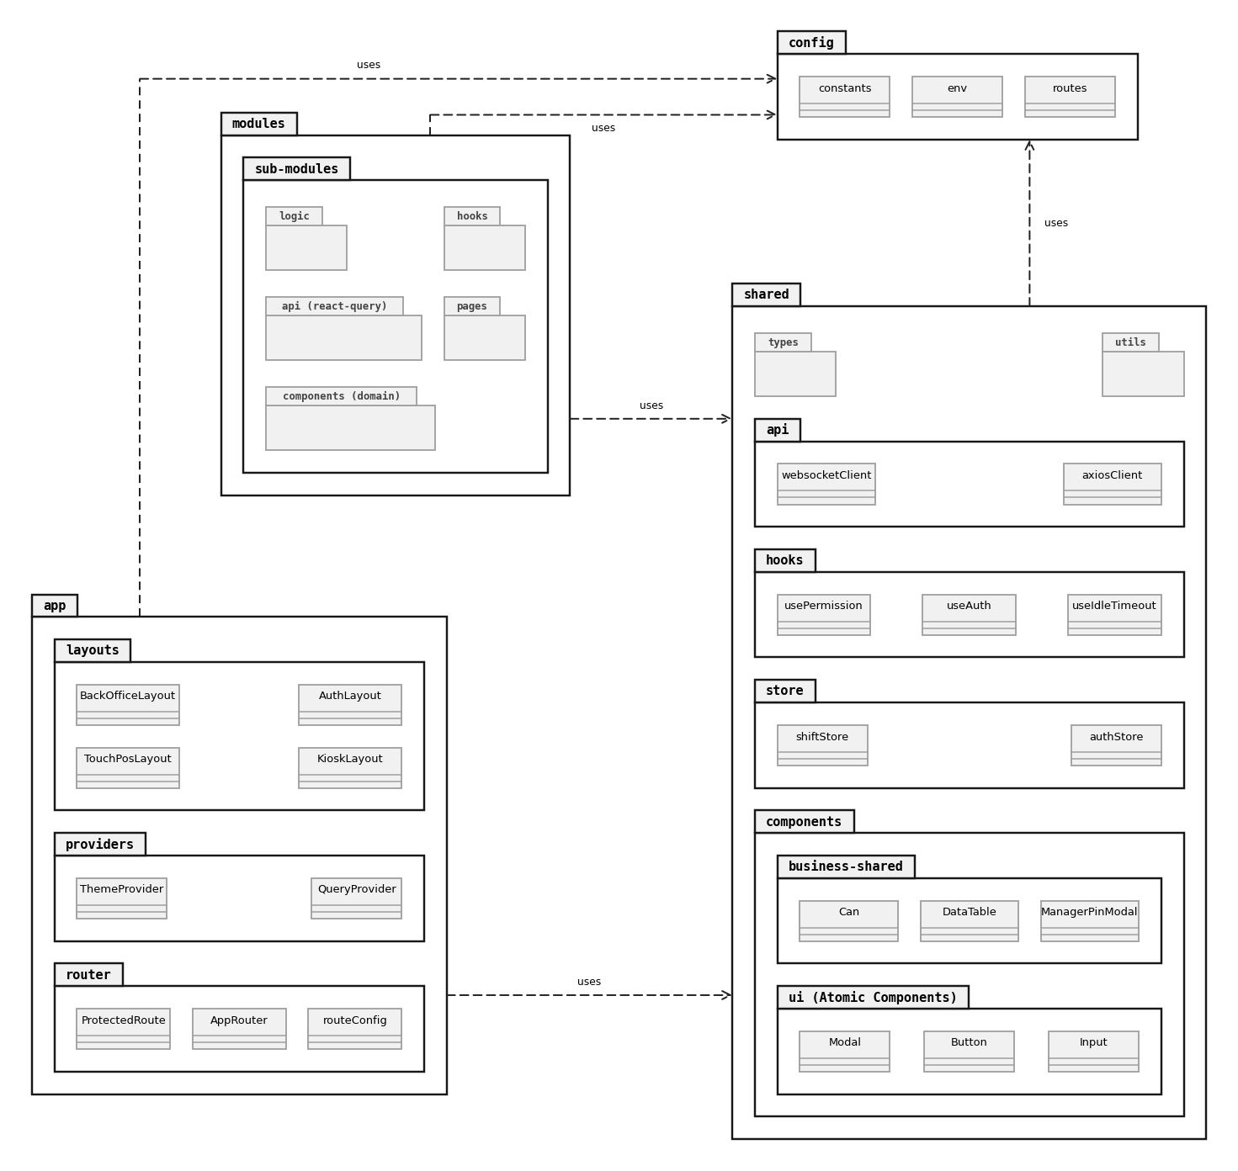

No | Package | Description
01 | app | Houses core application bootstrap logic, global routing (router), top-level context wrappers (providers), and page frame structures (layouts).
02 | config | Stores system-wide configuration files including environment variables (env), static constants, and application route definitions (routes).
03 | shared | Contains cross-cutting, domain-agnostic components and utilities reusable across all feature modules (such as base UI components, global Zustand stores, custom hooks, and API clients).
04 | shared/components | Encapsulates both generic atomic UI elements (ui (Atomic Components)) and higher-level reusable business widgets (business-shared like data tables and authorization guards).
05 | shared/store | Manages global application states (e.g., authentication session in authStore, active POS shift status in shiftStore) using Zustand.
06 | shared/hooks | Provides shared custom React hooks for authorization, permission checking, and system idle timeouts.
07 | shared/api | Houses centralized HTTP (axiosClient) and WebSocket (websocketClient) instances with configured interceptors for authentication and real-time events.
08 | modules | Organized by business domains, encapsulating feature-specific pages, domain components, React Query API hooks, custom business hooks, and client-side calculations.

3.2.4 Deployment View
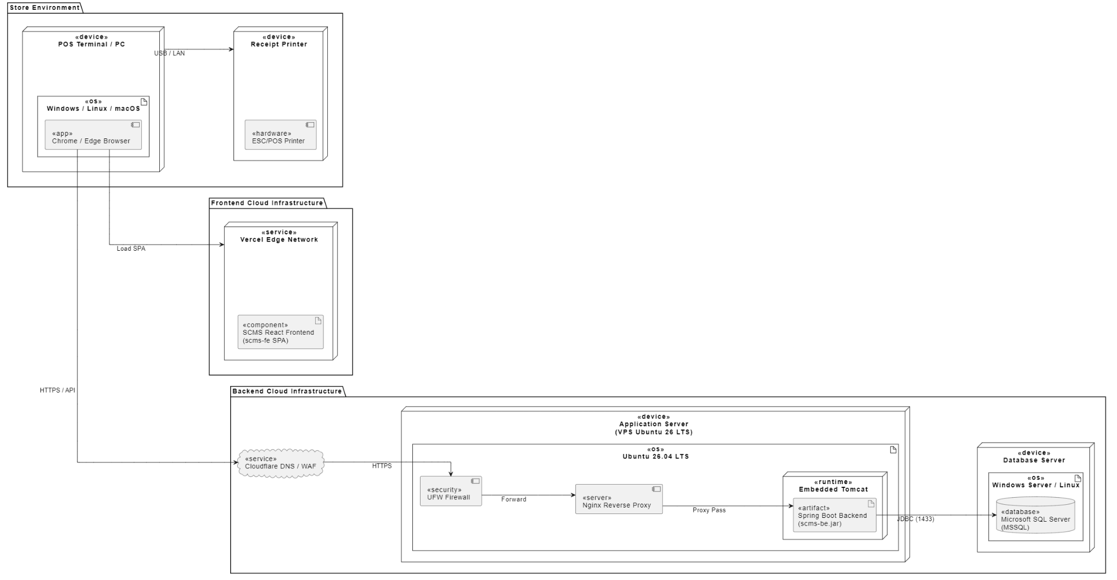
Figure 3-3: SCMS Deployment structure
Configuration Description
No | Component / Node | Description
01 | POS Terminal / PC | Physical client hardware (PC/Terminal) located at the store counter used by cashier staff to perform daily checkout transactions and shift management.
02 | Receipt Printer | Local hardware peripheral (ESC/POS compatible) connected directly to the POS Terminal via USB/LAN for printing sales receipts.
03 | Vercel Edge Network | Global serverless cloud infrastructure hosting and delivering the React single-page application (scms-fe) static build assets.
04 | Cloudflare DNS / WAF | Cloud security layer providing DNS resolution, Web Application Firewall (WAF) filtering, and SSL/TLS termination to protect backend endpoints.
05 | Application Server | Cloud Virtual Private Server (VPS) running Ubuntu 26.04 LTS, serving as the central execution host for application business logic.
06 | UFW Firewall | Operating system-level firewall configured on Ubuntu VPS to restrict inbound traffic strictly to authorized HTTP/HTTPS ports.
07 | Nginx Reverse Proxy | High-performance Web/Proxy server configured to handle incoming API requests and securely forward them (proxy_pass) to the local Spring Boot runtime.
08 | Spring Boot Backend | Runnable Java application (scms-be.jar) executed inside an embedded Tomcat container to process RESTful API requests, business validation, and authorization.
09 | Database Server | Dedicated cloud/standalone server running Microsoft SQL Server (MSSQL) to handle persistence and data management operations independently.

4 Detailed Component Design

4.1 Common Design

4.1.1 Architectural Objectives & Scope
The common design infrastructure is engineered to enforce consistency, high availability, sub-second POS execution, and enterprise security across all store branches. It eliminates code duplication by abstracting cross-cutting concerns into dedicated reusable packages: com.scms.common (shared utilities, exception handlers, DTOs, and context binders) on the backend, and src/shared (Zustand stores, Axios interceptors, atomic UI components, and helper utilities) on the frontend.

4.1.2 Error Handling Design
To ensure system resilience and prevent the leakage of sensitive infrastructure details, SCMS adopts a centralized, non-leaking exception handling architecture powered by Spring Boot's @RestControllerAdvice. Internal stack traces, raw SQL exceptions, and framework errors are intercepted and converted into predictable, standardized client envelopes.

4.1.2.1 Exception Hierarchy
All application exceptions derive from an abstract BaseException, segregated into specialized technical and business categories:
- BusinessException: Domain rule violations (e.g., VoucherExpiredException, ShiftClosedException).
- ResourceNotFoundException: Entity lookup failures (e.g., ProductNotFoundException, BranchNotFoundException).
- ValidationException: Payload constraint failures (Jakarta Bean Validation @Valid).
- UnauthorizedException: Missing, expired, or invalid JWT Bearer tokens.
- ForbiddenException: Role-Based Access Control (RBAC) violations or cross-branch data access attempts.
- ConflictException: Unique constraint collisions (e.g., duplicate barcode, concurrent shift conflict).
- IntegrationException: Third-party communication failures (SePay Webhook, VietQR, ESC/POS Printer).

4.1.2.2 Centralized Exception Handling (GlobalExceptionHandler)
The GlobalExceptionHandler class intercepts all exceptions thrown out of @RestController endpoints. It extracts contextual error codes, formats field-level validation errors, logs failures with the active traceId, and returns a sanitized ApiErrorResponse entity. Uncaught general exceptions are caught by a global fallback handler that masks internal details with a friendly error message and HTTP 500 status.

4.1.2.3 Standard Error Response Envelope (ApiErrorResponse)
Every failed HTTP request produces an immutable JSON envelope containing: success (false), status (HTTP status code), errorCode (standardized business enum), message (human-readable description), path (requested URI), timestamp (ISO-8601 UTC), traceId (correlation ID), and an optional fieldErrors array for form validation violations.
Table 4.1-1: HTTP Status Code Mapping Matrix
HTTP Status | Scenario / Exception Type | Error Code Example | Client Action
400 Bad Request | Malformed JSON syntax, invalid query parameters, failed Bean Validation (@Valid). | INVALID_INPUT_PAYLOAD | Highlight invalid fields on UI form.
401 Unauthorized | Missing, expired, or cryptographically invalid JWT Bearer token. | AUTH_TOKEN_EXPIRED | Clear local auth state; redirect to /login.
403 Forbidden | User lacks required role authority or attempts cross-branch data access. | ACCESS_DENIED | Display 'Insufficient Permissions' alert.
404 Not Found | Target resource ID does not exist within the active branch scope. | RESOURCE_NOT_FOUND | Render 404 Empty State / Toast notification.
409 Conflict | State conflicts, duplicate barcode/SKU, or concurrent update collisions. | RESOURCE_CONFLICT | Prompt user to reload latest data.
422 Unprocessable | Syntactically valid request violates domain logic (e.g., voucher minimum spend). | BUSINESS_RULE_VIOLATION | Display specific business rule rejection alert.
500 Internal Error | Unexpected infrastructure / database failure. Internal stack trace masked. | INTERNAL_SERVER_ERROR | Display friendly error; prompt user with traceId.
503 Unavailable | External integration unavailable (e.g., SePay API offline, printer disconnected). | GATEWAY_UNAVAILABLE | Offer offline/cash fallback to Cashier.

4.1.3 Logging & Distributed Tracing Design
To enable deterministic error diagnosis, forensic auditing, and sub-second bug reproduction in multi-user and multi-branch environments, SCMS implements structured logging combined with Mapped Diagnostic Context (MDC) distributed tracing.

4.1.3.1 Distributed Tracing & Correlation ID (traceId)
Every incoming HTTP request is assigned a unique Correlation Identifier (traceId / UUIDv4) upon entering the application container via TraceContextFilter (OncePerRequestFilter). The traceId is bound to the thread execution context using SLF4J MDC.put('traceId', traceId) and MDC.put('branchId', branchId). It is automatically emitted in every log line, returned in the X-Trace-Id HTTP response header, and embedded inside ApiErrorResponse payloads, allowing support staff to instantly grep logs.
Table 4.1-2: Logging Standards & Levels Governance
Log Level | Intended Usage | Environment | Retention | Target Destination
DEBUG | In-depth troubleshooting, method parameters, SQL execution timings. | Dev / Staging | 3 days | Rolling file: debug.log
INFO | Business lifecycle events: Shift opened, Order completed, User login, SePay Webhook. | Production | 30 days | Rolling file: app.log / ELK
WARN | Handled business rejections, retryable connection timeouts, invalid logins. | Production | 60 days | Rolling file: app.log
ERROR | Unhandled exceptions, SQL connection drops, payment mismatches (includes full stack trace). | Production | 180 days | Rolling file: error.log / Sentry

4.1.3.2 Structured JSON Log Format & Sensitive Data Masking
In production, Logback emits single-line JSON records using LogstashEncoder for automated ingestion into ELK / CloudWatch. An automated masking filter scrubs sensitive data before persistence: user passwords and PINs are replaced with [PROTECTED_CREDENTIAL], JWT tokens are truncated to eyJhbGciOi...[MASKED], and bank account numbers are masked as ******1234.

4.1.4 Message Processing & User Feedback Design
A unified communication contract between backend REST endpoints and the React frontend guarantees that users receive consistent, localized, and actionable feedback.

4.1.4.1 Standard API Response Envelope (ApiResponse<T>)
All successful HTTP endpoints return an immutable ApiResponse<T> containing: success (true), status (200), code ('SUCCESS'), message (contextual confirmation), data (generic payload object), timestamp, and traceId.
Table 4.1-3: Frontend Feedback Channels & Display Placement Matrix
Channel | UI Component | Screen Placement | Trigger Condition | Auto-dismiss
Ephemeral Toast | Toast / Notification | Top-Right or Bottom-Right | Async success (e.g., 'Order checkout completed'), network warnings. | Yes (3 - 5s)
Inline Form Error | FormHelperText | Directly beneath input element | Client validation failure, duplicate name, missing mandatory field. | No (until fixed)
Modal Dialog | Modal / AlertConfirm | Center Viewport (Modal Overlay) | Destructive actions (Cancel shift, Void order, Delete product). | No (User click)
Global Banner | SystemBanner | Top Sticky Bar (Full Width) | Server maintenance alert, offline network status, shift variance. | No (Persistent)
Error Screen | ErrorBoundary | Full Content Area | Fatal React rendering crash, 404 route missing, 500 API down. | No (Reload btn)

4.1.5 UI Standards & Layout Guidelines
The SCMS user interface is engineered for high operational ergonomics, touch friendliness at the POS station, and clean administrative oversight for managers and the COO.

4.1.5.1 Viewport Standards & Breakpoints
- POS Touchscreen Station: Fixed 1920x1080 (Full HD) standard, minimum supported 1366x768. Touch targets have a minimum dimension of 48px x 48px with 8px spacing to eliminate mis-clicks during peak hours.
- Administrative Shell: Responsive layout supporting Desktop (>= 1200px), Tablet (768px - 1199px), and Mobile management (< 768px).

4.1.5.2 Standard Layout Shells
- Administrative Shell (COO / Branch Manager): Features a collapsible left sidebar navigation (260px expanded, 80px icon-only), fixed top header bar (64px) housing branch selector and user profile, and fluid content container (padding 24px).
- POS Cashier Shell (Touchscreen POS): Two-panel split layout featuring a 65% width product catalog & category tab ribbon on the left, and a 35% fixed 420px shopping cart, modifier summary, voucher entry, and Cash/QR tender action panel on the right.
Table 4.1-4: Design System Tokens, Color Palette & Typography
Category | Token / Element | Standard Specification
Color Palette | Primary Brand | Deep Coffee #6F4E37 / Emerald #10B981 (Accent)
Color Palette | Background / Surface | Canvas #F9FAFB, Card Surface #FFFFFF, Border #E5E7EB
Color Palette | Feedback Colors | Success #10B981, Error/Danger #EF4444, Warning #F59E0B, Info #3B82F6
Typography | Font Family | 'Inter', -apple-system, BlinkMacSystemFont, 'Segoe UI', Roboto, sans-serif
Typography | Font Sizes | Heading 1: 28px (bold), Heading 2: 22px (semi-bold), Body: 14px, Small: 12px
Interactive | Touch Target | Minimum 48px x 48px on POS screens, 8px padding between clickable buttons
Tables | Data Table Standard | Zebra striping optional, sticky header, row height 52px, right-aligned numbers

4.1.6 Common Utility Classes & Components
Reusable cross-cutting logic is isolated inside com.scms.common.utils (Backend) and src/shared/utils (Frontend) adhering strictly to the DRY principle:
- DateTimeUtil (Backend): Standardizes timestamps across database and JSON APIs to ISO-8601 UTC (yyyy-MM-dd'T'HH:mm:ss.SSS'Z') and provides thread-safe local timezone conversion (Asia/Ho_Chi_Minh).
- MoneyUtil (Backend): Enforces rounding rules for Vietnamese Dong (VND: zero decimal places, HALF_UP rounding) and formats numeric values to currency representations (e.g., 125.000 ₫).
- SecurityUtil (Backend): Static accessor providing convenient access to SecurityContextHolder for extracting active user ID, username, and branch scope.
- ValidationUtil (Backend): Regular expression helpers for validating Vietnamese phone numbers, POS barcodes, and tax IDs.
- formatCurrency & formatDate (Frontend): Pure functional helpers wrapping browser Intl.NumberFormat and date-fns for fast, reactive UI rendering.

4.1.7 Transaction Management Architecture
Transaction management enforces ACID guarantees across all state-modifying operations, particularly inventory deductions, cash shift reconciliations, and POS order payments.
- Strict Layer Enforcement: @Transactional boundaries are declared exclusively at the Service Layer (@Service / ServiceImpl). Controllers and Repositories are strictly prohibited from initiating transaction scopes.
- Exception Rollback Policy: All transactions rollback automatically on unchecked exceptions (RuntimeException) and explicitly on checked exceptions via @Transactional(rollbackFor = Exception.class).
Table 4.1-5: Transaction Classification & Strategies Matrix
Transaction Category | Configuration Strategy | Isolation & Locking | Use Case Applications
Read-Only Transactions | @Transactional(readOnly = true) | Read Committed (Snapshot) | Product catalog lookups, sales reports, inventory inquiries. Disables Hibernate dirty checking; eliminates write-locks.
Standard Business Write | @Transactional(rollbackFor = Exception.class) | Read Committed | Order checkout, shift opening/closing, employee profile modification. Atomic single-branch write.
High-Contention / Stock Deduct | @Transactional + @Lock(LockModeType.PESSIMISTIC_WRITE) | Pessimistic Write Lock (SELECT ... WITH (UPDLOCK)) | Bulk inventory deduction during rush hours, preventing negative stock levels.
Isolated Sub-Transactions | @Transactional(propagation = Propagation.REQUIRES_NEW) | Independent Transaction Scope | Audit logging (AuditLogService), failed login attempt counters, external payment webhook logging. Commits even if parent fails.

4.1.7.1 Database Engine Concurrency Control (Microsoft SQL Server)
Microsoft SQL Server is configured with READ_COMMITTED_SNAPSHOT ON at the database level. Readers do not block writers, and writers do not block readers, guaranteeing sub-second response times for POS queries during active order processing. Concurrently modified entities (InventoryStock, CashDrawerShift) include a @Version private Long version; optimistic locking column to prevent lost updates.

4.1.8 Security Architecture: Authentication, Authorization & Encryption
- Authentication Architecture: Employs stateless JSON Web Tokens (JWT) with a Dual-Token lifecycle: short-lived Access Tokens (30 minutes) carrying identity and branch claims, and long-lived Refresh Tokens (7 days) stored in secure HTTP-only SameSite cookies.
- Role-Based Access Control (RBAC): Enforces hierarchical authorization (ROLE_COO > ROLE_BRANCH_MANAGER > ROLE_CASHIER = ROLE_STAFF) via declarative Spring Security @PreAuthorize annotations.
- Multi-Branch Isolation (BranchContext): SecurityContext extracts the active branchId from the JWT, binding it to a ThreadLocal BranchContext for the request lifespan. SCMSRepository instances append automatic branch scoping (WHERE branch_id = :branchId) to prevent cross-branch data leaks.
- Cryptography & Data Protection: Passwords hashed with BCrypt (work factor 12); network transmission secured via TLS 1.3 / HTTPS and WSS; database physical files protected with SQL Server Transparent Data Encryption (TDE).

4.2 Login/Logout
This section presents the detailed design of the Login/Logout feature. The COO and Branch Managers authenticate on the User Login screen (SCR-01) with username and password; the backend validates the credentials with a BCrypt hash comparison, applies the temporary lock policy after 5 consecutive failures, issues a JWT access token that carries the user's role and branch scope (BR-01, BR-04), and the client routes the user through the Role Dispatcher (SCR-03). Logout revokes the token and records an audit entry.

4.2.1 Screen Design

4.2.1.1 User Login Screen (SCR-01)
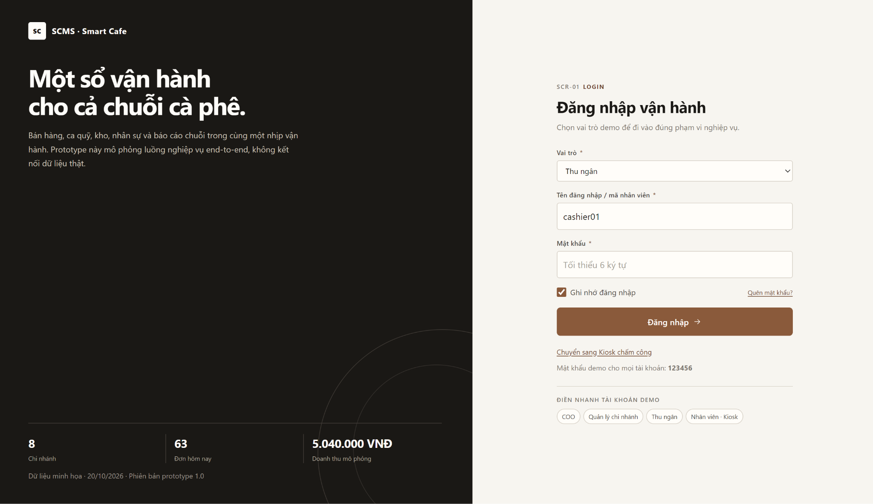
Table 4-1: User Login Screen (SCR-01) Definition
No | Object/Control Name | Type | Required | Length | Description
1 | cboRoleSelector | Dropdown | Yes | - | Selects the intended working module (Cashier, Branch Manager, COO, Staff). Used only as a routing hint; the real role is always resolved from the database (BR-01).
2 | txtUsername | Textbox | Yes | Max 30 | Username or employee ID (e.g., manager_d1). Trimmed before submission.
3 | txtPassword | Password | Yes | 6 - 32 | Masked password input. Minimum 6 characters; sent only over HTTPS.
4 | chkRememberMe | Checkbox | No | - | Keeps the refresh token in browser storage so the session survives a page reload. Default: checked.
5 | lnkForgotPassword | Link | No | - | Shows instructions to contact the Branch Manager or COO for a password reset.
6 | btnLogin | Button | Yes | - | Calls POST /api/v1/auth/login. On success stores the JWT and redirects to SCR-03; on failure displays MSG09 or the account-locked message.
7 | lnkSwitchToKiosk | Link | No | - | Switches the terminal to the Attendance Kiosk screen (SCR-02).

4.2.2 Class/Component Design

4.2.2.1 Classes/Component Structure
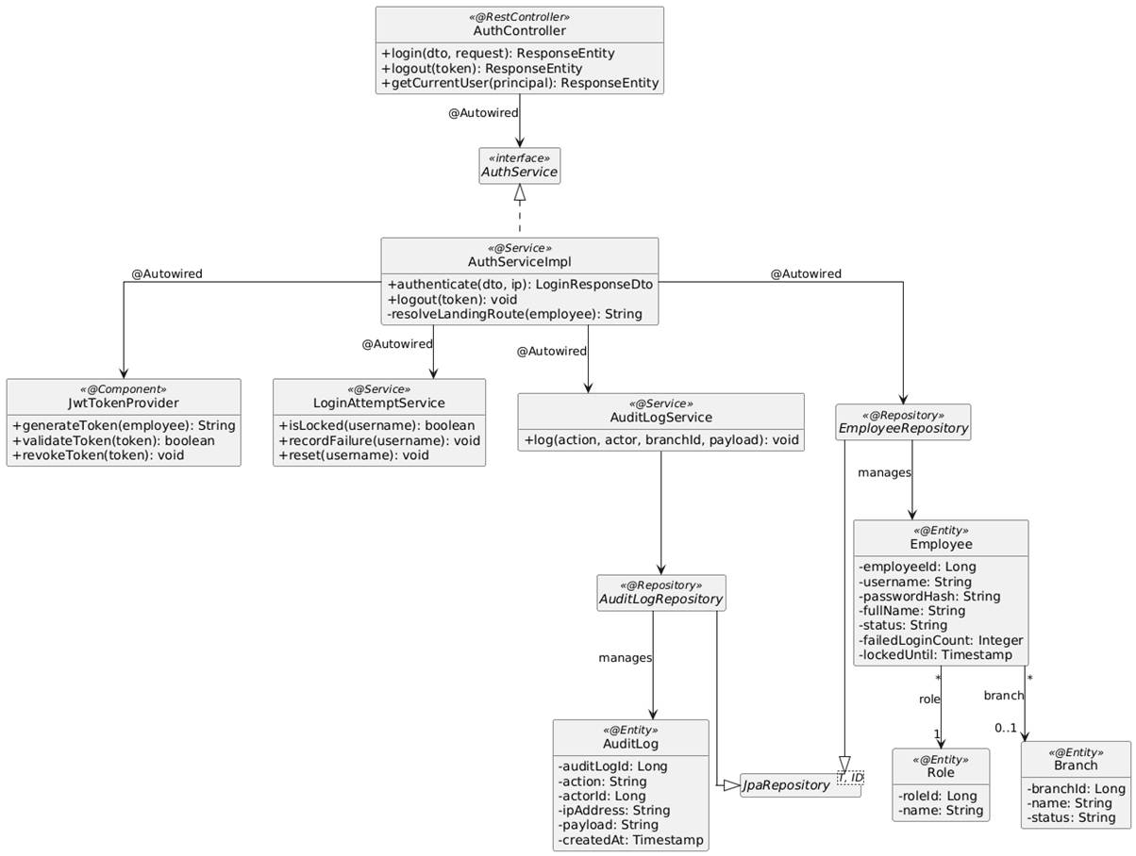

4.2.2.2 Classes/Component Description

4.2.2.2.1 AuthController Class
Class | AuthController
Description | Spring REST Controller exposing the authentication endpoints: login, logout and current-user profile.
Base Class | None (@RestController, @RequestMapping("/api/v1/auth"))
Constructor | +AuthController(AuthService authService)
Prototype | public class AuthController
Source File | AuthController.java
Namespace | com.scms.controller
Attributes
Name | Type & Description
authService | AuthService - Service interface injected via @Autowired.
Methods
Name | Input / Output / Description
login | Input: @RequestBody @Valid LoginRequestDto dto, HttpServletRequest request  Output: ResponseEntity<LoginResponseDto>  Description: POST /login. Authenticates the credentials and returns access token, role, branchId and default landing route (UC01 main flow).
logout | Input: @RequestHeader("Authorization") String token  Output: ResponseEntity<Void>  Description: POST /logout. Revokes the current token and records a LOGOUT audit entry.
getCurrentUser | Input: @AuthenticationPrincipal UserPrincipal principal  Output: ResponseEntity<CurrentUserDto>  Description: GET /me. Returns the profile, role and data scope used by SCR-03.

4.2.2.2.2 AuthServiceImpl Class
Class | AuthServiceImpl
Description | Service implementation performing credential validation, lock policy, token issuing and session termination.
Base Class | None (implements AuthService)
Constructor | +AuthServiceImpl(EmployeeRepository employeeRepo, PasswordEncoder passwordEncoder, JwtTokenProvider jwtTokenProvider, LoginAttemptService loginAttemptService, AuditLogService auditLogService)
Prototype | public class AuthServiceImpl implements AuthService
Source File | AuthServiceImpl.java
Namespace | com.scms.service.impl
Attributes
Name | Type & Description
employeeRepo | EmployeeRepository - Loads the employee account by username.
passwordEncoder | PasswordEncoder - BCrypt encoder used to verify the password hash.
jwtTokenProvider | JwtTokenProvider - Generates, validates and revokes JWT tokens.
loginAttemptService | LoginAttemptService - Counts failed attempts and locks the account after 5 consecutive failures.
auditLogService | AuditLogService - Writes LOGIN / LOGOUT / LOGIN_FAILED entries (SCR-17).
Methods
Name | Input / Output / Description
authenticate | Input: LoginRequestDto dto, String ipAddress  Output: LoginResponseDto  Description: Checks lock state, loads the account, verifies status = ACTIVE and password hash, resets the failure counter, resolves role and branch scope, issues the token and logs the login. Throws BadCredentialsException (MSG09) or AccountLockedException.
logout | Input: String token  Output: void  Description: Validates the token, adds its jti to the revoked-token store and logs the logout.
resolveLandingRoute | Input: Employee employee  Output: String  Description: Maps the role to the default screen: COO -> SCR-10, Branch Manager -> SCR-07, Cashier -> SCR-04.

4.2.3 Object Interactions (Sequence Diagrams)

4.2.3.1 SD-01: User Login (UC01)
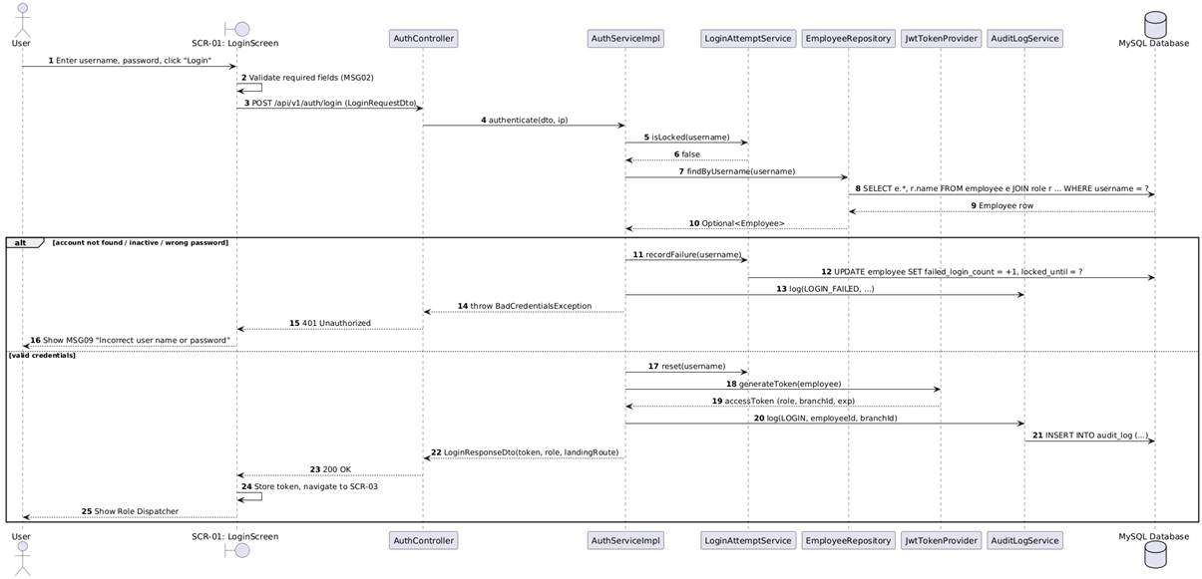

4.2.3.2 SD-02: User Logout (UC01)
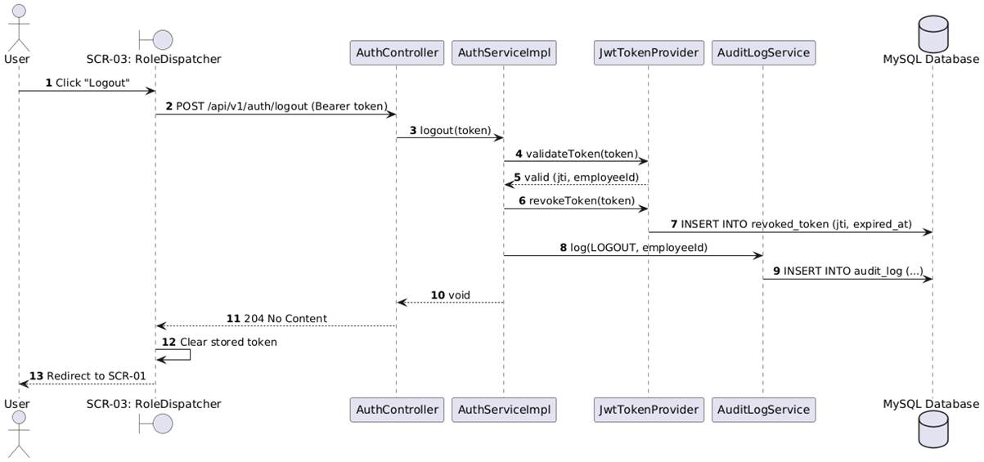

4.3 Manage Roles & Permissions
This section presents the detailed design of the Manage Roles & Permissions feature (TAB-09 of SCR-16). Only the COO can configure the role matrix (BR-02). The COO selects a role, the system loads its permission matrix (screen/feature x action), the COO toggles permissions and saves. The backend validates the change against security policies (COO role locked, dependent permissions), persists the matrix, evicts the permission cache so the new rules apply immediately to all sessions of that role, and writes a diff payload to the Audit Log (BR-51).

4.3.1 Screen Design

4.3.1.1 Roles & Permissions Matrix Tab (SCR-16 / TAB-09)
Table 4-3: Roles & Permissions Matrix Tab (SCR-16 / TAB-09) Definition
No | Object/Control Name | Type | Required | Length | Description
1 | tabSwitcher | Tabs | - | - | Switches between TAB-10 (Bank & SePay Webhook Config) and TAB-09 (Roles & Permissions Matrix).
2 | cboRole | Dropdown | Yes | - | Lists system roles (Staff, Cashier, Branch Manager, COO) loaded from GET /api/v1/roles. Changing the value reloads the matrix.
3 | lblRoleDescription | Label | - | Max 200 | Scope description of the selected role.
4 | lblBoundUsers | Label | - | - | Number of active accounts bound to the role; shows the impact of the change.
5 | tblPermissionMatrix | Data Grid | Yes | - | Rows = screens/features, columns = View, Create, Edit, Delete, Approve, Cancel/Refund. Each cell is a checkbox bound to a permission code (e.g. ORDER_REFUND).
6 | pnlPolicyNotice | Alert Box | - | - | Explains locked rules (COO matrix read-only, dependent permissions) and shows validation errors returned by the server.
7 | btnSavePermissions | Button | Yes | - | Calls PUT /api/v1/roles/{roleId}/permissions; on success shows MSG03, on policy violation shows the error and reverts unsaved cells.
8 | btnResetDefault | Button | No | - | Restores the default permission template of the selected role (requires confirmation).
9 | btnCancelChanges | Button | No | - | Discards local edits and reloads the stored matrix.

4.3.2 Class/Component Design

4.3.2.1 Classes/Component Structure
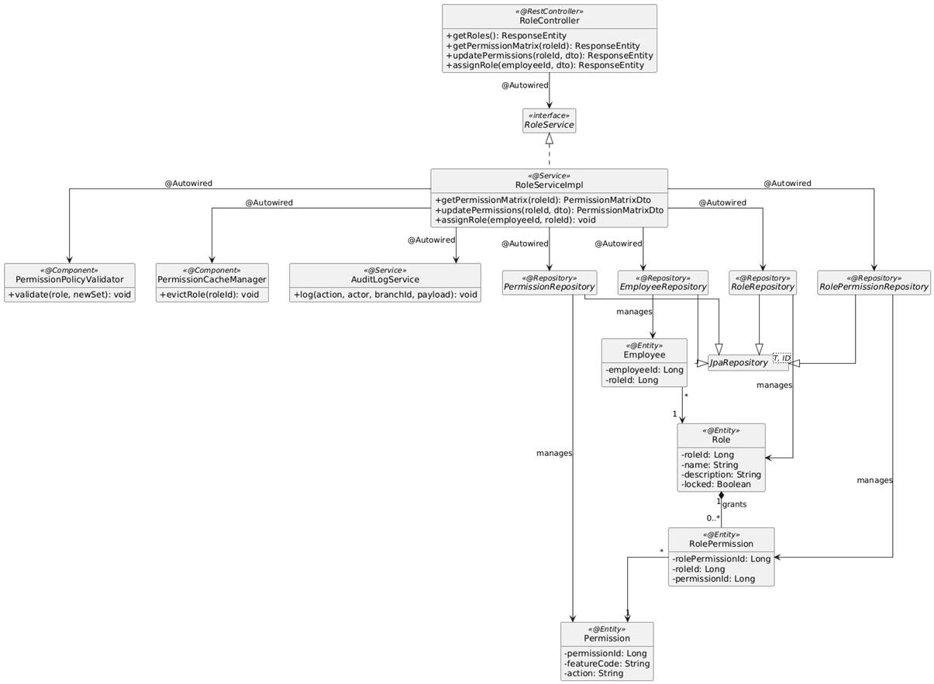

4.3.2.2 Classes/Component Description
4.3.2.2.1 RoleController Class
Class | RoleController
Description | Spring REST Controller exposing role listing, permission matrix retrieval/update and role assignment to employees. Secured with @PreAuthorize("hasRole('COO')").
Base Class | None (@RestController, @RequestMapping("/api/v1/roles"))
Constructor | +RoleController(RoleService roleService)
Prototype | public class RoleController
Source File | RoleController.java
Namespace | com.scms.controller
Attributes
Name | Type & Description
roleService | RoleService - Service interface injected via @Autowired.
Methods
Name | Input / Output / Description
getRoles | Input: None  Output: ResponseEntity<List<RoleDto>>  Description: GET endpoint returning all roles with description and bound user count.
getPermissionMatrix | Input: @PathVariable Long roleId  Output: ResponseEntity<PermissionMatrixDto>  Description: GET /{roleId}/permissions. Returns every feature with the granted actions of the role.
updatePermissions | Input: @PathVariable Long roleId, @RequestBody @Valid UpdatePermissionMatrixDto dto  Output: ResponseEntity<PermissionMatrixDto>  Description: PUT /{roleId}/permissions. Validates and saves the new matrix (UC02 main flow, BR-02).
assignRole | Input: @PathVariable Long employeeId, @RequestBody AssignRoleDto dto  Output: ResponseEntity<Void>  Description: PUT /assignments/{employeeId}. Assigns a role to an employee account.

4.3.2.2.2 RoleServiceImpl Class
Class | RoleServiceImpl
Description | Service implementation managing the RBAC matrix: loading, policy validation, persistence, cache eviction and auditing.
Base Class | None (implements RoleService)
Constructor | +RoleServiceImpl(RoleRepository roleRepo, PermissionRepository permissionRepo, RolePermissionRepository rolePermissionRepo, EmployeeRepository employeeRepo, PermissionPolicyValidator policyValidator, PermissionCacheManager permissionCache, AuditLogService auditLogService)
Prototype | public class RoleServiceImpl implements RoleService
Source File | RoleServiceImpl.java
Namespace | com.scms.service.impl
Attributes
Name | Type & Description
roleRepo | RoleRepository - Reads roles.
permissionRepo | PermissionRepository - Reads the catalog of permission codes (feature + action).
rolePermissionRepo | RolePermissionRepository - Persists role-permission mappings.
employeeRepo | EmployeeRepository - Updates the role of an employee.
policyValidator | PermissionPolicyValidator - Checks security constraints of a permission set.
permissionCache | PermissionCacheManager - Evicts cached authorities so changes take effect immediately.
auditLogService | AuditLogService - Writes PERMISSION_UPDATE entries with before/after diff.
Methods
Name | Input / Output / Description
getPermissionMatrix | Input: Long roleId  Output: PermissionMatrixDto  Description: Loads all permissions and marks the ones granted to the role.
updatePermissions | Input: Long roleId, UpdatePermissionMatrixDto dto  Output: PermissionMatrixDto  Description: @Transactional. Loads the old set, calls policyValidator.validate(), replaces role_permission rows, evicts the cache, logs the diff. Throws PermissionPolicyException on violation (AT1).
assignRole | Input: Long employeeId, Long roleId  Output: void  Description: Changes the role of an employee and logs ROLE_ASSIGN.

4.3.2.2.3 PermissionPolicyValidator Class
Class | PermissionPolicyValidator
Description | Component that enforces RBAC security constraints before saving.
Base Class | None (@Component)
Constructor | +PermissionPolicyValidator()
Prototype | public class PermissionPolicyValidator
Source File | PermissionPolicyValidator.java
Namespace | com.scms.security
Attributes
Name | Type & Description
- | None (stateless component)
Methods
Name | Input / Output / Description
validate | Input: Role role, Set<Permission> newSet  Output: void  Description: Rejects any change on the COO role (BR-02), requires VIEW when CREATE/EDIT/DELETE/APPROVE is granted, and forbids granting cross-branch permissions to branch roles (BR-04). Throws PermissionPolicyException with a reason message.

4.3.3 Object Interactions (Sequence Diagrams)

4.3.3.1 SD-01: View Role Permission Matrix (UC02)
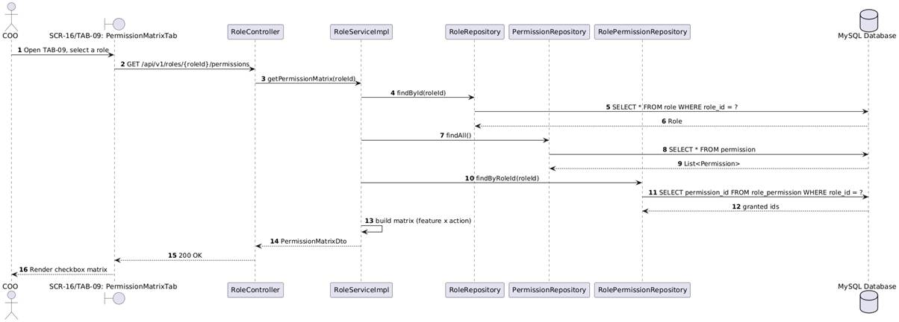

4.3.3.2 SD-02: Update Role Permissions (UC02)
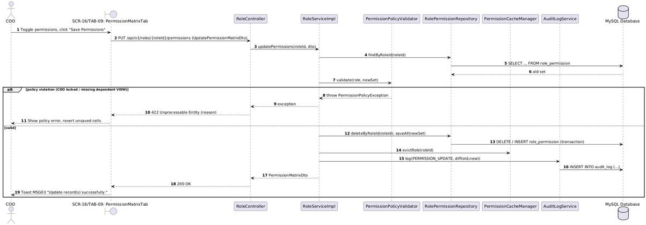

4.4 Check In
This section presents the detailed design of the Check In feature executed on the Attendance Kiosk (SCR-02). Staff and Cashiers authenticate either by swiping an RFID card (BR-06) or, as a fallback, by selecting their name and entering a 4-digit PIN (BR-08). The backend verifies the PIN hash with lockout protection, matches the current time against the employee's shift assignment for today (UC08), records the check-in timestamp with the punctuality status and returns the result banner. An unscheduled check-in is still recorded but flagged for manager review (AT2).

4.4.1 Screen Design

4.4.1.1 Attendance Kiosk Screen - Check In (SCR-02)
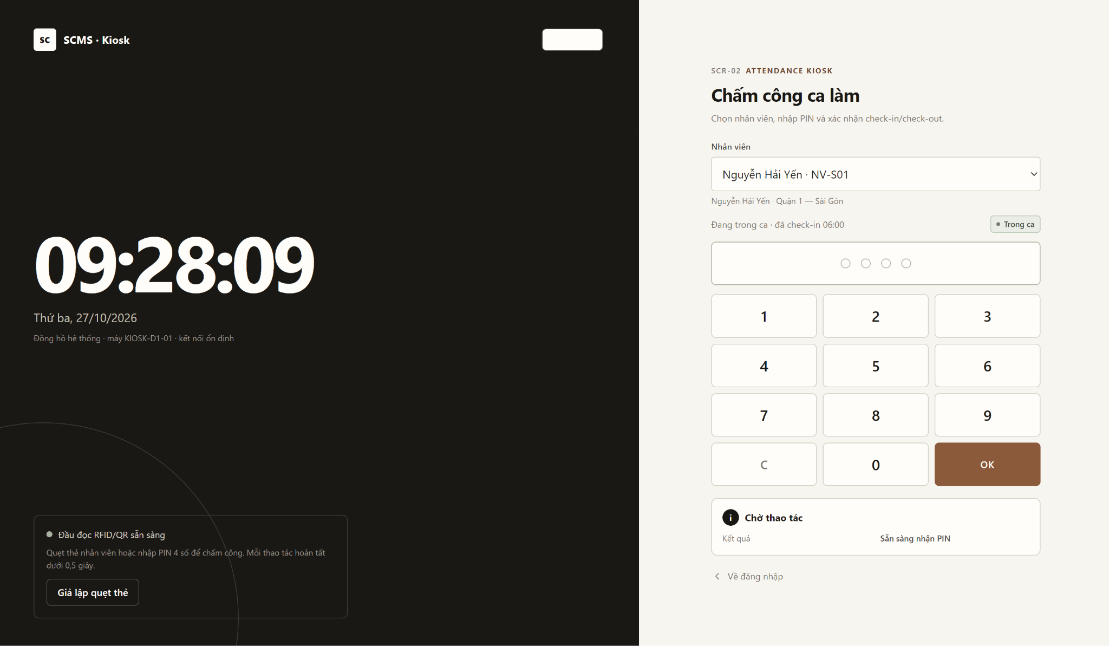
Table 4-4: Attendance Kiosk Screen - Check In (SCR-02) Definition
No | Object/Control Name | Type | Required | Length | Description
1 | lblSystemClock | Label | - | - | Real-time clock synchronised with the server time (GET /api/v1/system/time every 60s).
2 | btnBackToLogin | Button | No | - | Returns to SCR-01 User Login.
3 | pnlRfidScanArea | Component | - | - | Captures keyboard-wedge input from the USB RFID/QR reader and calls POST /api/v1/attendance/card-swipe (BR-06).
4 | lblReaderStatus | Label | - | Max 50 | Reader connection status, e.g. "Ready for check-in/out".
5 | cboEmployee | Dropdown | Yes | - | Active employees of the branch scheduled today (Full Name + Employee ID); used by the PIN fallback (BR-08).
6 | txtPin | Password | Yes | 4 | Masked PIN display; exactly 4 digits.
7 | btnNumpad[0-9] | Button Grid | - | - | Large 44x44 px touch keys to enter the PIN.
8 | btnClear | Button | No | - | Clears the entered PIN digits.
9 | btnSubmitOk | Button | Yes | - | Submits POST /api/v1/attendance/check-in with employeeId and PIN.
10 | lblResultBanner | Label / Box | - | Max 150 | Shows the latest result: name, ID, Check-in, timestamp, On Time / Late or warning "No scheduled shift found for today".

4.4.2 Class/Component Design

4.4.2.1 Classes/Component Structure
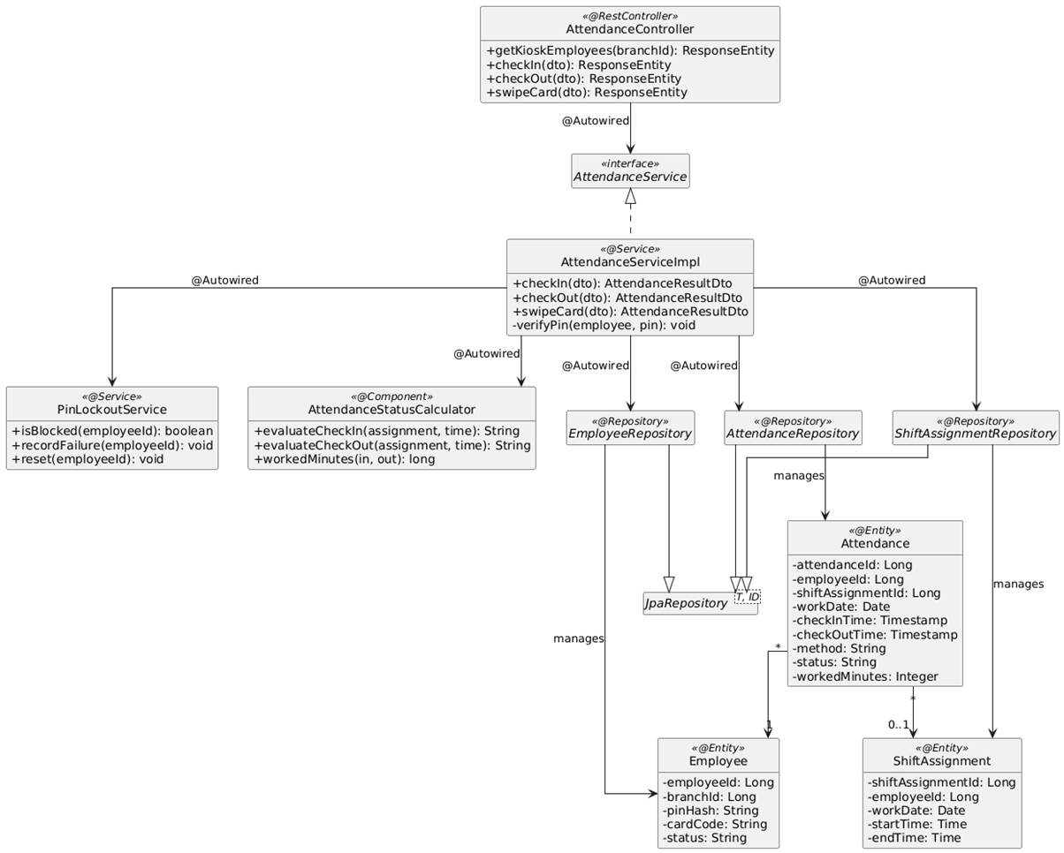

4.4.2.2 Classes/Component Description
4.4.2.2.1 AttendanceController Class
Class | AttendanceController
Description | Spring REST Controller serving the Attendance Kiosk (SCR-02): employee list for the PIN fallback, PIN check-in/check-out and RFID card swipe.
Base Class | None (@RestController, @RequestMapping("/api/v1/attendance"))
Constructor | +AttendanceController(AttendanceService attendanceService)
Prototype | public class AttendanceController
Source File | AttendanceController.java
Namespace | com.scms.controller
Attributes
Name | Type & Description
attendanceService | AttendanceService - Service interface injected via @Autowired.
Methods
Name | Input / Output / Description
getKioskEmployees | Input: @RequestParam Long branchId  Output: ResponseEntity<List<KioskEmployeeDto>>  Description: GET /kiosk/employees. Active Staff/Cashier of the branch scheduled today (Employee Selector).
checkIn | Input: @RequestBody @Valid PinAttendanceRequestDto dto  Output: ResponseEntity<AttendanceResultDto>  Description: POST /check-in. PIN-based check-in (UC03).
checkOut | Input: @RequestBody @Valid PinAttendanceRequestDto dto  Output: ResponseEntity<AttendanceResultDto>  Description: POST /check-out. PIN-based check-out (UC04).
swipeCard | Input: @RequestBody @Valid CardSwipeRequestDto dto  Output: ResponseEntity<AttendanceResultDto>  Description: POST /card-swipe. RFID swipe: records check-in if no open record, otherwise check-out (BR-06).

4.4.2.2.2 AttendanceServiceImpl Class
Class | AttendanceServiceImpl
Description | Service implementation handling kiosk authentication and attendance recording.
Base Class | None (implements AttendanceService)
Constructor | +AttendanceServiceImpl(EmployeeRepository employeeRepo, AttendanceRepository attendanceRepo, ShiftAssignmentRepository assignmentRepo, PasswordEncoder pinEncoder, PinLockoutService pinLockoutService, AttendanceStatusCalculator statusCalculator)
Prototype | public class AttendanceServiceImpl implements AttendanceService
Source File | AttendanceServiceImpl.java
Namespace | com.scms.service.impl
Attributes
Name | Type & Description
employeeRepo | EmployeeRepository - Loads the employee and PIN hash / card code.
attendanceRepo | AttendanceRepository - Persists and queries attendance records.
assignmentRepo | ShiftAssignmentRepository - Finds the scheduled shift of the employee for today (UC08 data).
pinEncoder | PasswordEncoder - BCrypt encoder comparing the 4-digit PIN with its hash.
pinLockoutService | PinLockoutService - Blocks an employee for 5 minutes after 5 consecutive wrong PINs.
statusCalculator | AttendanceStatusCalculator - Computes On Time / Late / Early Leave status and worked minutes.
Methods
Name | Input / Output / Description
checkIn | Input: PinAttendanceRequestDto dto  Output: AttendanceResultDto  Description: @Transactional. Checks lockout, verifies PIN (AT1), rejects a duplicate open check-in, finds today's ShiftAssignment, evaluates status (On Time/Late) or flags UNSCHEDULED (AT2), saves the Attendance with method = PIN.
swipeCard | Input: CardSwipeRequestDto dto  Output: AttendanceResultDto  Description: Finds the employee by cardCode; if an open record exists and >= 15 minutes elapsed (BR-07) performs check-out, else performs check-in with method = RFID.
verifyPin | Input: Employee employee, String pin  Output: void  Description: Compares the PIN with pinHash; on failure increments the lockout counter and throws InvalidPinException ("Incorrect PIN. Please try again.").

4.4.3 Object Interactions (Sequence Diagrams)

4.4.3.1 SD-01: Check In by PIN (UC03)
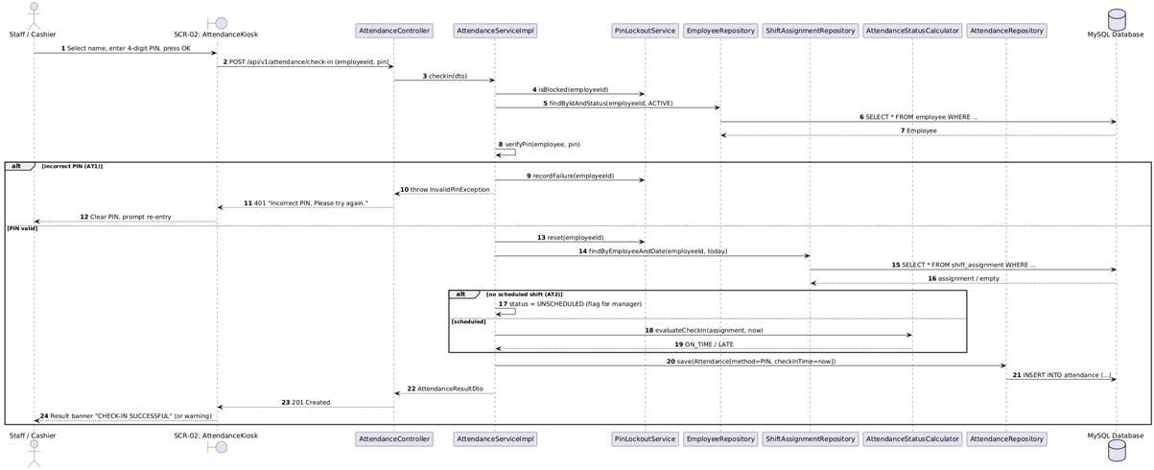

4.4.3.2 SD-02: Check In / Out by RFID Card Swipe (UC03)
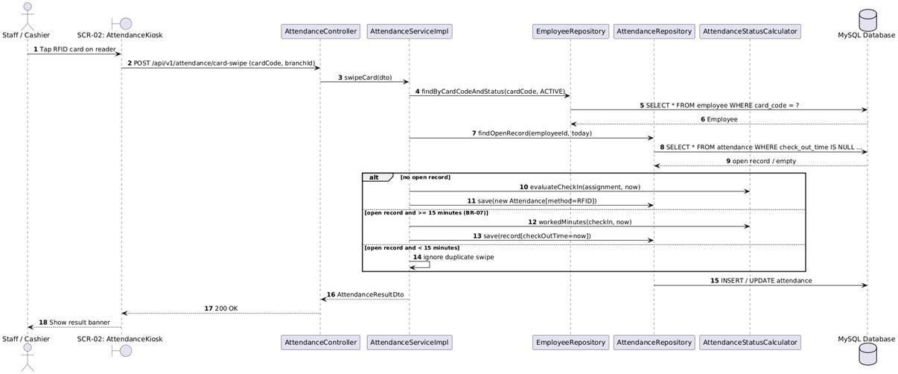

4.5 Check Out
This section presents the detailed design of the Check Out feature. It reuses the Attendance Kiosk components of UC03. The employee authenticates by PIN (or RFID card, see 4.4.3 SD-02); the system verifies that an open check-in record exists for the current day, enforces the 15-minute minimum interval (BR-07), records the check-out timestamp, computes the total worked time and early-leave status against the assigned shift, and displays the result. If no open check-in exists the employee is asked to contact the Branch Manager for a manual adjustment (BR-10).

4.5.1 Screen Design

4.4.1.1 Attendance Kiosk Screen - Check In (SCR-02)
Table 4-4: Attendance Kiosk Screen - Check In (SCR-02) Definition
No | Object/Control Name | Type | Required | Length | Description
1 | lblSystemClock | Label | - | - | Real-time clock synchronised with the server time (GET /api/v1/system/time every 60s).
2 | btnBackToLogin | Button | No | - | Returns to SCR-01 User Login.
3 | pnlRfidScanArea | Component | - | - | Captures keyboard-wedge input from the USB RFID/QR reader and calls POST /api/v1/attendance/card-swipe (BR-06).
4 | lblReaderStatus | Label | - | Max 50 | Reader connection status, e.g. "Ready for check-in/out".
5 | cboEmployee | Dropdown | Yes | - | Active employees of the branch scheduled today (Full Name + Employee ID); used by the PIN fallback (BR-08).
6 | txtPin | Password | Yes | 4 | Masked PIN display; exactly 4 digits.
7 | btnNumpad[0-9] | Button Grid | - | - | Large 44x44 px touch keys to enter the PIN.
8 | btnClear | Button | No | - | Clears the entered PIN digits.
9 | btnSubmitOk | Button | Yes | - | Submits POST /api/v1/attendance/check-in with employeeId and PIN.
10 | lblResultBanner | Label / Box | - | Max 150 | Shows the latest result: name, ID, Check-in, timestamp, On Time / Late or warning "No scheduled shift found for today".

4.5.2 Class/Component Design

4.5.2.1 Classes/Component Structure
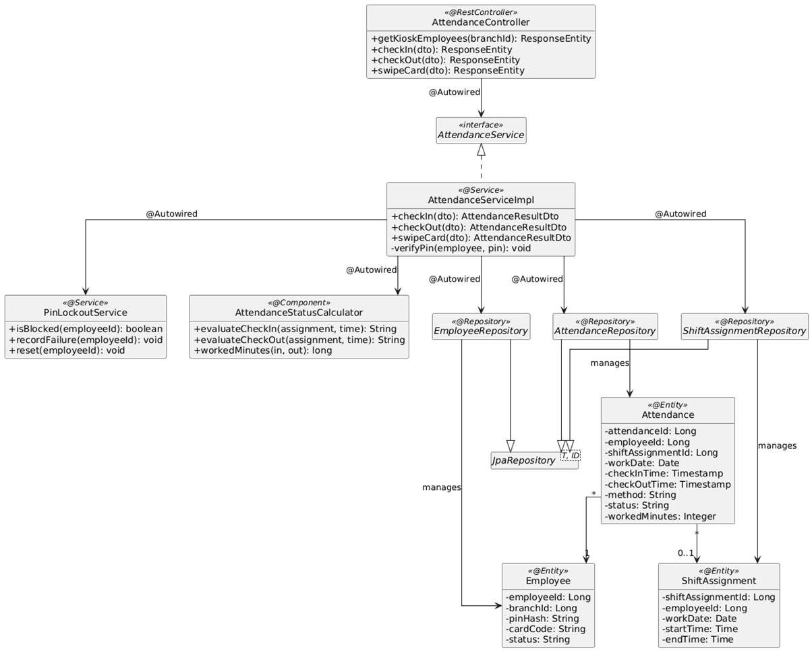

4.5.2.2 Classes/Component Description
4.5.2.2.1 AttendanceServiceImpl Class
Class | AttendanceServiceImpl
Description | Service implementation (shared with UC03). Methods specific to the check-out flow are described below.
Base Class | None (implements AttendanceService)
Constructor | +AttendanceServiceImpl(EmployeeRepository employeeRepo, AttendanceRepository attendanceRepo, ShiftAssignmentRepository assignmentRepo, PasswordEncoder pinEncoder, PinLockoutService pinLockoutService, AttendanceStatusCalculator statusCalculator)
Prototype | public class AttendanceServiceImpl implements AttendanceService
Source File | AttendanceServiceImpl.java
Namespace | com.scms.service.impl
Attributes
Name | Type & Description
employeeRepo | EmployeeRepository - Loads the employee and PIN hash / card code.
attendanceRepo | AttendanceRepository - Persists and queries attendance records.
assignmentRepo | ShiftAssignmentRepository - Finds the scheduled shift of the employee for today (UC08 data).
pinEncoder | PasswordEncoder - BCrypt encoder comparing the 4-digit PIN with its hash.
pinLockoutService | PinLockoutService - Blocks an employee for 5 minutes after 5 consecutive wrong PINs.
statusCalculator | AttendanceStatusCalculator - Computes On Time / Late / Early Leave status and worked minutes.
Methods
Name | Input / Output / Description
checkOut | Input: PinAttendanceRequestDto dto  Output: AttendanceResultDto  Description: @Transactional. Verifies PIN, loads the open attendance record of today (AT1 if none -> NoOpenCheckInException), checks interval >= 15 minutes (BR-07), sets checkOutTime, workedMinutes and final status, saves the record.
findOpenRecord | Input: Long employeeId, LocalDate workDate  Output: Optional<Attendance>  Description: Returns the attendance row with checkOutTime IS NULL (also covers overnight shifts started the previous day).

4.5.2.2.2 AttendanceStatusCalculator Class
Class | AttendanceStatusCalculator
Description | Component computing punctuality and worked time.
Base Class | None (@Component)
Constructor | +AttendanceStatusCalculator()
Prototype | public class AttendanceStatusCalculator
Source File | AttendanceStatusCalculator.java
Namespace | com.scms.service.support
Attributes
Name | Type & Description
- | None (stateless component)
Methods
Name | Input / Output / Description
evaluateCheckOut | Input: ShiftAssignment assignment, LocalDateTime time  Output: String  Description: Returns EARLY_LEAVE when time < shift end - tolerance, otherwise COMPLETED.
workedMinutes | Input: LocalDateTime checkIn, LocalDateTime checkOut  Output: long  Description: Duration in minutes between check-in and check-out used for payroll.

4.5.3 Object Interactions (Sequence Diagrams)

4.5.3.1 SD-01: Check Out by PIN (UC04)
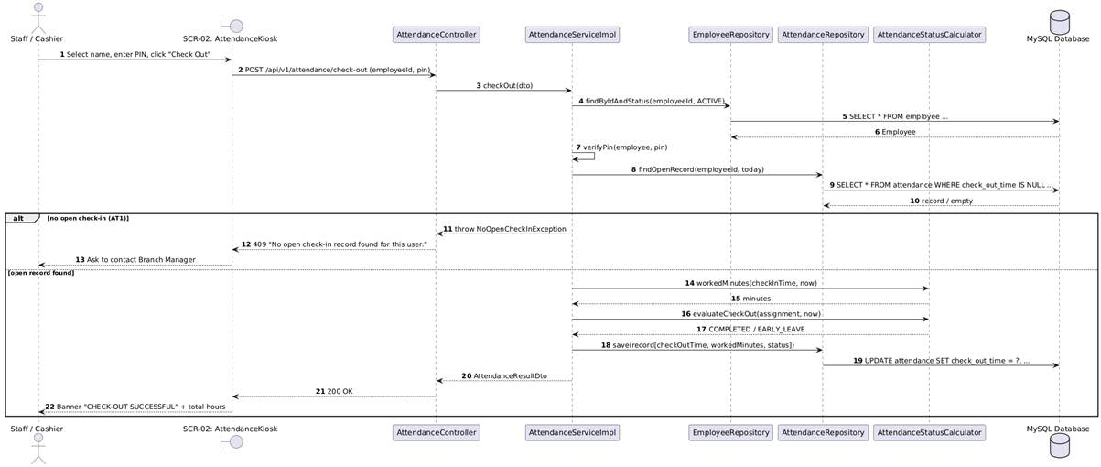

4.6 Manage Branch
This section presents the detailed design of the Manage Branch feature on SCR-13 Branches & Managers. The COO (the only authorised role, BR-11) views the branch list, creates a new branch, edits its profile (code, name, address, hotline, opening hours, table count, tax code) or changes its operational status (Open, Temporarily Closed, Maintenance, Inactive). Branches are never hard-deleted; deactivation is a status change so that historical orders, shifts and inventory stay intact. Every change is written to the Audit Log.

4.6.1 Screen Design

4.6.1.1 Branches & Managers Screen (SCR-13)
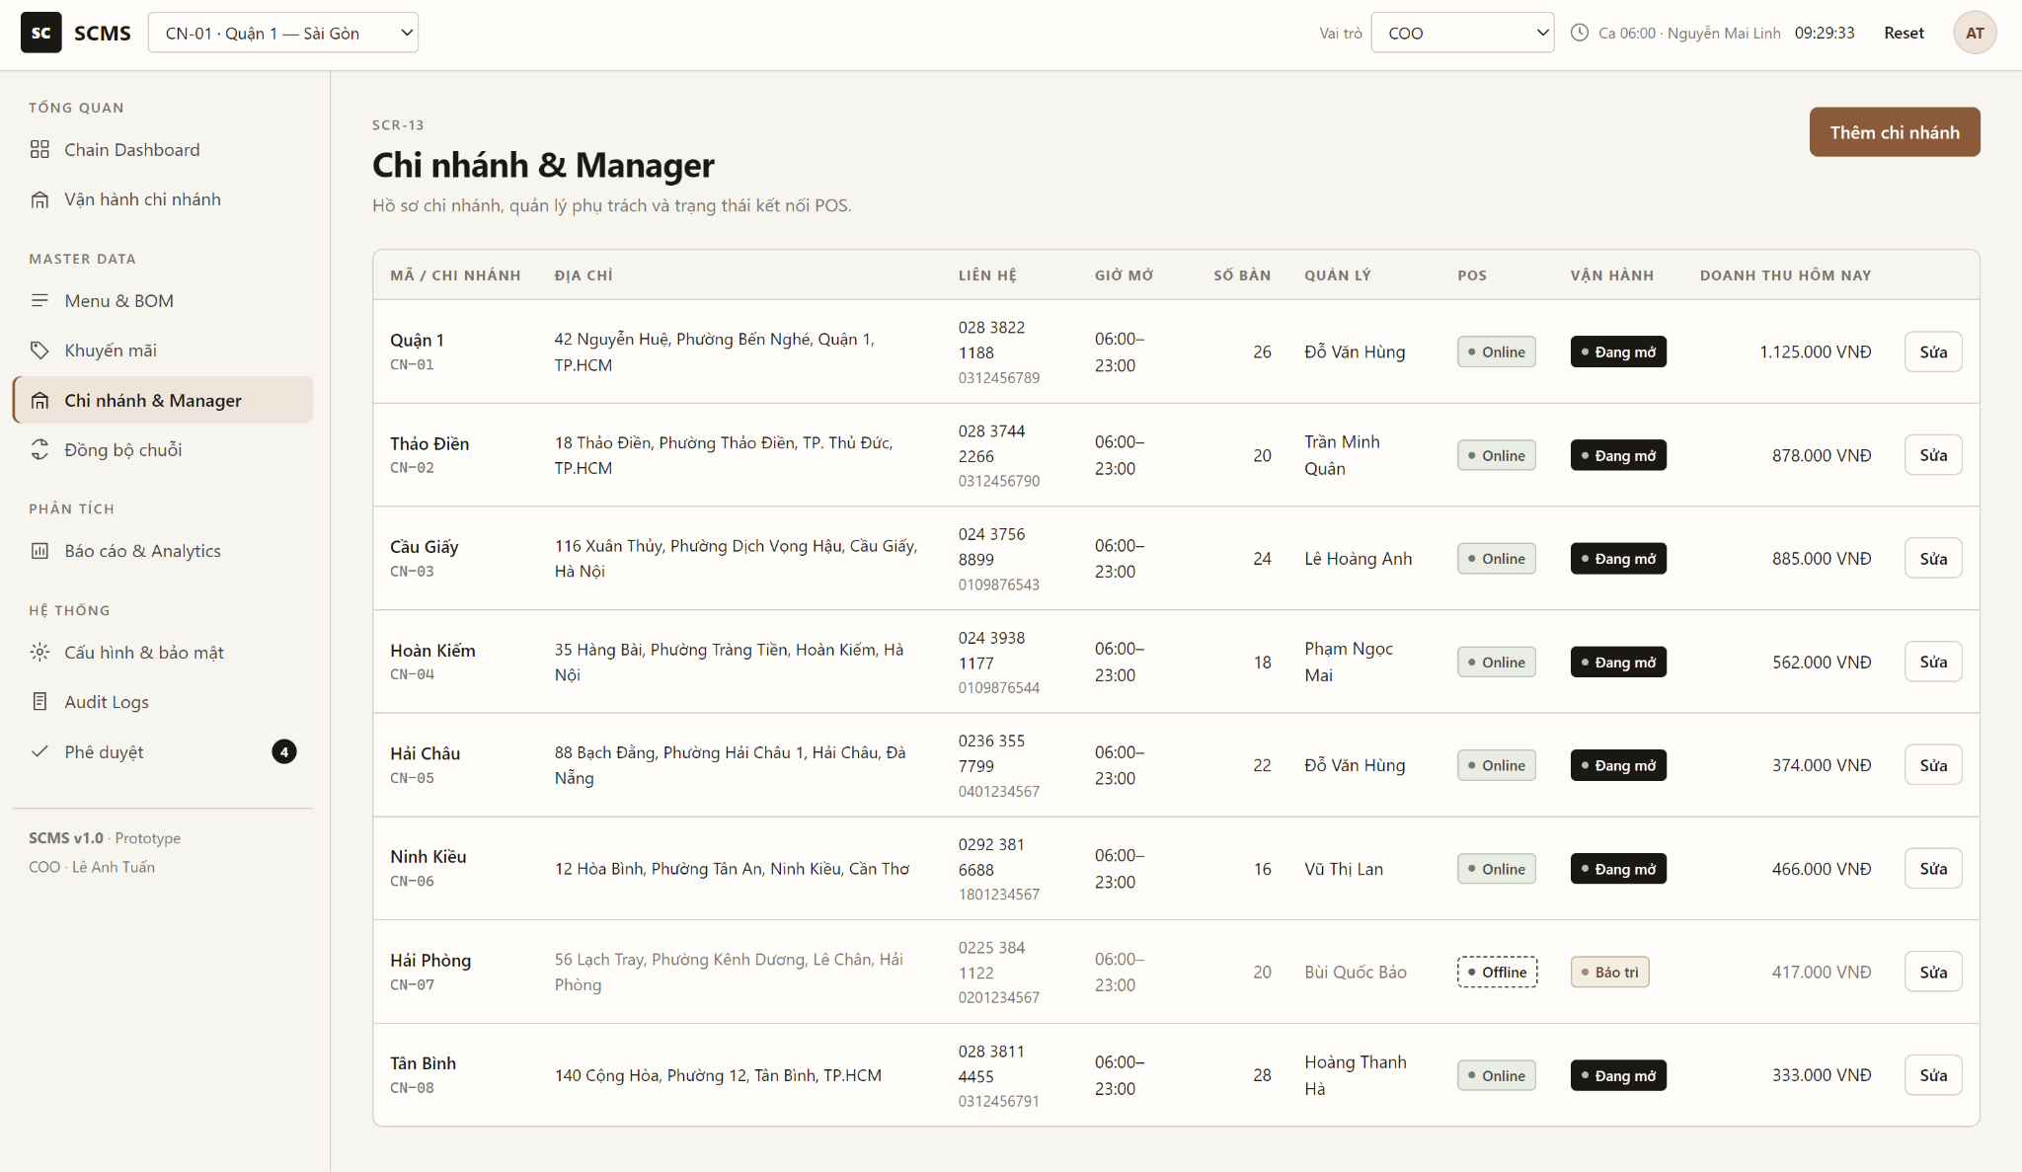
Table 4-6: Branches & Managers Screen (SCR-13) Definition
No | Object/Control Name | Type | Required | Length | Description
1 | btnAddBranch | Button | No | - | Opens POP-13A in create mode.
2 | txtSearchBranch | Textbox | No | Max 50 | Live search (300 ms debounce) by branch code or name.
3 | tblBranches | Data Grid | Yes | - | Branch Code, Name, Address, Phone, Assigned Manager, Manager Account, POS Status, Action. Paginated, loaded from GET /api/v1/branches.
4 | lblPosStatus | Label | - | 20 | Online / Offline connection status of the branch POS.
5 | btnEditBranch | Button | No | - | Opens POP-13A pre-filled with the selected branch.
6 | btnNavSidebar | Menu | - | - | HQ sidebar navigation (SCR-10 ... SCR-17).

4.6.1.2 Create / Edit Branch Profile Popup (POP-13A)
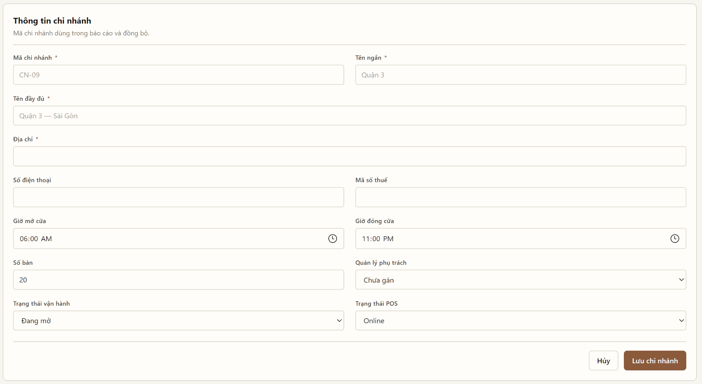
Table 4-7: Create / Edit Branch Profile Popup (POP-13A) Definition
No | Object/Control Name | Type | Required | Length | Description
1 | txtBranchCode | Textbox | Yes | Max 10 | Unique branch code (e.g. CN04). Read-only in edit mode.
2 | txtBranchName | Textbox | Yes | Max 100 | Branch display name.
3 | txtHotline | Textbox | No | 10 - 11 | Digits only, starting with 0.
4 | txtAddress | Textbox | Yes | Max 255 | Physical address.
5 | tpOpeningTime / tpClosingTime | Time Picker | Yes | 5 | Operating hours; closing time must be later than opening time.
6 | txtTableCount | Number | No | 3 | Number of tables at the branch (>= 0).
7 | txtTaxCode | Textbox | No | Max 20 | Branch tax code.
8 | cboStatus | Dropdown | Yes | - | Open / Temporarily Closed / Maintenance / Inactive.
9 | lblAssignedManager | Dropdown | No | - | Displays the bound Branch Manager; assignment itself is done in UC06.
10 | btnSaveBranch | Button | Yes | - | POST /api/v1/branches (create) or PUT /api/v1/branches/{id} (update); shows MSG04 / MSG03.
11 | btnDeactivate | Button | No | - | Confirmation popup then PATCH /api/v1/branches/{id}/status.
12 | btnCancel | Button | No | - | Closes the popup without saving.

4.6.2 Class/Component Design

4.6.2.1 Classes/Component Structure
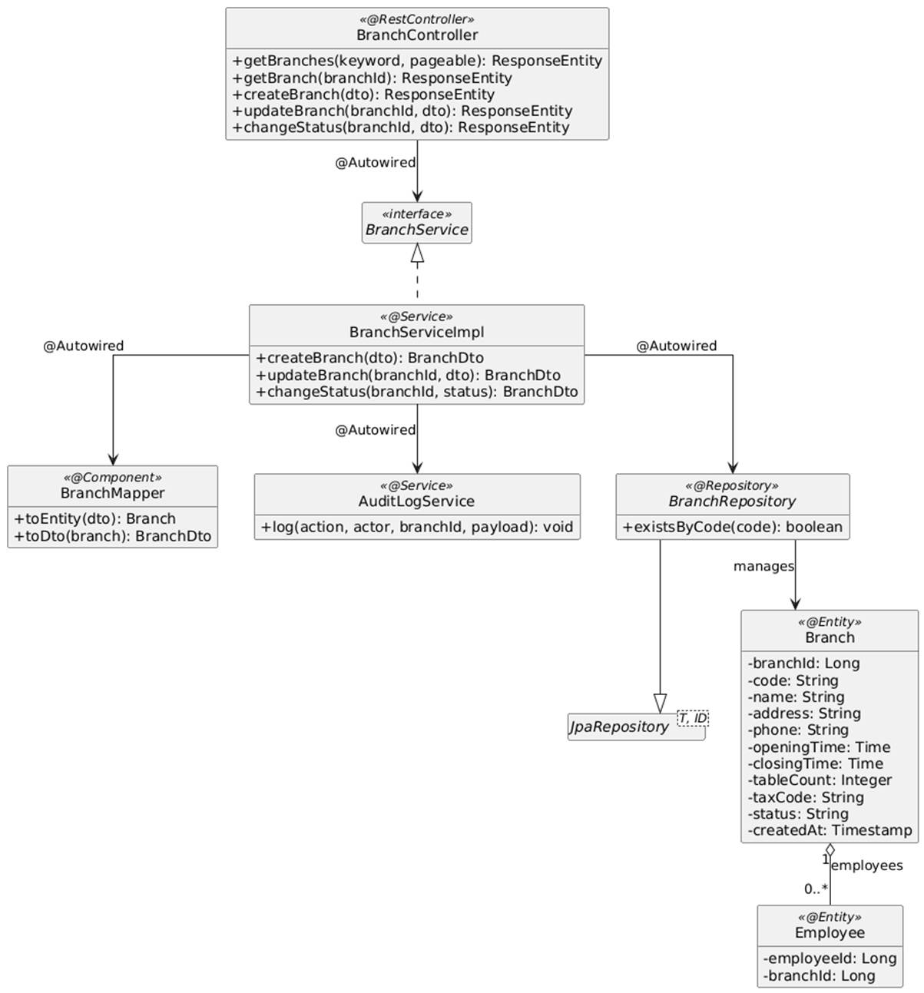

4.6.2.2 Classes/Component Description
4.6.2.2.1 BranchController Class
Class | BranchController
Description | Spring REST Controller exposing CRUD-style branch management endpoints for the COO (@PreAuthorize("hasRole('COO')"), BR-11).
Base Class | None (@RestController, @RequestMapping("/api/v1/branches"))
Constructor | +BranchController(BranchService branchService)
Prototype | public class BranchController
Source File | BranchController.java
Namespace | com.scms.controller
Attributes
Name | Type & Description
branchService | BranchService - Service interface injected via @Autowired.
Methods
Name | Input / Output / Description
getBranches | Input: @RequestParam String keyword, Pageable pageable  Output: ResponseEntity<Page<BranchDto>>  Description: GET endpoint listing branches with assigned manager and POS status.
getBranch | Input: @PathVariable Long branchId  Output: ResponseEntity<BranchDetailDto>  Description: GET /{branchId}. Loads one branch for the edit form.
createBranch | Input: @RequestBody @Valid CreateBranchDto dto  Output: ResponseEntity<BranchDto>  Description: POST endpoint creating a branch (UC05 main flow).
updateBranch | Input: @PathVariable Long branchId, @RequestBody @Valid UpdateBranchDto dto  Output: ResponseEntity<BranchDto>  Description: PUT endpoint updating the branch profile.
changeStatus | Input: @PathVariable Long branchId, @RequestBody ChangeBranchStatusDto dto  Output: ResponseEntity<BranchDto>  Description: PATCH /{branchId}/status. Changes operational status / deactivates.

4.6.2.2.2 BranchServiceImpl Class
Class | BranchServiceImpl
Description | Service implementation validating and persisting branch profiles.
Base Class | None (implements BranchService)
Constructor | +BranchServiceImpl(BranchRepository branchRepo, BranchMapper branchMapper, AuditLogService auditLogService)
Prototype | public class BranchServiceImpl implements BranchService
Source File | BranchServiceImpl.java
Namespace | com.scms.service.impl
Attributes
Name | Type & Description
branchRepo | BranchRepository - Persists branch records.
branchMapper | BranchMapper - Maps DTOs <-> Branch entity.
auditLogService | AuditLogService - Logs BRANCH_CREATE / BRANCH_UPDATE / BRANCH_STATUS with diff payload.
Methods
Name | Input / Output / Description
createBranch | Input: CreateBranchDto dto  Output: BranchDto  Description: Checks existsByCode (AT1 -> DuplicateBranchCodeException), validates opening < closing time, saves with createdAt, logs audit.
updateBranch | Input: Long branchId, UpdateBranchDto dto  Output: BranchDto  Description: Loads the branch (404 if missing), applies changes, saves, logs before/after diff.
changeStatus | Input: Long branchId, BranchStatus status  Output: BranchDto  Description: Updates status (soft deactivation - no hard delete) and logs the operation.

4.6.3 Object Interactions (Sequence Diagrams)

4.6.3.1 SD-01: View Branch List (UC05)
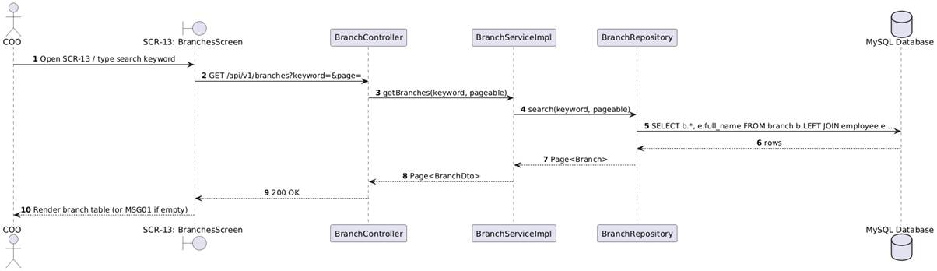

4.6.3.2 SD-02: Create / Update Branch (UC05)
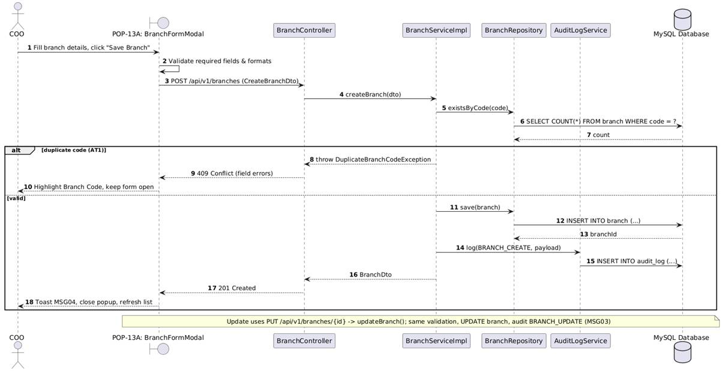

4.6.3.3 SD-03: Deactivate / Change Branch Status (UC05)
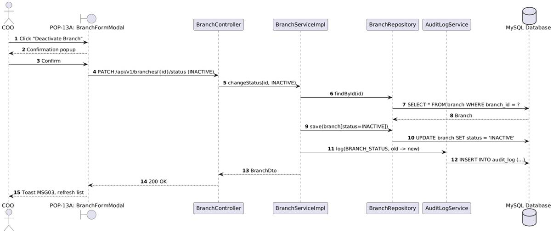

4.7 Manage Branch Manager
This section presents the detailed design of the Manage Branch Manager feature. From SCR-13 the COO opens POP-13B to create a Branch Manager account or edit an existing one: profile, credentials (username, password hashed with BCrypt), assigned branch scope, approval limit and status. Each manager belongs to exactly one branch; only the COO can reassign it, the reassignment is written to the Audit Log and historical data remains with the original branch (BR-12). Username and email must be unique (AT1).

4.7.1 Screen Design

4.7.1.1 Create / Edit Branch Manager Account Popup (POP-13B)
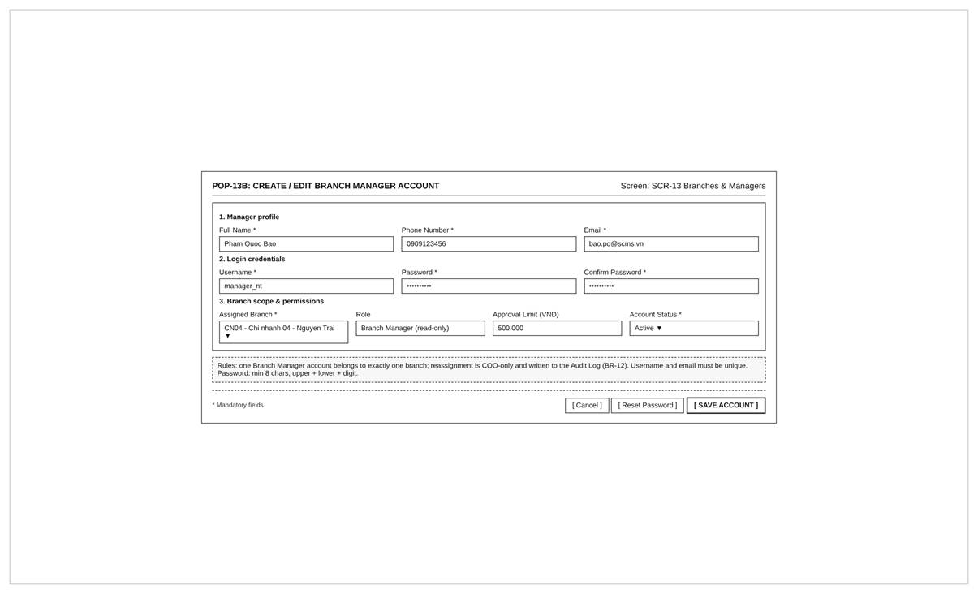
Table 4-8: Create / Edit Branch Manager Account Popup (POP-13B) Definition
No | Object/Control Name | Type | Required | Length | Description
1 | txtFullName | Textbox | Yes | Max 100 | Manager full name.
2 | txtPhone | Textbox | Yes | 10 - 11 | Digits only, starting with 0.
3 | txtEmail | Textbox | Yes | Max 100 | Unique, valid e-mail format.
4 | txtUsername | Textbox | Yes | 4 - 30 | Unique login username. Read-only in edit mode.
5 | txtPassword / txtConfirmPassword | Password | Yes (create) | 8 - 32 | Strong password (upper, lower, digit). Optional in edit mode; stored as BCrypt hash.
6 | cboAssignedBranch | Dropdown | Yes | - | Active branches loaded from GET /api/v1/branches?status=OPEN. Changing it in edit mode triggers a reassignment (BR-12).
7 | lblRole | Label | - | - | Fixed role Branch Manager.
8 | txtApprovalLimit | Number | No | 15 | Approval threshold (VND) for refunds / cash adjustments (BR-35).
9 | cboAccountStatus | Dropdown | Yes | - | Active / Locked / Inactive.
10 | btnResetPassword | Button | No | - | Generates a temporary password for the manager.
11 | btnSaveAccount | Button | Yes | - | POST /api/v1/branch-managers or PUT /api/v1/branch-managers/{id}; shows MSG04 / MSG03 or "Username/Email already exists in the system."
12 | btnCancel | Button | No | - | Closes the popup without saving.

4.7.2 Class/Component Design

4.7.2.1 Classes/Component Structure
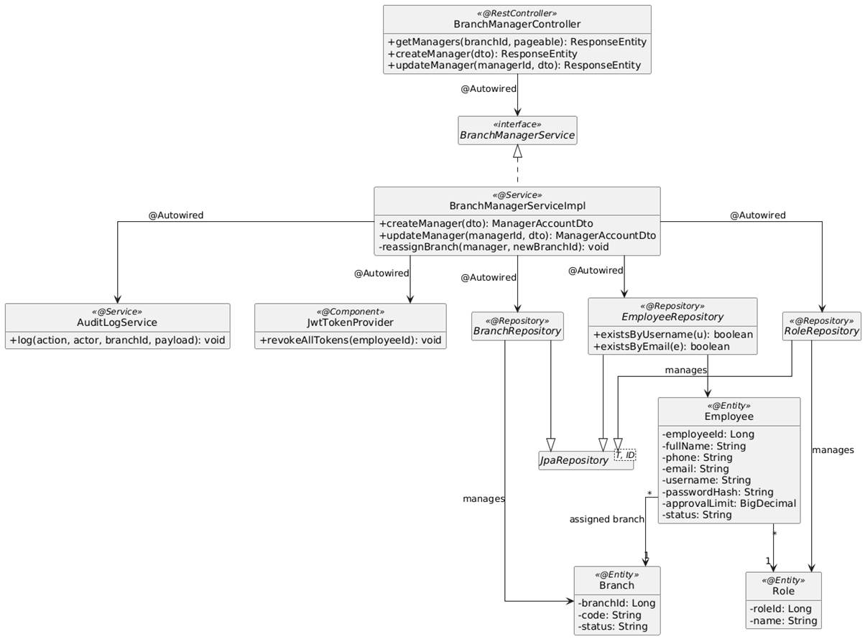

4.7.2.2 Classes/Component Description
4.7.2.2.1 BranchManagerController Class
Class | BranchManagerController
Description | Spring REST Controller for Branch Manager account management, restricted to the COO.
Base Class | None (@RestController, @RequestMapping("/api/v1/branch-managers"))
Constructor | +BranchManagerController(BranchManagerService managerService)
Prototype | public class BranchManagerController
Source File | BranchManagerController.java
Namespace | com.scms.controller
Attributes
Name | Type & Description
managerService | BranchManagerService - Service interface injected via @Autowired.
Methods
Name | Input / Output / Description
getManagers | Input: @RequestParam Long branchId, Pageable pageable  Output: ResponseEntity<Page<ManagerAccountDto>>  Description: GET endpoint listing manager accounts and their branches.
createManager | Input: @RequestBody @Valid CreateManagerAccountDto dto  Output: ResponseEntity<ManagerAccountDto>  Description: POST endpoint creating an account bound to a branch (UC06 main flow).
updateManager | Input: @PathVariable Long managerId, @RequestBody @Valid UpdateManagerAccountDto dto  Output: ResponseEntity<ManagerAccountDto>  Description: PUT endpoint updating profile, status, approval limit, password or assigned branch.

4.7.2.2.2 BranchManagerServiceImpl Class
Class | BranchManagerServiceImpl
Description | Service implementation validating and persisting Branch Manager accounts and their branch scope.
Base Class | None (implements BranchManagerService)
Constructor | +BranchManagerServiceImpl(EmployeeRepository employeeRepo, BranchRepository branchRepo, RoleRepository roleRepo, PasswordEncoder passwordEncoder, AuditLogService auditLogService)
Prototype | public class BranchManagerServiceImpl implements BranchManagerService
Source File | BranchManagerServiceImpl.java
Namespace | com.scms.service.impl
Attributes
Name | Type & Description
employeeRepo | EmployeeRepository - Persists the manager account (Employee with role BRANCH_MANAGER).
branchRepo | BranchRepository - Validates the target branch.
roleRepo | RoleRepository - Loads the BRANCH_MANAGER role.
passwordEncoder | PasswordEncoder - Hashes the password (BCrypt).
auditLogService | AuditLogService - Logs MANAGER_CREATE / MANAGER_UPDATE / MANAGER_REASSIGN.
Methods
Name | Input / Output / Description
createManager | Input: CreateManagerAccountDto dto  Output: ManagerAccountDto  Description: @Transactional. Checks unique username/email (AT1), password strength, branch exists and is active, hashes the password, saves the Employee with role BRANCH_MANAGER and branchId, logs audit.
updateManager | Input: Long managerId, UpdateManagerAccountDto dto  Output: ManagerAccountDto  Description: Applies profile/status changes; if branchId changed calls reassignBranch(); re-hashes password when provided.
reassignBranch | Input: Employee manager, Long newBranchId  Output: void  Description: Moves the account to the new branch, revokes active tokens and logs MANAGER_REASSIGN with old/new branch (BR-12).

4.7.3 Object Interactions (Sequence Diagrams)

4.7.3.1 SD-01: Create Branch Manager Account (UC06)
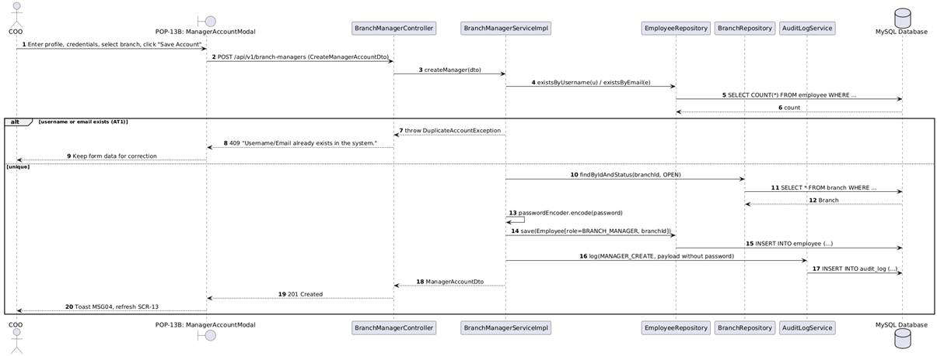

4.7.3.2 SD-02: Update / Reassign Branch Manager (UC06)
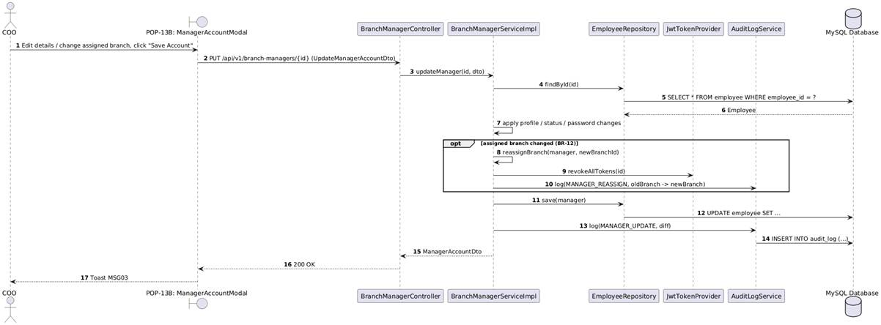

4.8 Manage Employee Profiles
This section presents the detailed design of the Manage Employee Profiles feature on TAB-03 of SCR-09 Employee & Shifts. The Branch Manager views the staff directory of his/her own branch only (BR-04), adds employees, edits profile data (name, phone, position, hourly wage, attendance PIN, RFID card) and deactivates terminated employees. Hard delete is prohibited (BR-13); PINs are 4 digits, unique within the branch and stored hashed; an RFID card can belong to only one active employee (BR-05); a new hourly wage applies only to shifts after the change (BR-14).

4.8.1 Screen Design

4.8.1.1 Profiles & Hourly Wage Tab (SCR-09 / TAB-03)
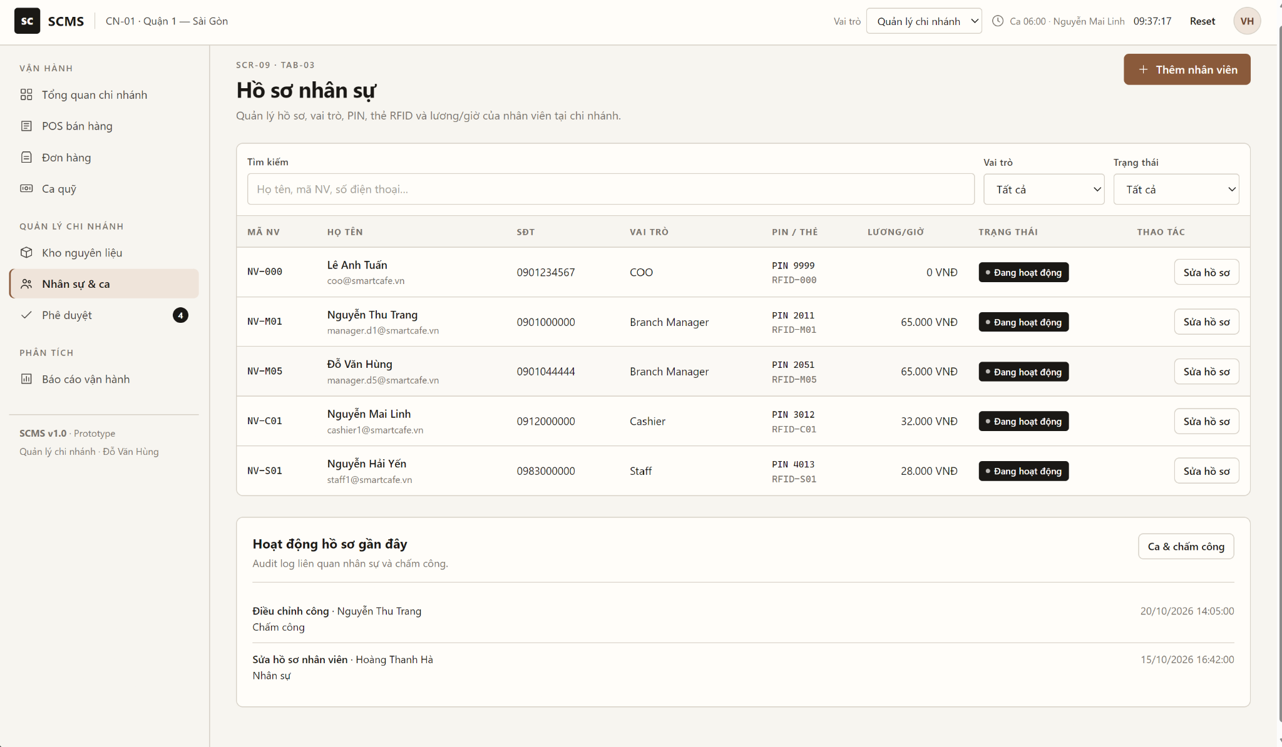
Table 4-9: Profiles & Hourly Wage Tab (SCR-09 / TAB-03) Definition
No | Object/Control Name | Type | Required | Length | Description
1 | btnAddEmployee | Button | No | - | Opens POP-09A in create mode.
2 | tabSwitcher | Tabs | - | - | Switches between TAB-04 (Shifts & Attendance Logs) and TAB-03 (Profiles & Hourly Wage).
3 | txtSearchEmployee | Textbox | No | Max 50 | Live search by employee ID, name or phone.
4 | cboPositionFilter | Dropdown | No | - | Filters by position: All, Cashier, Staff (Barista), Staff (Waiter).
5 | cboStatusFilter | Dropdown | No | - | Filters by employment status: Active / Inactive / All.
6 | tblProfiles | Data Grid | Yes | - | Employee ID, Full Name, Phone, Position, Hourly Wage, PIN / RFID (masked), Status, Action. Data from GET /api/v1/employees (current branch).
7 | btnEditProfile | Button | No | - | Opens POP-09A pre-filled with the selected employee.
8 | btnDeactivate | Button | No | - | Confirmation popup, then PATCH /api/v1/employees/{id}/status (Inactive, BR-13).

4.8.1.2 Add / Edit Employee Profile Popup (POP-09A)
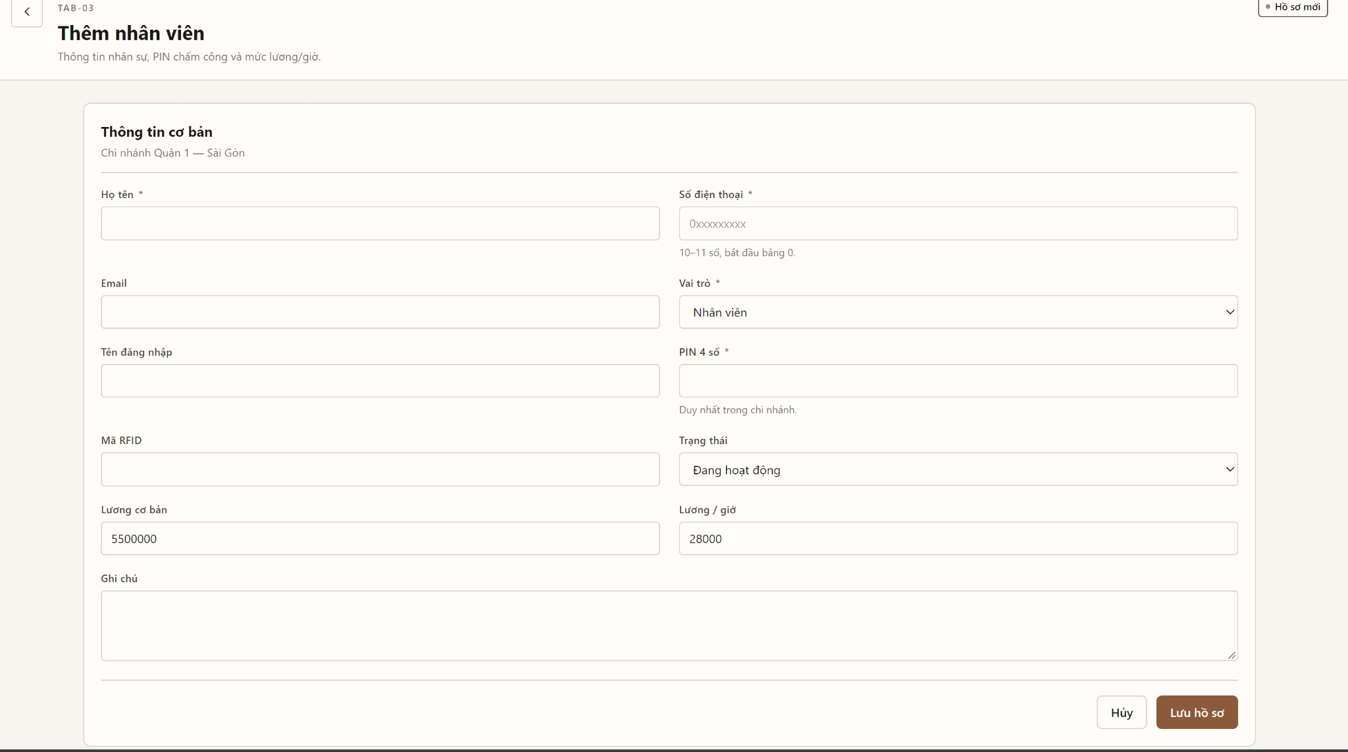
Table 4-10: Add / Edit Employee Profile Popup (POP-09A) Definition
No | Object/Control Name | Type | Required | Length | Description
1 | txtFullName | Textbox | Yes | Max 100 | Employee full name.
2 | txtPhone | Textbox | Yes | 10 - 11 | Digits only, starting with 0.
3 | cboPosition | Dropdown | Yes | - | Cashier / Staff; determines the role bound to the profile.
4 | txtHourlyWage | Number | Yes | 10 | Hourly wage rate (VND, positive integer). Effective for shifts after save (BR-14).
5 | txtPin | Password | Yes | 4 | Attendance PIN, exactly 4 digits, unique within the branch.
6 | txtRfidCode | Textbox | No | Max 15 | RFID card code; unique among active employees (BR-05).
7 | cboStatus | Dropdown | Yes | - | Active / Inactive.
8 | dtStartDate | Date Picker | No | 10 | Start working date (DD/MM/YYYY).
9 | btnSaveEmployee | Button | Yes | - | POST /api/v1/employees or PUT /api/v1/employees/{id}; shows MSG04 / MSG03 or "PIN code already in use by another staff member."
10 | btnCancel | Button | No | - | Closes without saving.

4.8.2 Class/Component Design

4.8.2.1 Classes/Component Structure
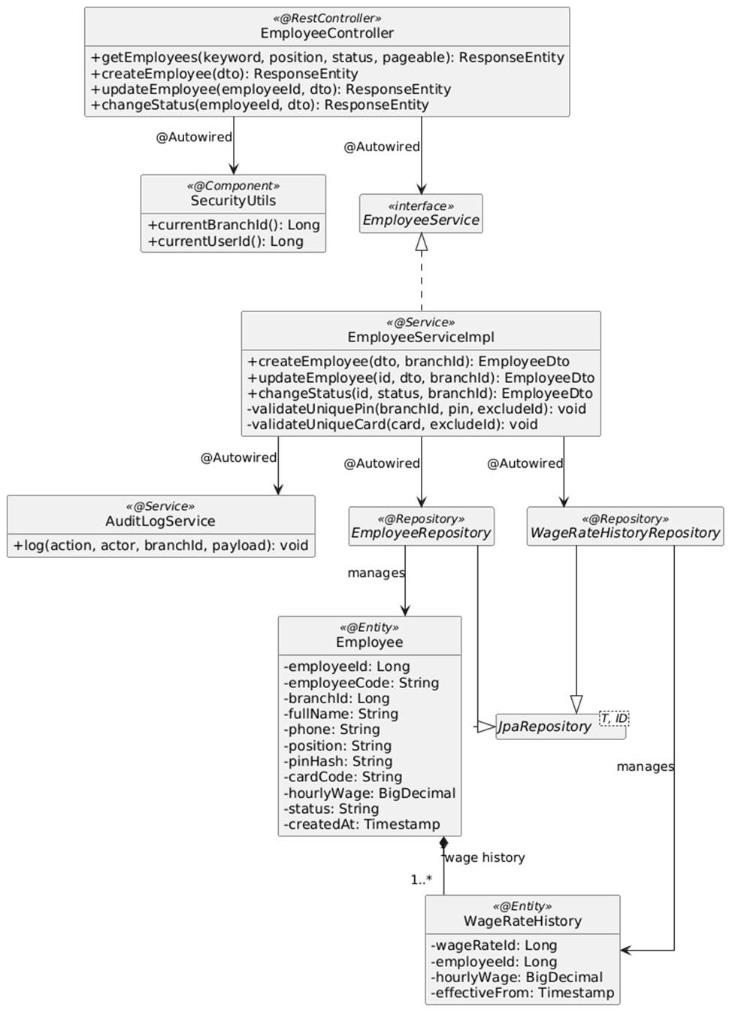

4.8.2.2 Classes/Component Description
4.8.2.2.1 EmployeeController Class
Class | EmployeeController
Description | Spring REST Controller for branch employee profile management. The branch scope is taken from the authenticated principal, never from the request (BR-04).
Base Class | None (@RestController, @RequestMapping("/api/v1/employees"))
Constructor | +EmployeeController(EmployeeService employeeService, SecurityUtils securityUtils)
Prototype | public class EmployeeController
Source File | EmployeeController.java
Namespace | com.scms.controller
Attributes
Name | Type & Description
employeeService | EmployeeService - Service interface injected via @Autowired.
securityUtils | SecurityUtils - Resolves current user and branchId from the JWT.
Methods
Name | Input / Output / Description
getEmployees | Input: @RequestParam String keyword, String position, String status, Pageable pageable  Output: ResponseEntity<Page<EmployeeDto>>  Description: GET endpoint listing employees of the manager's branch.
createEmployee | Input: @RequestBody @Valid CreateEmployeeDto dto  Output: ResponseEntity<EmployeeDto>  Description: POST endpoint adding an employee (UC07 main flow).
updateEmployee | Input: @PathVariable Long employeeId, @RequestBody @Valid UpdateEmployeeDto dto  Output: ResponseEntity<EmployeeDto>  Description: PUT endpoint updating the profile, wage, PIN or RFID.
changeStatus | Input: @PathVariable Long employeeId, @RequestBody ChangeEmployeeStatusDto dto  Output: ResponseEntity<EmployeeDto>  Description: PATCH /{employeeId}/status. Deactivates / reactivates (no hard delete, BR-13).

4.8.2.2.2 EmployeeServiceImpl Class
Class | EmployeeServiceImpl
Description | Service implementation validating and persisting employee profiles inside the branch scope.
Base Class | None (implements EmployeeService)
Constructor | +EmployeeServiceImpl(EmployeeRepository employeeRepo, WageRateHistoryRepository wageHistoryRepo, PasswordEncoder pinEncoder, AuditLogService auditLogService)
Prototype | public class EmployeeServiceImpl implements EmployeeService
Source File | EmployeeServiceImpl.java
Namespace | com.scms.service.impl
Attributes
Name | Type & Description
employeeRepo | EmployeeRepository - Persists employee profiles.
wageHistoryRepo | WageRateHistoryRepository - Stores hourly wage versions with effectiveFrom (BR-14).
pinEncoder | PasswordEncoder - Hashes attendance PINs.
auditLogService | AuditLogService - Logs EMPLOYEE_CREATE / EMPLOYEE_UPDATE / EMPLOYEE_STATUS.
Methods
Name | Input / Output / Description
createEmployee | Input: CreateEmployeeDto dto, Long branchId  Output: EmployeeDto  Description: @Transactional. Calls validateUniquePin() (AT1) and validateUniqueCard(), hashes PIN, generates employee code, saves the profile and the first wage record, logs audit.
updateEmployee | Input: Long employeeId, UpdateEmployeeDto dto, Long branchId  Output: EmployeeDto  Description: Ensures the employee belongs to branchId, re-validates PIN/RFID when changed, inserts a new wage history row if the rate changed, saves and logs diff.
changeStatus | Input: Long employeeId, EmployeeStatus status, Long branchId  Output: EmployeeDto  Description: Switches status to INACTIVE/ACTIVE; clears RFID binding on deactivation.
validateUniquePin | Input: Long branchId, String pin, Long excludeId  Output: void  Description: Matches the raw PIN against the hashes of active employees of the branch; throws DuplicatePinException.

4.8.3 Object Interactions (Sequence Diagrams)

4.8.3.1 SD-01: Add New Employee Profile (UC07)
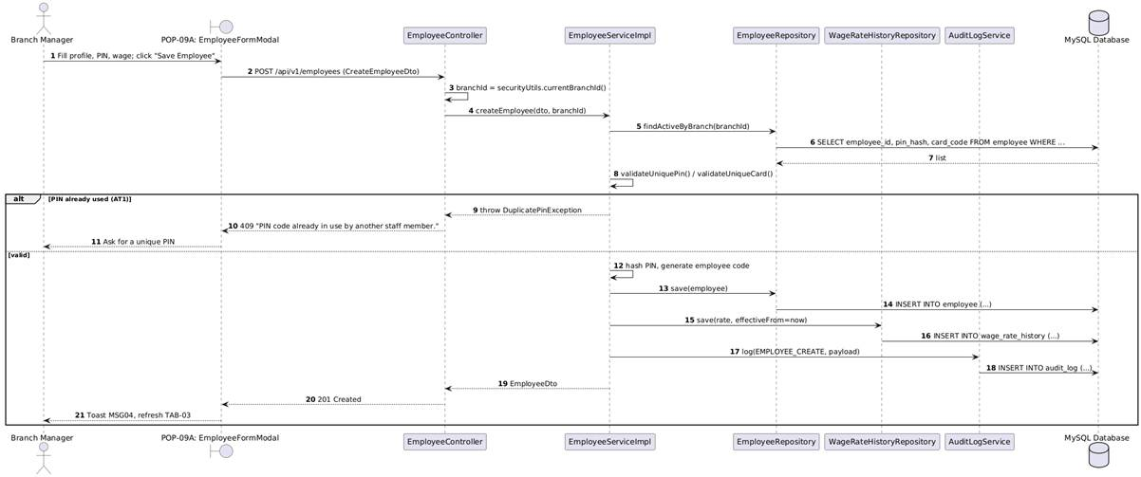

4.8.3.2 SD-02: Update / Deactivate Employee Profile (UC07)
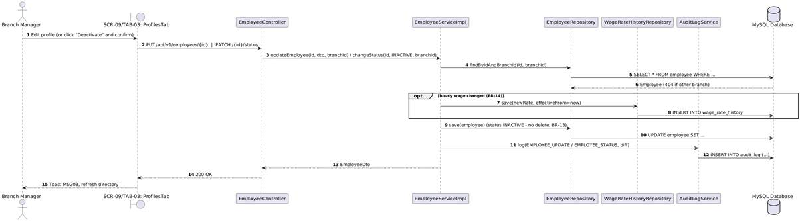

4.9 Manage Work Shifts
This section presents the detailed design of the Manage Work Shifts feature on TAB-04 of SCR-09. The Branch Manager configures shift templates (Morning, Afternoon, Evening or custom time frames), picks a date range and assigns active employees. Before saving, the system checks every assignment for overlapping shifts of the same employee on the same day (BR-15); conflicts are returned to the screen and highlighted (AT1). The saved assignments become the roster used by the Kiosk to validate check-in (UC03).

4.9.1 Screen Design

4.9.1.1 Shifts & Attendance Logs Tab (SCR-09 / TAB-04)
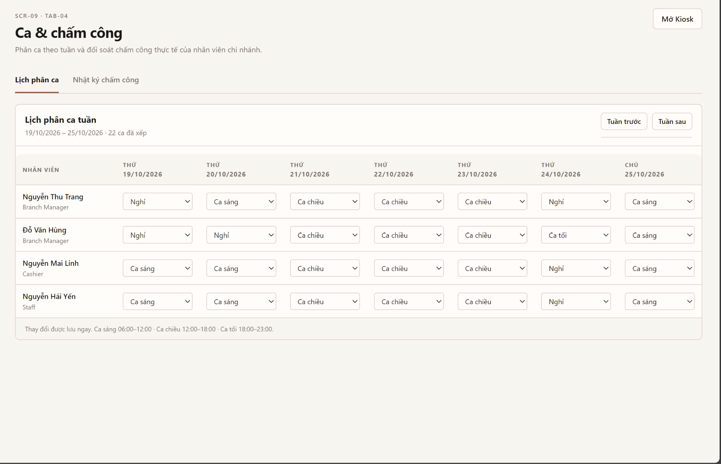
Table 4-11: Shifts & Attendance Logs Tab (SCR-09 / TAB-04) Definition
No | Object/Control Name | Type | Required | Length | Description
1 | btnAddShift | Button | No | - | Opens POP-09B to create a shift schedule.
2 | tabSwitcher | Tabs | - | - | Switches between TAB-04 and TAB-03.
3 | tblWeeklySchedule | Data Grid | Yes | - | Roster matrix (employee x Monday..Sunday) from GET /api/v1/work-schedules?weekStart=. Clicking a cell opens POP-09B for that day.
4 | cboWeekPicker | Date Picker | No | - | Selects the week to display (previous / next week).
5 | tblKioskLogs | Data Grid | - | - | Today's check-in/check-out logs from SCR-02 (read-only).
6 | btnAdjustAttendance | Button | No | - | Opens the attendance adjustment dialog (BR-10).

4.9.1.2 Create / Edit Work Shift Schedule Popup (POP-09B)
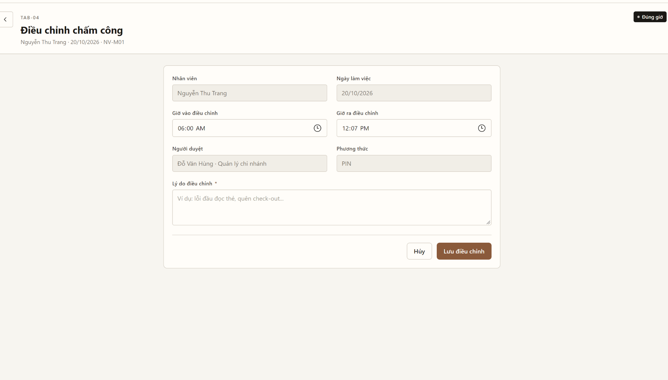
Table 4-12: Create / Edit Work Shift Schedule Popup (POP-09B) Definition
No | Object/Control Name | Type | Required | Length | Description
1 | cboShiftTemplate | Dropdown | Yes | - | Morning / Afternoon / Evening / Custom; pre-fills start and end time.
2 | tpStartTime / tpEndTime | Time Picker | Yes | 5 | Shift time frame within branch opening hours; end > start (overnight not allowed).
3 | dtApplyFrom / dtApplyTo | Date Picker | Yes | 10 | Date range of the schedule (from <= to, not in the past).
4 | chkRepeatDays | Checkbox Group | No | - | Weekdays on which the shift is generated.
5 | tblAssignEmployees | Data Grid | Yes | - | Active employees of the branch with a Select checkbox and an availability column filled by POST /api/v1/work-schedules/check-conflicts.
6 | pnlConflictWarning | Alert Box | - | - | Lists conflicting employees and shift times (AT1, BR-15).
7 | btnSaveSchedule | Button | Yes | - | POST /api/v1/work-schedules; on success shows MSG04 and refreshes the roster.
8 | btnCancel | Button | No | - | Closes without saving.

4.9.2 Class/Component Design

4.9.2.1 Classes/Component Structure
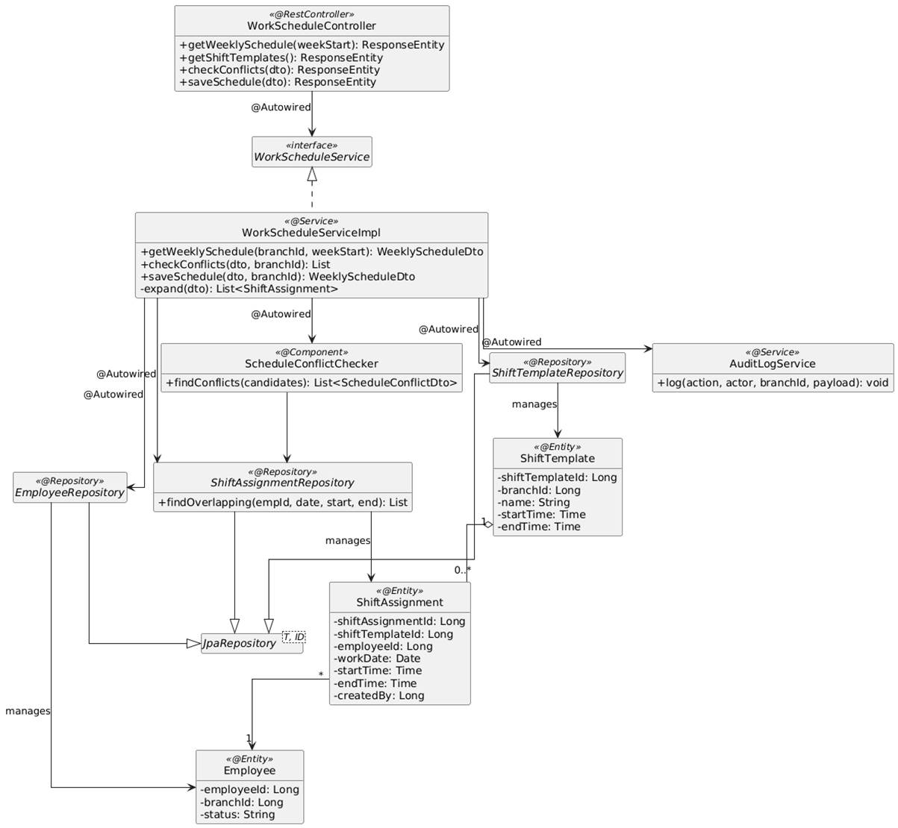

4.9.2.2 Classes/Component Description
4.9.2.2.1 WorkScheduleController Class
Class | WorkScheduleController
Description | Spring REST Controller for shift templates and employee shift assignments of a branch.
Base Class | None (@RestController, @RequestMapping("/api/v1/work-schedules"))
Constructor | +WorkScheduleController(WorkScheduleService scheduleService, SecurityUtils securityUtils)
Prototype | public class WorkScheduleController
Source File | WorkScheduleController.java
Namespace | com.scms.controller
Attributes
Name | Type & Description
scheduleService | WorkScheduleService - Service interface injected via @Autowired.
securityUtils | SecurityUtils - Resolves branchId of the current manager.
Methods
Name | Input / Output / Description
getWeeklySchedule | Input: @RequestParam LocalDate weekStart  Output: ResponseEntity<WeeklyScheduleDto>  Description: GET endpoint returning the roster of the manager's branch for a week.
getShiftTemplates | Input: None  Output: ResponseEntity<List<ShiftTemplateDto>>  Description: GET /templates. Shift templates of the branch.
checkConflicts | Input: @RequestBody @Valid SaveScheduleDto dto  Output: ResponseEntity<List<ScheduleConflictDto>>  Description: POST /check-conflicts. Dry-run conflict detection used to fill the availability column.
saveSchedule | Input: @RequestBody @Valid SaveScheduleDto dto  Output: ResponseEntity<WeeklyScheduleDto>  Description: POST endpoint saving shift assignments (UC08 main flow).

4.9.2.2.2 WorkScheduleServiceImpl Class
Class | WorkScheduleServiceImpl
Description | Service implementation expanding a schedule request into daily assignments, detecting conflicts and persisting the roster.
Base Class | None (implements WorkScheduleService)
Constructor | +WorkScheduleServiceImpl(ShiftTemplateRepository templateRepo, ShiftAssignmentRepository assignmentRepo, EmployeeRepository employeeRepo, ScheduleConflictChecker conflictChecker, AuditLogService auditLogService)
Prototype | public class WorkScheduleServiceImpl implements WorkScheduleService
Source File | WorkScheduleServiceImpl.java
Namespace | com.scms.service.impl
Attributes
Name | Type & Description
templateRepo | ShiftTemplateRepository - Reads shift templates.
assignmentRepo | ShiftAssignmentRepository - Persists and queries shift assignments.
employeeRepo | EmployeeRepository - Validates that employees are active and belong to the branch.
conflictChecker | ScheduleConflictChecker - Detects overlapping assignments (BR-15).
auditLogService | AuditLogService - Logs SCHEDULE_SAVE.
Methods
Name | Input / Output / Description
saveSchedule | Input: SaveScheduleDto dto, Long branchId  Output: WeeklyScheduleDto  Description: @Transactional. Validates time frame and date range, expands days x employees into ShiftAssignment candidates, calls conflictChecker.findConflicts(); throws ScheduleConflictException with the conflict list (AT1) or saveAll() and logs audit.
checkConflicts | Input: SaveScheduleDto dto, Long branchId  Output: List<ScheduleConflictDto>  Description: Same expansion without persisting; returns conflicts for display.
getWeeklySchedule | Input: Long branchId, LocalDate weekStart  Output: WeeklyScheduleDto  Description: Builds the employee x day matrix for the week.

4.9.2.2.3 ScheduleConflictChecker Class
Class | ScheduleConflictChecker
Description | Component that checks overlapping work shifts.
Base Class | None (@Component)
Constructor | +ScheduleConflictChecker(ShiftAssignmentRepository assignmentRepo)
Prototype | public class ScheduleConflictChecker
Source File | ScheduleConflictChecker.java
Namespace | com.scms.service.support
Attributes
Name | Type & Description
assignmentRepo | ShiftAssignmentRepository - Queries existing assignments.
Methods
Name | Input / Output / Description
findConflicts | Input: List<ShiftAssignment> candidates  Output: List<ScheduleConflictDto>  Description: For each candidate queries existing assignments of the same employee on the same date where start < candidate.end AND end > candidate.start; also detects duplicates inside the request.

4.9.3 Object Interactions (Sequence Diagrams)

4.9.3.1 SD-01: View Weekly Shift Schedule (UC08)
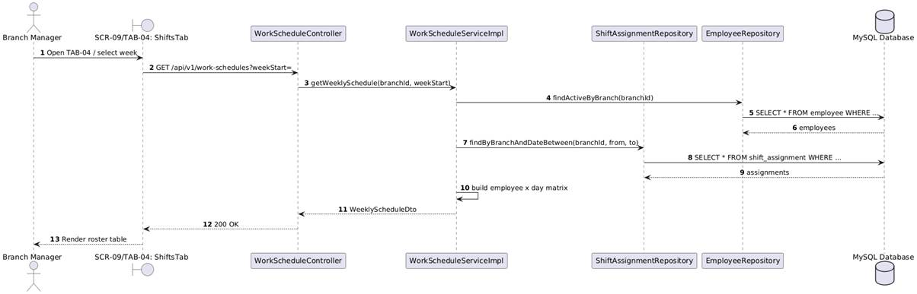

4.9.3.2 SD-02: Create Shift Schedule & Assign Employees (UC08)
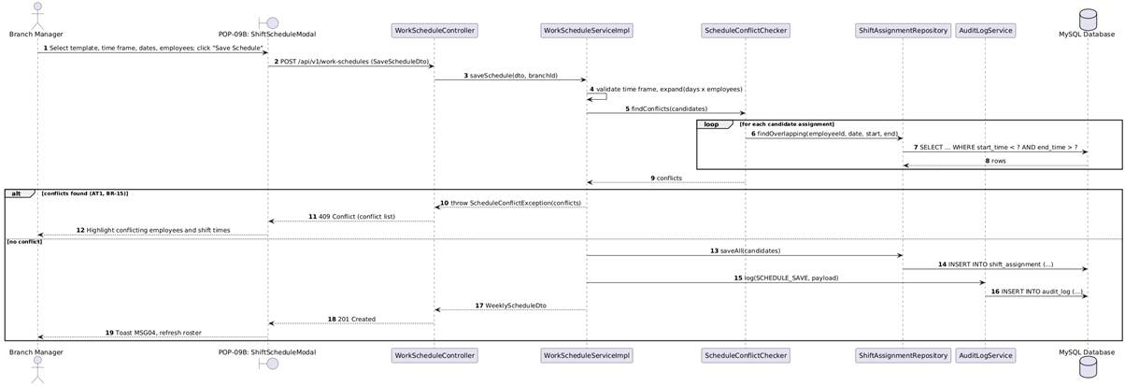

4.10 Manage Menu Categories
This section presents the detailed design of the Manage Menu Categories feature on SCR-11 Master Menu & Recipe. The COO centrally manages the master menu structure (BR-16): creates categories, edits name, description, display sequence and status, assigns and reorders products inside a category, and deactivates categories. A category that still contains active products cannot be deleted or deactivated (AT1). Changes are stored in the master database and reach branches only after being published via the Chain Sync Center (UC14, BR-23).

4.10.1 Screen Design

4.10.1.1 Menu Categories Screen (SCR-11)
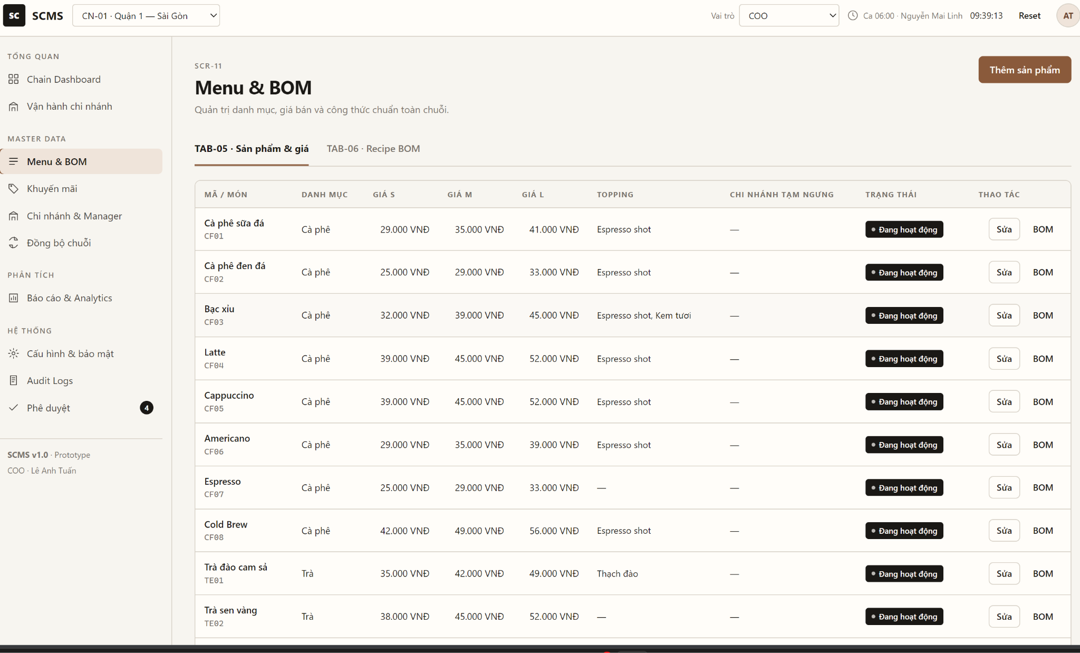
Table 4-13: Menu Categories Screen (SCR-11) Definition
No | Object/Control Name | Type | Required | Length | Description
1 | btnCreateCategory | Button | No | - | Opens POP-11A in create mode.
2 | tabSwitcher | Tabs | - | - | Menu Categories / TAB-05 Products & Pricing by Size / TAB-06 Standard Recipe BOM.
3 | txtSearchCategory | Textbox | No | Max 50 | Live search by category code or name.
4 | cboStatusFilter | Dropdown | No | - | All / Active / Inactive.
5 | tblCategories | Data Grid | Yes | - | Display Sequence, Code, Name, Description, number of products, Status, Action; drag-and-drop reorder calls PUT /api/v1/menu-categories/sequence.
6 | btnEditCategory | Button | No | - | Opens POP-11A pre-filled with the category and its products.
7 | btnDeactivateCategory | Button | No | - | Confirmation popup then PATCH /api/v1/menu-categories/{id}/status.

4.10.1.2 Create / Edit Menu Category Popup (POP-11A)
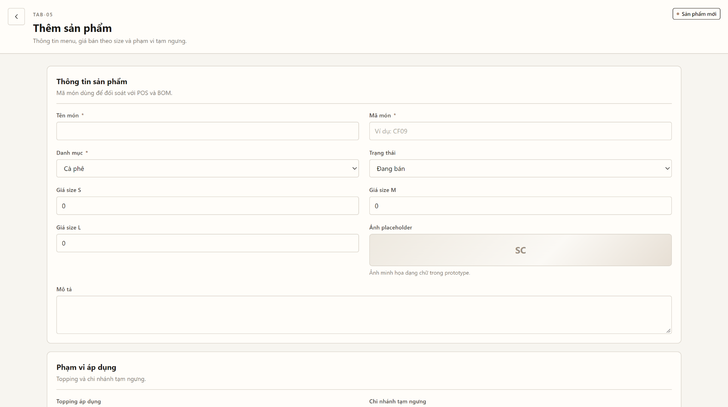
Table 4-14: Create / Edit Menu Category Popup (POP-11A) Definition
No | Object/Control Name | Type | Required | Length | Description
1 | txtCategoryCode | Textbox | No | 10 | Auto-generated code (CATnn), read-only.
2 | txtCategoryName | Textbox | Yes | Max 100 | Unique category name.
3 | txtDisplaySequence | Number | Yes | 3 | Positive integer ordering of the category on POS.
4 | cboActiveStatus | Dropdown | Yes | - | Active / Inactive.
5 | txtDescription | Textarea | No | Max 255 | Category description.
6 | tblAssignedProducts | Data Grid | No | - | Products in the category with drag handle for order; uncheck to remove.
7 | cboAddProduct / btnAddProduct | Dropdown / Button | No | - | Searches products (GET /api/v1/products?keyword=) and adds them to the category.
8 | btnSaveCategory | Button | Yes | - | POST /api/v1/menu-categories or PUT /api/v1/menu-categories/{id}; shows MSG04 / MSG03.
9 | btnCancel | Button | No | - | Closes without saving.

4.10.2 Class/Component Design

4.10.2.1 Classes/Component Structure
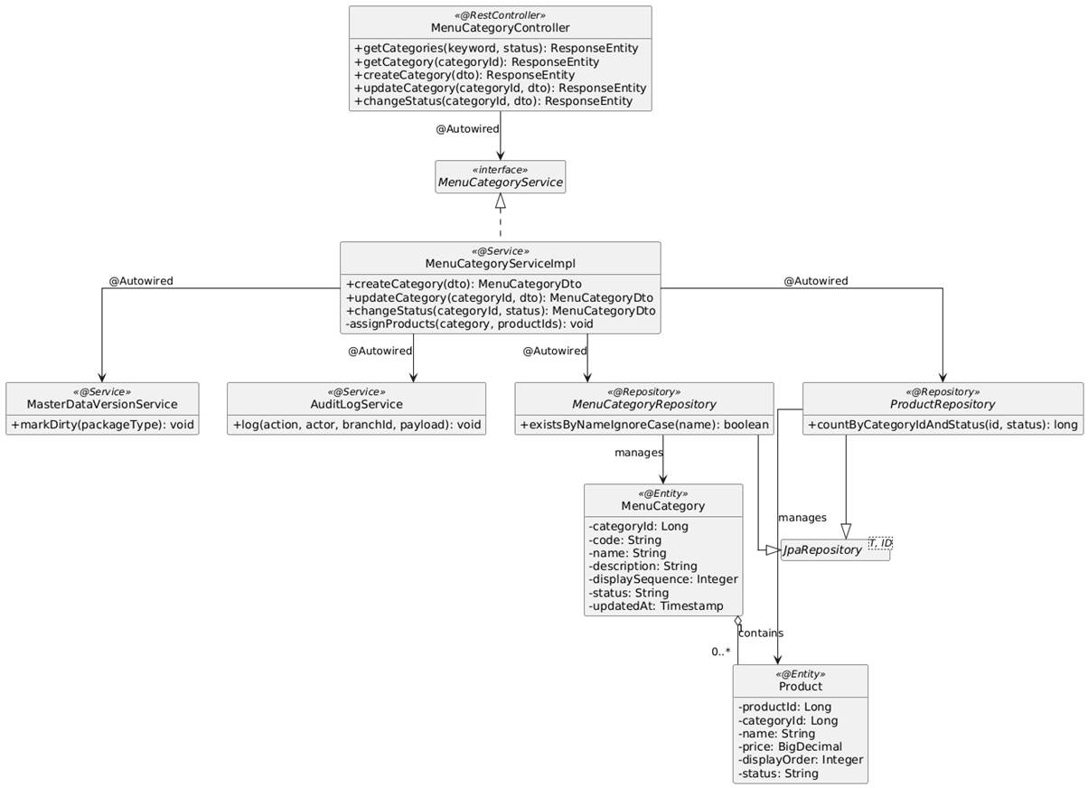

4.10.2.2 Classes/Component Description
4.10.2.2.1 MenuCategoryController Class
Class | MenuCategoryController
Description | Spring REST Controller for master menu category management (COO only, BR-16).
Base Class | None (@RestController, @RequestMapping("/api/v1/menu-categories"))
Constructor | +MenuCategoryController(MenuCategoryService categoryService)
Prototype | public class MenuCategoryController
Source File | MenuCategoryController.java
Namespace | com.scms.controller
Attributes
Name | Type & Description
categoryService | MenuCategoryService - Service interface injected via @Autowired.
Methods
Name | Input / Output / Description
getCategories | Input: @RequestParam String keyword, String status  Output: ResponseEntity<List<MenuCategoryDto>>  Description: GET endpoint listing categories ordered by display sequence with product count.
getCategory | Input: @PathVariable Long categoryId  Output: ResponseEntity<MenuCategoryDetailDto>  Description: GET /{categoryId}. Category with its ordered products.
createCategory | Input: @RequestBody @Valid SaveMenuCategoryDto dto  Output: ResponseEntity<MenuCategoryDto>  Description: POST endpoint creating a category and product mapping (UC09 main flow).
updateCategory | Input: @PathVariable Long categoryId, @RequestBody @Valid SaveMenuCategoryDto dto  Output: ResponseEntity<MenuCategoryDto>  Description: PUT endpoint updating details and product assignment/order.
changeStatus | Input: @PathVariable Long categoryId, @RequestBody ChangeStatusDto dto  Output: ResponseEntity<MenuCategoryDto>  Description: PATCH /{categoryId}/status. Activates / deactivates (AT1 check).

4.10.2.2.2 MenuCategoryServiceImpl Class
Class | MenuCategoryServiceImpl
Description | Service implementation validating the menu structure and persisting categories and category-product mappings.
Base Class | None (implements MenuCategoryService)
Constructor | +MenuCategoryServiceImpl(MenuCategoryRepository categoryRepo, ProductRepository productRepo, AuditLogService auditLogService, MasterDataVersionService syncVersionService)
Prototype | public class MenuCategoryServiceImpl implements MenuCategoryService
Source File | MenuCategoryServiceImpl.java
Namespace | com.scms.service.impl
Attributes
Name | Type & Description
categoryRepo | MenuCategoryRepository - Persists categories.
productRepo | ProductRepository - Loads products and updates their category / display order.
auditLogService | AuditLogService - Logs MENU_CATEGORY_CREATE / UPDATE / STATUS.
syncVersionService | MasterDataVersionService - Marks master menu data as changed (pending publish in UC14).
Methods
Name | Input / Output / Description
createCategory | Input: SaveMenuCategoryDto dto  Output: MenuCategoryDto  Description: @Transactional. Validates unique name and positive sequence, generates code, saves the category, assigns products in the given order, marks master data dirty, logs audit.
updateCategory | Input: Long categoryId, SaveMenuCategoryDto dto  Output: MenuCategoryDto  Description: Updates details, re-assigns products (removed products move to 'Uncategorized'), reorders, logs diff.
changeStatus | Input: Long categoryId, String status  Output: MenuCategoryDto  Description: Before deactivation counts active products (countByCategoryIdAndStatus); if > 0 throws CategoryNotEmptyException (AT1), else updates status.

4.10.3 Object Interactions (Sequence Diagrams)

4.10.3.1 SD-01: Create / Update Menu Category (UC09)
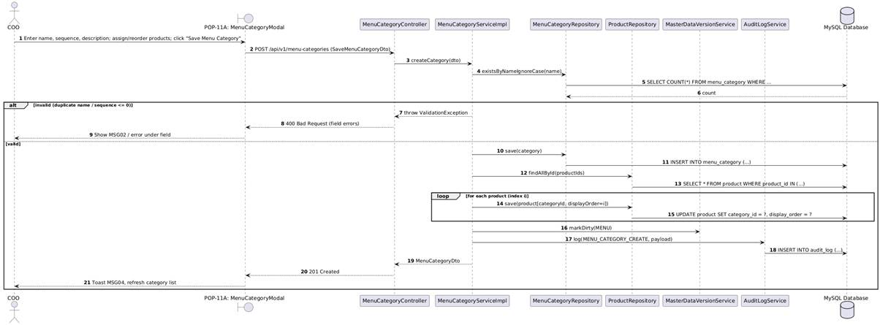

4.10.3.2 SD-02: Deactivate Menu Category (UC09)
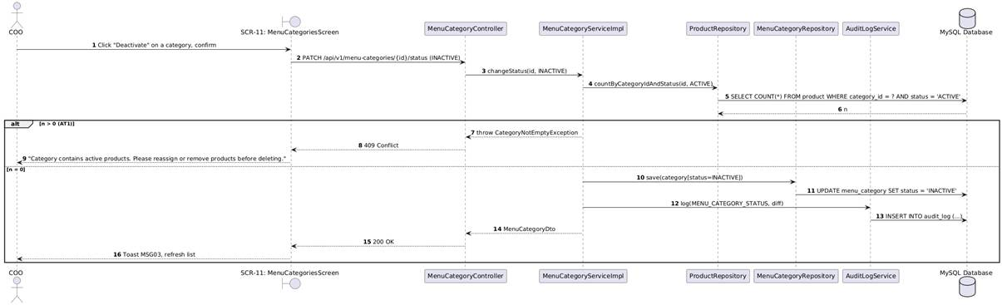

4.11 Raw Material Inventory Management Subsystem

4.11.1 Screen Design

4.11.1.1 Branch Inventory Management Screen
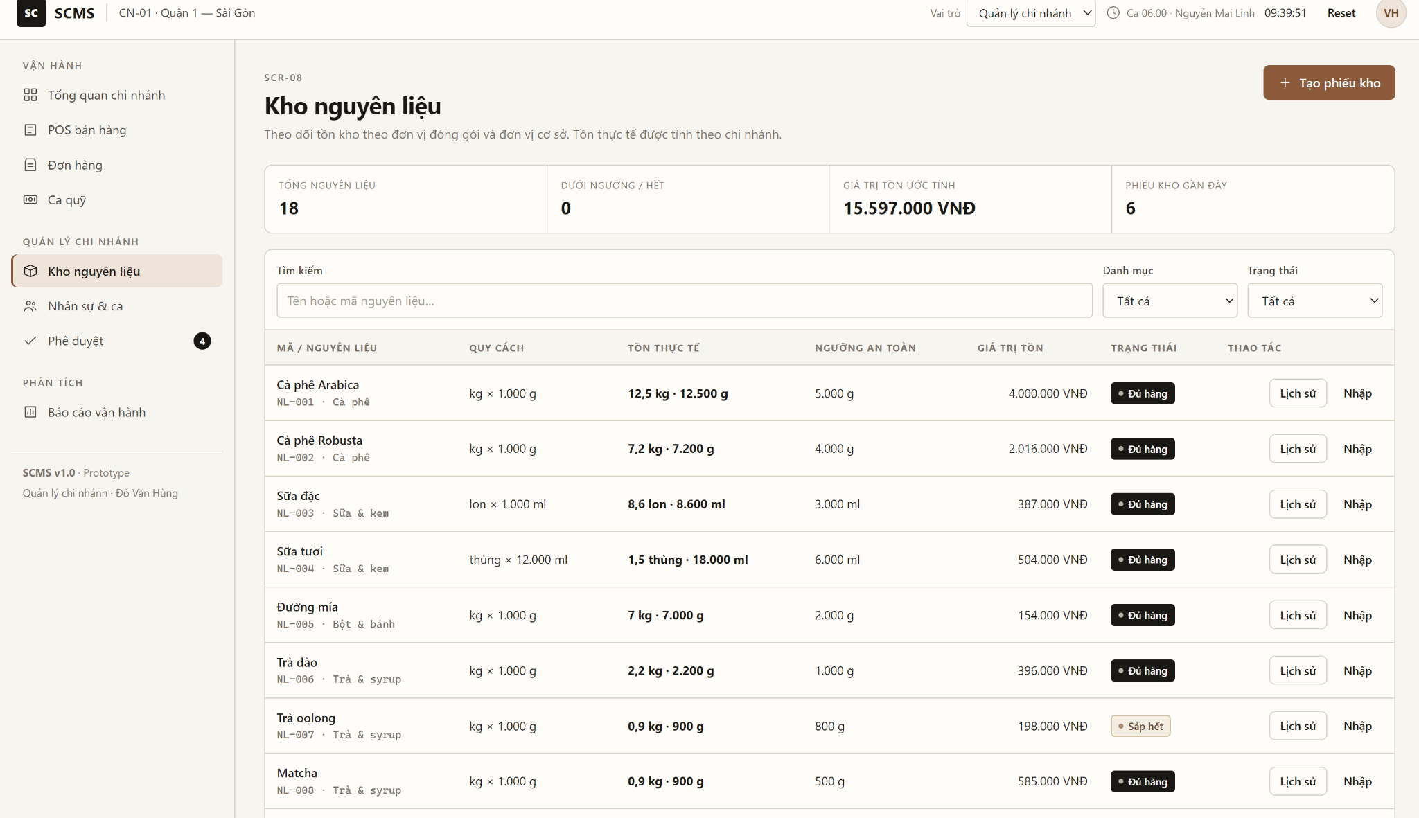

No | Object/Control Name | Type | Required | Length | Description
1 | pnlLowStockAlert | Alert Box | Dynamic | - | Prominent visual container automatically rendered when current on-hand stock is at or below minimum safety stock threshold (BR-40, UC33).
2 | btnQuickRestock | Button | No | - | Quick action button navigating directly to POP-04A with nearly depleted items pre-selected for supplier restocking.
3 | txtSearchMaterial | Textbox | No | Max 50 | Real-time search input filtering inventory records by ingredient code or material name.
4 | cboCategoryFilter | Dropdown | No | - | Filters catalog items by category: All Categories, Coffee Beans, Dairy & Milk, Syrups & Flavoring, Packaging.
5 | cboStockStatusFilter | Dropdown | No | - | Filters materials by condition: All Conditions, Low Stock (Below Minimum), Sufficient Stock.
6 | tblInventoryList | Data Grid | Yes | - | Master inventory ledger displaying code, name, packaging specification, base unit, minimum safety stock, on-hand balance, holding value, and status badges (BR-40).
7 | btnOpenStockSlip | Button | No | - | Primary header button opening the multi-purpose stock voucher creation menu (Receive, Issue, Dispose, Stocktake).
8 | btnExportStockCard | Button | No | - | Exports store inventory ledger and lot transaction history to a formatted Excel spreadsheet.
9 | tblRecentStockSlips | Data Grid | Yes | - | Audit table listing the 4 most recent stock vouchers (Slip Code, Type, Timestamp, Authorizer, Destination, Amount, Status) for operational tracking.
10 | btnNavBranchDash | Button | No | - | Sidebar shortcut returning to the primary Branch Dashboard screen (SCR-07).

4.2.1.2 Receive Stock Delivery Slip
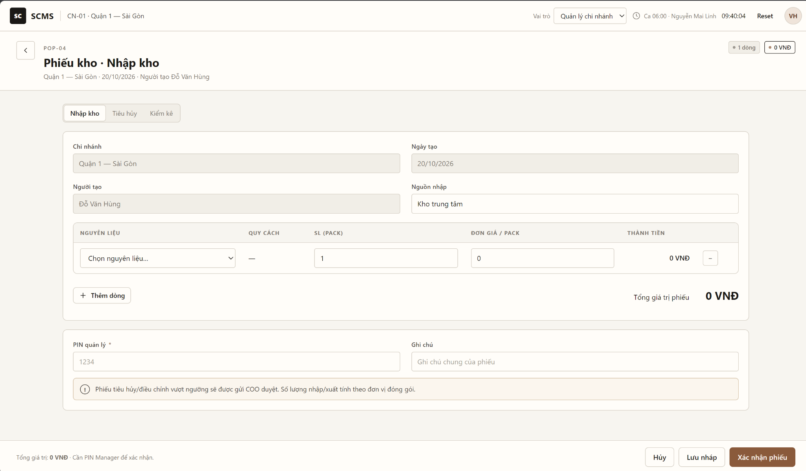

No | Object/Control Name | Type | Required | Length | Description
1 | cboReceiveSource | Dropdown | Yes | - | Selects inbound origin: Supplier Delivery, Internal Commissary Transfer, Post-Stocktake Surplus Adjustment.
2 | cboSupplier | Dropdown | Yes | - | Selects certified vendor: Cau Dat Coffee Co., Dalat Milk JSC, Monin Vietnam Syrups Co., Vinamilk.
3 | txtSlipNumber | Textbox | Yes | 20 | Auto-generated inbound transaction code (e.g., PNK-20261018-001), read-only.
4 | txtInvoiceRef | Textbox | No | Max 30 | Vendor delivery note / purchase order invoice reference number.
5 | txtReceiverName | Textbox | Yes | Max 50 | Logged-in Branch Manager inspecting and accepting delivery custody, read-only.
6 | txtReceiptDate | Textbox | Yes | 19 | Receipt timestamp, defaulted to current system datetime.
7 | tblImportItems | Data Grid | Yes | - | Inbound item grid: No, Item Code, Raw Material Name, Packaging Specification, Inbound Qty, Unit Cost, Subtotal, Expiry Date, Delete Action.
8 | btnAddItemRow | Button | No | - | Appends an empty row allowing addition of another material line.
9 | lblTotalSlipValue | Label | Yes | - | Computed sum of all line item costs including 10% VAT payable to vendor.
10 | btnConfirmReceive | Button | Yes | - | Validates bulk packaging units, creates stock transaction, increments branch inventory (BR-40), and records audit log (BR-51).
11 | btnCancel | Button | No | - | Closes modal and aborts receipt without altering inventory records.

4.2.1.3 Issue Stock to Bar Counter Slip
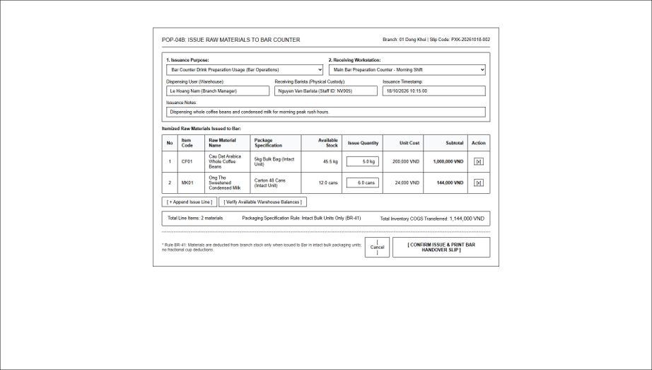

No | Object/Control Name | Type | Required | Length | Description
1 | cboIssuePurpose | Dropdown | Yes | - | Operational purpose: Barista Counter Drink Preparation, Sister Branch Transfer, Staff Training / R&D.
2 | cboReceivingBar | Dropdown | Yes | - | Destination station: Main Bar Preparation Counter - Morning Shift, Main Bar - Afternoon Shift, POS Front Counter.
3 | txtSlipNumber | Textbox | Yes | 20 | Auto-generated issue slip code (e.g., PXK-20261018-002), read-only.
4 | txtBaristaSign | Textbox | Yes | Max 50 | Barista on shift accepting physical custody of raw materials.
5 | txtIssuerName | Textbox | Yes | Max 50 | Branch Manager dispensing materials from warehouse, read-only.
6 | tblIssueItems | Data Grid | Yes | - | Line items: No, Item Code, Name, Intact Package Spec, Available Stock, Issue Quantity, Unit Cost, Subtotal, Delete Action.
7 | btnAddIssueItem | Button | No | - | Appends an empty row to requisition line items.
8 | btnConfirmIssue | Button | Yes | - | Validates issueQty <= onHand (BR-42) and intact packaging unit compliance (BR-41), deducts warehouse stock, and prints bar transfer voucher.
9 | btnCancel | Button | No | - | Closes modal without dispensing materials.

4.2.1.4 Raw Material Disposal & Write-Off Slip
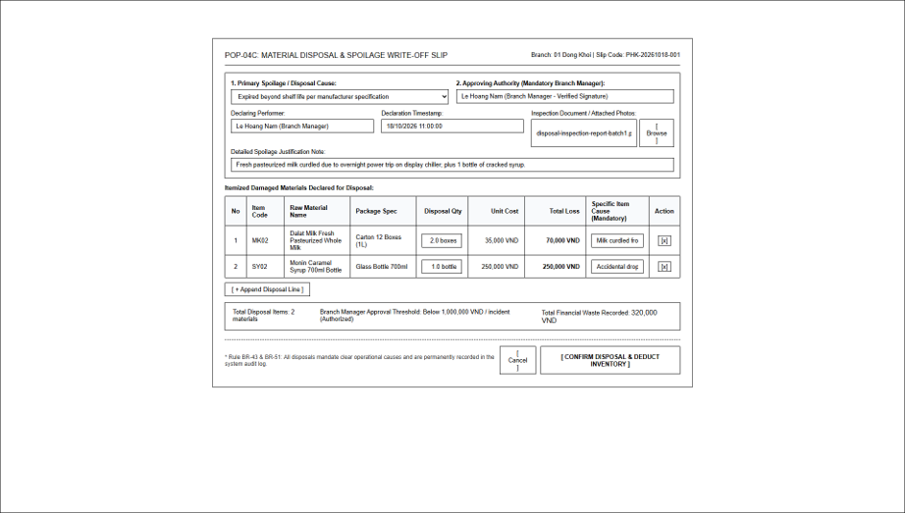

No | Object/Control Name | Type | Required | Length | Description
1 | cboDisposalReason | Dropdown | Yes | - | Predefined disposal classification: Expired beyond shelf life, Packaging leakage / transit damage, Refrigerator cooling failure, Ingredient degradation (BR-43).
2 | txtSlipNumber | Textbox | Yes | 20 | Auto-generated disposal code (e.g., PHK-20261018-001), read-only.
3 | txtManagerApproval | Textbox | Yes | Max 50 | Authorizing Branch Manager verified signature, read-only.
4 | txtCreatedDate | Textbox | Yes | 19 | Timestamp of disposal verification.
5 | fileDamageReport | File Upload | No | - | Upload control for physical inspection report or damaged stock photo evidence.
6 | tblDisposalItems | Data Grid | Yes | - | Details: No, Item Code, Material Name, Package Spec, Disposal Qty, Cost Price, Total Financial Loss, Mandatory Item Cause (BR-43), Action.
7 | lblTotalLoss | Label | Yes | - | Cumulative financial waste value recorded to store loss ledger.
8 | btnConfirmDisposal | Button | Yes | - | Enforces disposal reason (BR-43), validates Branch Manager approval limit (BR-51), deducts store stock, and logs audit record.
9 | btnCancel | Button | No | - | Closes modal without executing write-off.

4.2.1.5 Store Inventory Audit & Reconciliation Slip
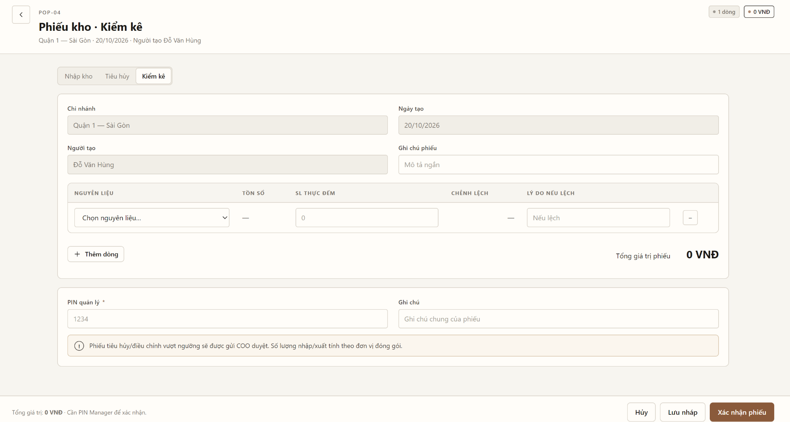

No | Object/Control Name | Type | Required | Length | Description
1 | cboStocktakeRound | Dropdown | Yes | - | Audit session type: Periodic End-of-Day Store Closing Audit, Spot Audit by Management, Shift Handover Audit.
2 | txtSlipNumber | Textbox | Yes | 20 | Auto-generated audit session code (e.g., PKK-20261017-001), read-only.
3 | txtInspectorName | Textbox | Yes | Max 50 | Auditing personnel (Branch Manager and Barista witness), read-only.
4 | txtStocktakeTime | Textbox | Yes | 19 | Timestamp of count finalization.
5 | tblStocktakeItems | Data Grid | Yes | - | Reconciliation grid: No, Item Code, Name, Package Spec, Book Stock, Counted Qty, Variance Qty (BR-44), Variance Value, Mandatory Justification Reason.
6 | lblDiscrepancySummary | Label | Yes | - | Net shrinkage and discrepancy summary in VND.
7 | btnConfirmStocktake | Button | Yes | - | Reconciles actual count, automatically realigns book balance to physical count (BR-44), closes audit session, and captures audit log (BR-51).
8 | btnCancel | Button | No | - | Exits stocktake mode without altering inventory records.

4.11.2 Class/Component Design

4.11.2.1 Classes/Component Structure

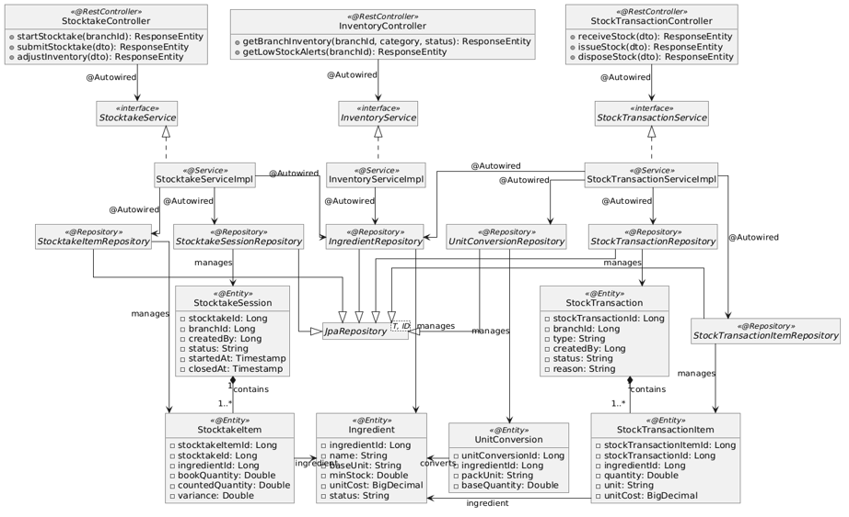

4.11.2.2 Class/Communication Description
InventoryController Class
Class | InventoryController
Description | Spring REST Controller exposing HTTP endpoints for store inventory inquiries, filtering, and safety stock threshold monitoring.
Base Class | None (@RestController, @RequestMapping("/api/v1/inventory"))
Constructor | +InventoryController(InventoryService inventoryService)
Prototype | public class InventoryController
Source File | InventoryController.java
Namespace | com.scms.controller
Attributes
Name | Type & Description
inventoryService | InventoryService - Service interface injected via @Autowired managing inventory queries and alerts.
Methods
Name | Input / Output / Description
getBranchInventory | Input: Long branchId, String category, String status  Output: ResponseEntity<List<IngredientStockDto>>  Description: GET endpoint retrieving active ingredients and on-hand balances for branch.
getLowStockAlerts | Input: Long branchId  Output: ResponseEntity<List<LowStockAlertDto>>  Description: GET endpoint returning ingredients where onHand <= minStock (BR-40, UC33).

StockTransactionController Class
Class | StockTransactionController
Description | Spring REST Controller handling multi-type warehouse transactions: Receiving from suppliers (UC28), Issuing to bar counter (UC29), and Disposing of damaged stock (UC30).
Base Class | None (@RestController, @RequestMapping("/api/v1/stock-transactions"))
Constructor | +StockTransactionController(StockTransactionService stockTxService)
Prototype | public class StockTransactionController
Source File | StockTransactionController.java
Namespace | com.scms.controller
Attributes
Name | Type & Description
stockTxService | StockTransactionService - Service interface orchestrating inbound, outbound, and disposal voucher operations.
Methods
Name | Input / Output / Description
receiveStock | Input: @RequestBody @Valid CreateReceiveSlipDto dto  Output: ResponseEntity<StockTxResponseDto>  Description: POST endpoint creating goods receipt and incrementing inventory by bulk package units (BR-40, UC28).
issueStock | Input: @RequestBody @Valid CreateIssueSlipDto dto  Output: ResponseEntity<StockTxResponseDto>  Description: POST endpoint creating bar issue voucher and deducting store inventory in intact units (BR-41, BR-42, UC29).
disposeStock | Input: @RequestBody @Valid CreateDisposalSlipDto dto  Output: ResponseEntity<StockTxResponseDto>  Description: POST endpoint writing off spoiled/expired stock with mandatory explanation (BR-43, BR-51, UC30).

StocktakeController Class
Class | StocktakeController
Description | Spring REST Controller managing store stocktaking sessions, discrepancy computation, and physical count balance realignment.
Base Class | None (@RestController, @RequestMapping("/api/v1/stocktake"))
Constructor | +StocktakeController(StocktakeService stocktakeService)
Prototype | public class StocktakeController
Source File | StocktakeController.java
Namespace | com.scms.controller
Attributes
Name | Type & Description
stocktakeService | StocktakeService - Service interface executing periodic inventory audits and ledger adjustments.
Methods
Name | Input / Output / Description
createStocktakeSession | Input: Long branchId  Output: ResponseEntity<StocktakeSessionDto>  Description: POST endpoint opening a new audit session and snapshotting book balances (UC31).
adjustInventory | Input: @RequestBody @Valid CreateStocktakeAdjustmentDto dto  Output: ResponseEntity<StocktakeResponseDto>  Description: POST endpoint calculating variance (counted - book), realigning on-hand stock, and logging audit trail (BR-44, BR-51, UC32).

StockTransactionServiceImpl Class
Class | StockTransactionServiceImpl
Description | Service implementation orchestrating inventory transaction validation, unit conversion calculations, and ledger persistence.
Base Class | None (implements StockTransactionService)
Constructor | +StockTransactionServiceImpl(StockTransactionRepository txRepo, StockTransactionItemRepository itemRepo, IngredientRepository ingRepo, UnitConversionRepository convRepo)
Prototype | public class StockTransactionServiceImpl implements StockTransactionService
Source File | StockTransactionServiceImpl.java
Namespace | com.scms.service.impl
Attributes
Name | Type & Description
txRepo | StockTransactionRepository - Repository persisting transaction master records.
itemRepo | StockTransactionItemRepository - Repository persisting transaction line items.
ingRepo | IngredientRepository - Repository updating ingredient on-hand quantities.
convRepo | UnitConversionRepository - Repository querying packaging-to-base unit conversion ratios.
Methods
Name | Input / Output / Description
receiveStock | Input: CreateReceiveSlipDto dto  Output: StockTransaction  Description: Validates bulk packaging unit, converts to base quantity, increments on-hand stock, logs audit entry.
issueStockToBar | Input: CreateIssueSlipDto dto  Output: StockTransaction  Description: Checks onHand >= requested, enforces intact packaging units, deducts stock, persists issue slip.
disposeStock | Input: CreateDisposalSlipDto dto  Output: StockTransaction  Description: Enforces mandatory reason, validates Branch Manager approval limit, deducts stock balance.

4.11.2.3 Object Interactions (Sequence Diagrams)

4.11.2.3.1: (SD-01) View Branch Inventory & Safety Stock Alert (UC33)

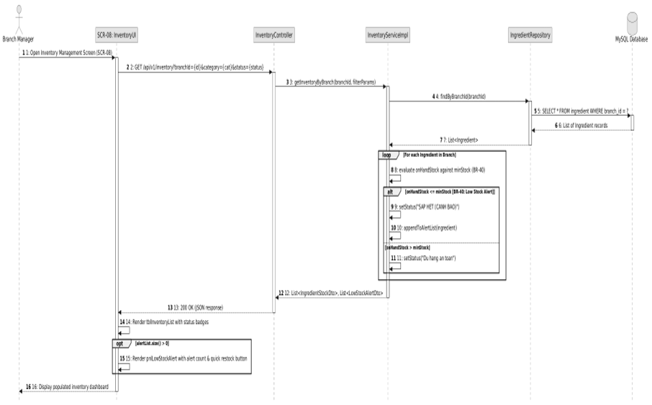

4.2.3.2 : SD-Receive Stock Delivery from
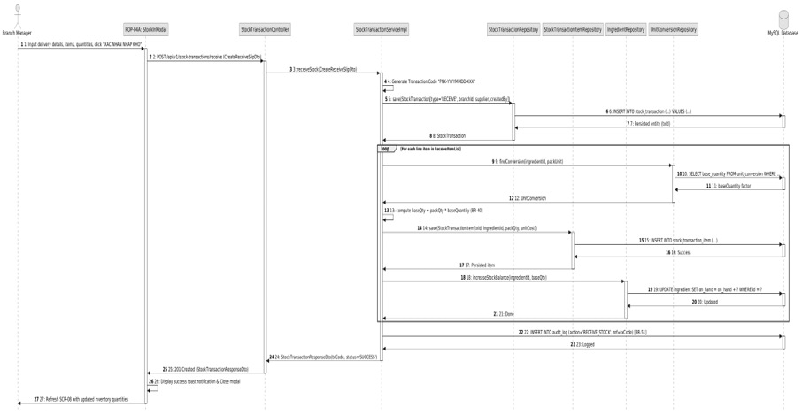

4.2.3.3: SD-03: Issue Stock to Bar Counter
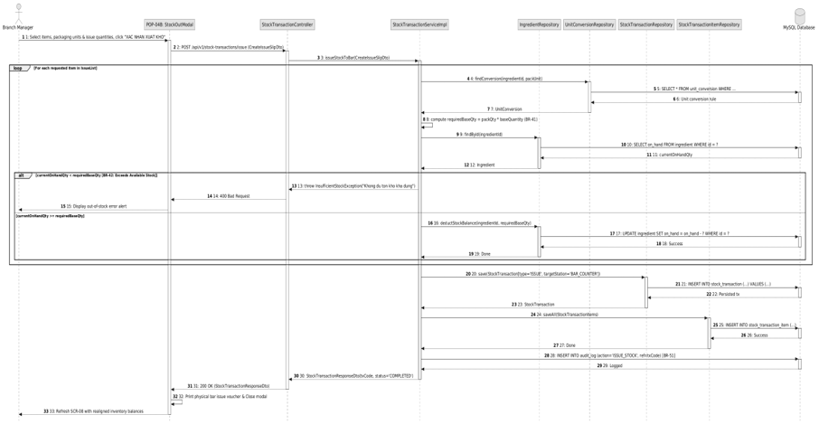

4.2.3.4 SD-04: Record Damaged / Disposed Materials
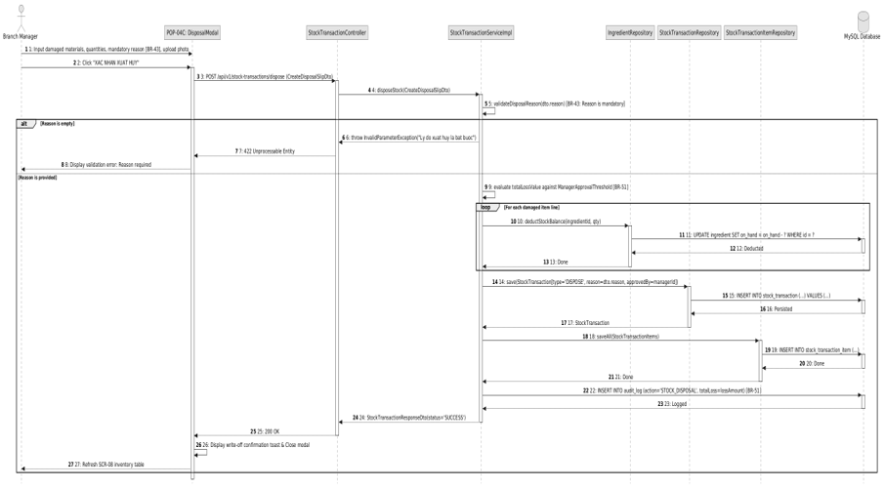

4.2.3.5 SD-05: Periodic Stocktake & Inventory Adjustment
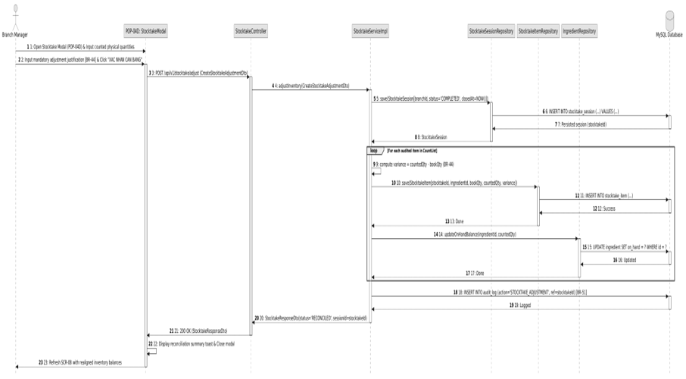

5. Database Design

5.1 Database Design
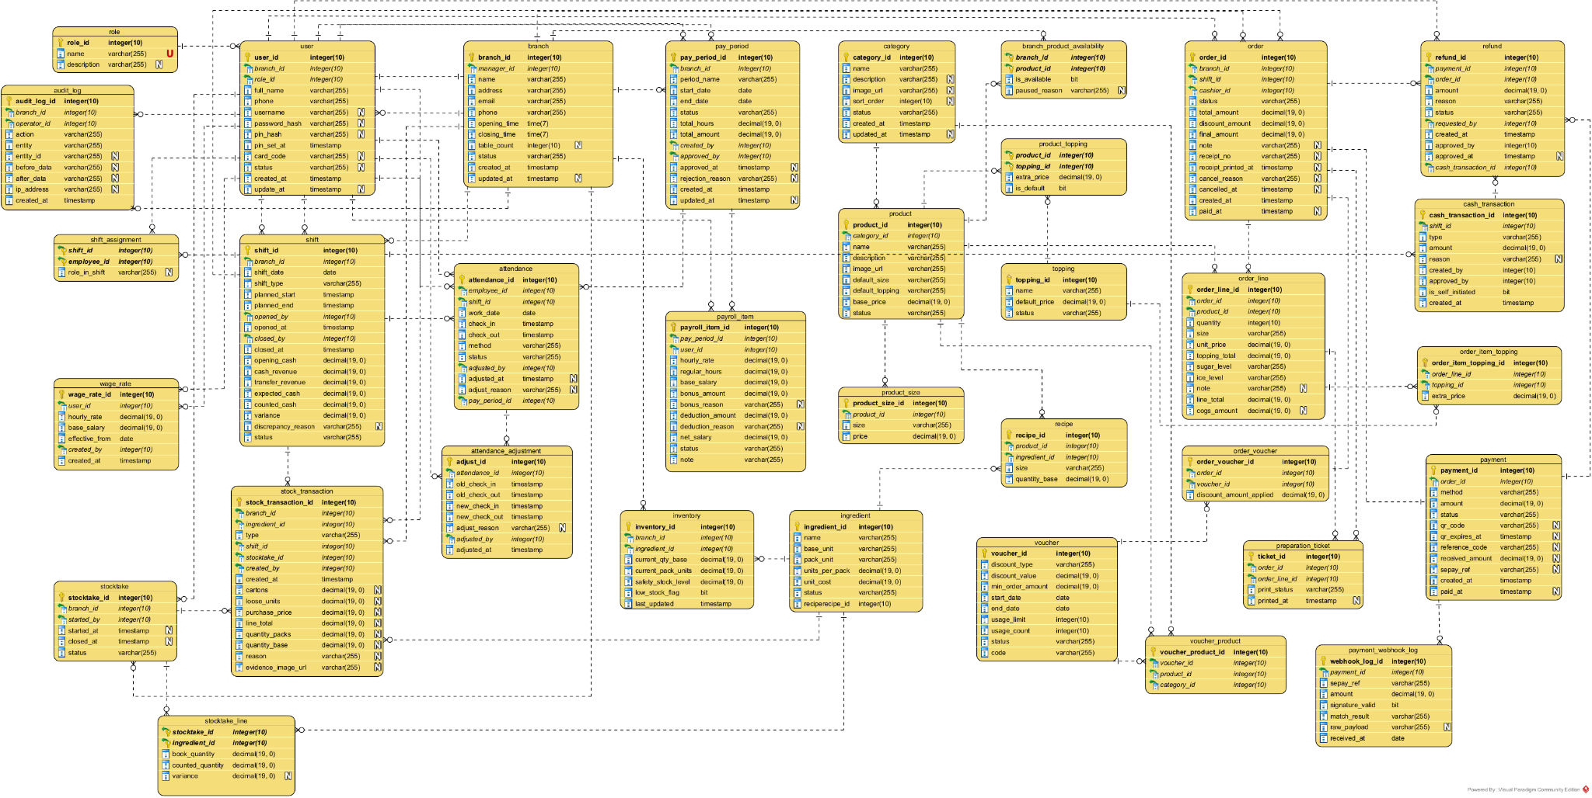

5.1.1. branch
Description: Stores information about each branch in the chain.
Group: A. Organization & Access Control
No | Field Name | Type | Size | Unique | Not Null | PK/FK | Notes
1 | branch_id | INT |  | No | Yes | PK | Branch identifier (primary key)
2 | manager_id | INT |  | No | No | FK→user(user_id) | Current branch manager
3 | name | VARCHAR | 255 | No | Yes |  | Branch name
4 | address | VARCHAR | 255 | No | Yes |  | Physical address
5 | email | VARCHAR | 255 | No | No |  | Contact email
6 | phone | VARCHAR | 255 | No | No |  | Contact phone number
7 | opening_time | TIME |  | No | Yes |  | Daily opening time
8 | closing_time | TIME |  | No | Yes |  | Daily closing time
9 | table_count | INT |  | No | No |  | Number of tables
10 | status | VARCHAR | 20 | No | Yes |  | OPEN / TEMP_CLOSED / MAINTENANCE
11 | created_at | TIMESTAMP |  | No | Yes |  | Creation timestamp
12 | updated_at | TIMESTAMP |  | No | No |  | Last update timestamp

5.1.2. role
Description: Defines the user roles available in the system.
Group: A. Organization & Access Control
No | Field Name | Type | Size | Unique | Not Null | PK/FK | Notes
1 | role_id | INT |  | No | Yes | PK | Role identifier
2 | name | VARCHAR | 50 | Yes | Yes |  | COO / Branch Manager / Cashier / Staff
3 | description | VARCHAR | 255 | No | No |  | Description of the role scope

5.1.3. user
Description: Employee profile and login account. Each user belongs to one branch (except COO) and has one role.
Group: A. Organization & Access Control
No | Field Name | Type | Size | Unique | Not Null | PK/FK | Notes
1 | user_id | INT |  | No | Yes | PK | User identifier
2 | branch_id | INT |  | No | No | FK→branch(branch_id) | Assigned branch; NULL for COO
3 | role_id | INT |  | No | Yes | FK→role(role_id) | Assigned role
4 | full_name | VARCHAR | 255 | No | Yes |  | Full name
5 | phone | VARCHAR | 20 | No | Yes |  | Phone number
6 | username | VARCHAR | 50 | Yes | No |  | Login username (required for COO / Branch Manager)
7 | password_hash | VARCHAR | 255 | No | No |  | BCrypt password hash
8 | pin_hash | VARCHAR | 255 | No | No |  | Hashed 4-digit PIN used at the kiosk and for counter approvals
9 | pin_set_at | TIMESTAMP |  | No | No |  | Timestamp of the most recent PIN change
10 | card_code | VARCHAR | 50 | Yes | No |  | RFID/NFC card code (BR-05: one card per active employee)
11 | status | VARCHAR | 20 | No | Yes |  | ACTIVE / INACTIVE (BR-13: hard delete prohibited)
12 | created_at | TIMESTAMP |  | No | Yes |  | Creation timestamp
13 | update_at | TIMESTAMP |  | No | No |  | Last update timestamp

5.1.4. category
Description: Menu categories, centrally managed by the COO (UC09).
Group: B. Menu & Products
No | Field Name | Type | Size | Unique | Not Null | PK/FK | Notes
1 | category_id | INT |  | No | Yes | PK | Category identifier
2 | name | VARCHAR | 100 | No | Yes |  | Category name
3 | description | VARCHAR | 500 | No | No |  | Description
4 | image_url | VARCHAR | 255 | No | No |  | Category image URL
5 | sort_order | INT |  | No | No |  | Display order
6 | status | VARCHAR | 20 | No | Yes |  | ACTIVE / INACTIVE
7 | created_at | TIMESTAMP |  | No | Yes |  | Creation timestamp
8 | updated_at | TIMESTAMP |  | No | No |  | Last update timestamp

5.1.5. product
Description: Products sold at the counter. Selling price is stored per size in product_size (BR-18).
Group: B. Menu & Products
No | Field Name | Type | Size | Unique | Not Null | PK/FK | Notes
1 | product_id | INT |  | No | Yes | PK | Product identifier
2 | category_id | INT |  | No | Yes | FK→category(category_id) | Category
3 | name | VARCHAR | 150 | No | Yes |  | Product name
4 | description | VARCHAR | 1000 | No | No |  | Description
5 | image_url | VARCHAR | 500 | No | No |  | Product image URL
6 | default_size | VARCHAR | 10 | No | No |  | Default size (S/M/L)
7 | default_topping | VARCHAR | 255 | No | No |  | Default topping
8 | base_price | DECIMAL | 19,2 | No | Yes |  | Reference base price
9 | status | VARCHAR | 20 | No | Yes |  | AVAILABLE / UNAVAILABLE / INACTIVE (BR-17)

5.1.6. product_size
Description: Selling price of a product for each cup size.
Group: B. Menu & Products | Additional constraints: (product_id, size) UNIQUE
No | Field Name | Type | Size | Unique | Not Null | PK/FK | Notes
1 | product_size_id | INT |  | No | Yes | PK | Price row identifier
2 | product_id | INT |  | No | Yes | FK→product(product_id) | Product
3 | size | VARCHAR | 10 | No | Yes |  | S / M / L
4 | price | DECIMAL | 19,2 | No | Yes |  | Selling price for this size

5.1.7. topping
Description: Master list of toppings.
Group: B. Menu & Products
No | Field Name | Type | Size | Unique | Not Null | PK/FK | Notes
1 | topping_id | INT |  | No | Yes | PK | Topping identifier
2 | name | VARCHAR | 100 | Yes | Yes |  | Topping name
3 | default_price | DECIMAL | 19,2 | No | Yes |  | Default unit price
4 | status | VARCHAR | 20 | No | Yes |  | ACTIVE / INACTIVE

5.1.8. product_topping
Description: Toppings allowed for each product (many-to-many).
Group: B. Menu & Products | Additional constraints: Composite PK (product_id, topping_id)
No | Field Name | Type | Size | Unique | Not Null | PK/FK | Notes
1 | product_id | INT |  | No | No | PK + FK→product(product_id) | Product
2 | topping_id | INT |  | No | No | PK + FK→topping(topping_id) | Topping
3 | extra_price | DECIMAL | 19,2 | No | Yes |  | Surcharge when this topping is selected for the product
4 | is_default | BIT |  | No | Yes |  | Whether this topping is selected by default

5.1.9. branch_product_availability
Description: Per-branch availability override for products (many-to-many).
Group: B. Menu & Products | Additional constraints: Composite PK (branch_id, product_id)
No | Field Name | Type | Size | Unique | Not Null | PK/FK | Notes
1 | branch_id | INT |  | No | No | PK + FK→branch(branch_id) | Branch
2 | product_id | INT |  | No | No | PK + FK→product(product_id) | Product
3 | is_available | BIT |  | No | Yes |  | Whether the product is currently sellable at this branch
4 | paused_reason | VARCHAR | 500 | No | No |  | Reason why the product is paused

5.1.10. recipe
Description: Bill of materials (BOM) defining ingredient quantities per product and size (BR-19).
Group: B. Menu & Products | Additional constraints: (product_id, ingredient_id, size) UNIQUE
No | Field Name | Type | Size | Unique | Not Null | PK/FK | Notes
1 | recipe_id | INT |  | No | Yes | PK | Recipe line identifier
2 | product_id | INT |  | No | Yes | FK→product(product_id) | Product
3 | ingredient_id | INT |  | No | Yes | FK→ingredient(ingredient_id) | Ingredient
4 | size | VARCHAR | 10 | No | No |  | Applicable size; NULL means all sizes
5 | quantity_base | DECIMAL | 19,4 | No | Yes |  | Required quantity in base unit

5.1.11. ingredient
Description: Raw materials used for beverage and food preparation.
Group: C. Inventory & Ingredients
No | Field Name | Type | Size | Unique | Not Null | PK/FK | Notes
1 | ingredient_id | INT |  | No | Yes | PK | Ingredient identifier
2 | name | VARCHAR | 150 | No | Yes |  | Ingredient name
3 | base_unit | VARCHAR | 20 | No | Yes |  | Base unit of measure (ml, g, can)
4 | pack_unit | VARCHAR | 20 | No | No |  | Bulk packaging unit (carton, bag) - BR-40
5 | units_per_pack | DECIMAL | 19,4 | No | No |  | Number of base units contained in one pack unit
6 | unit_cost | DECIMAL | 19,2 | No | No |  | Reference cost per base unit
7 | status | VARCHAR | 20 | No | Yes |  | ACTIVE / INACTIVE

5.1.12. inventory
Description: Current stock level of each ingredient at each branch.
Group: C. Inventory & Ingredients | Additional constraints: (branch_id, ingredient_id) UNIQUE
No | Field Name | Type | Size | Unique | Not Null | PK/FK | Notes
1 | inventory_id | INT |  | No | Yes | PK | Inventory row identifier
2 | branch_id | INT |  | No | Yes | FK→branch(branch_id) | Branch
3 | ingredient_id | INT |  | No | Yes | FK→ingredient(ingredient_id) | Ingredient
4 | current_qty_base | DECIMAL | 19,4 | No | Yes |  | On-hand quantity in base units
5 | current_pack_units | DECIMAL | 19,4 | No | Yes |  | On-hand quantity in pack units
6 | safety_stock_level | DECIMAL | 19,4 | No | Yes |  | Safety stock threshold per branch (BR-45)
7 | low_stock_flag | BIT |  | No | Yes |  | TRUE when on-hand quantity is at or below the threshold
8 | last_updated | TIMESTAMP |  | No | Yes |  | Last update timestamp

5.1.13. stocktake
Description: Physical inventory count session at a branch (UC31).
Group: C. Inventory & Ingredients
No | Field Name | Type | Size | Unique | Not Null | PK/FK | Notes
1 | stocktake_id | INT |  | No | Yes | PK | Stocktake session identifier
2 | branch_id | INT |  | No | Yes | FK→branch(branch_id) | Branch
3 | started_by | INT |  | No | Yes | FK→user(user_id) | Employee who started the session
4 | started_at | TIMESTAMP |  | No | Yes |  | Start timestamp
5 | closed_at | TIMESTAMP |  | No | No |  | Close timestamp
6 | status | VARCHAR | 20 | No | Yes |  | OPEN / ADJUSTED / CLOSED

5.1.14. stocktake_line
Description: Counted quantity per ingredient within a stocktake session (UC32, BR-44).
Group: C. Inventory & Ingredients | Additional constraints: Composite PK (stocktake_id, ingredient_id)
No | Field Name | Type | Size | Unique | Not Null | PK/FK | Notes
1 | stocktake_id | INT |  | No | No | PK + FK→stocktake(stocktake_id) | Stocktake session
2 | ingredient_id | INT |  | No | No | PK + FK→ingredient(ingredient_id) | Ingredient
3 | book_quantity | DECIMAL | 19,4 | No | Yes |  | System (book) quantity at count time
4 | counted_quantity | DECIMAL | 19,4 | No | Yes |  | Physically counted quantity
5 | variance | DECIMAL | 19,4 | No | Yes |  | Variance = counted - book

5.1.15. stock_transaction
Description: Stock documents: receiving, issue to bar, damage/disposal, adjustment (UC28-UC30, UC32).
Group: C. Inventory & Ingredients
No | Field Name | Type | Size | Unique | Not Null | PK/FK | Notes
1 | stock_transaction_id | INT |  | No | Yes | PK | Stock transaction identifier
2 | branch_id | INT |  | No | Yes | FK→branch(branch_id) | Branch
3 | ingredient_id | INT |  | No | Yes | FK→ingredient(ingredient_id) | Ingredient
4 | type | VARCHAR | 20 | No | Yes |  | RECEIVE / ISSUE / DISPOSAL / ADJUST
5 | shift_id | INT |  | No | No | FK→shift(shift_id) | Shift in which the transaction occurred
6 | stocktake_id | INT |  | No | No | FK→stocktake(stocktake_id) | Source stocktake session (when type = ADJUST)
7 | created_by | INT |  | No | Yes | FK→user(user_id) | Employee who created the record
8 | created_at | TIMESTAMP |  | No | Yes |  | Creation timestamp
9 | cartons | DECIMAL | 19,4 | No | No |  | Number of cartons received (BR-40)
10 | loose_units | DECIMAL | 19,4 | No | No |  | Number of loose units received
11 | purchase_price | DECIMAL | 19,2 | No | No |  | Purchase price per carton (RECEIVE only)
12 | line_total | DECIMAL | 19,2 | No | No |  | Line total = quantity x price (RECEIVE only)
13 | quantity_packs | DECIMAL | 19,4 | No | No |  | Quantity in pack units (issue / disposal)
14 | quantity_base | DECIMAL | 19,4 | No | No |  | Quantity converted to base units
15 | reason | VARCHAR | 500 | No | No |  | Reason - mandatory for DISPOSAL (BR-43)
16 | evidence_image_url | VARCHAR | 500 | No | No |  | Evidence photo URL

5.1.16. shift
Description: Work shift, which is also the cash drawer session. Unit of cash and revenue reconciliation (UC24-UC27).
Group: D. Shifts, Attendance & Payroll
No | Field Name | Type | Size | Unique | Not Null | PK/FK | Notes
1 | shift_id | INT |  | No | Yes | PK | Shift identifier
2 | branch_id | INT |  | No | Yes | FK→branch(branch_id) | Branch
3 | shift_date | DATE |  | No | Yes |  | Working date
4 | shift_type | VARCHAR | 20 | No | Yes |  | MORNING / EVENING / NIGHT
5 | planned_start | TIMESTAMP |  | No | Yes |  | Planned start time
6 | planned_end | TIMESTAMP |  | No | Yes |  | Planned end time
7 | opened_by | INT |  | No | Yes | FK→user(user_id) | Employee who opened the shift
8 | opened_at | TIMESTAMP |  | No | No |  | Actual open timestamp
9 | closed_by | INT |  | No | No | FK→user(user_id) | Employee who closed the shift
10 | closed_at | TIMESTAMP |  | No | No |  | Actual close timestamp
11 | opening_cash | DECIMAL | 19,2 | No | Yes |  | Declared opening cash (BR-36)
12 | cash_revenue | DECIMAL | 19,2 | No | Yes |  | Cash revenue collected during the shift
13 | transfer_revenue | DECIMAL | 19,2 | No | Yes |  | Bank transfer revenue collected during the shift
14 | expected_cash | DECIMAL | 19,2 | No | No |  | Theoretical cash balance (BR-39)
15 | counted_cash | DECIMAL | 19,2 | No | No |  | Physically counted cash at closing (BR-38)
16 | variance | DECIMAL | 19,2 | No | No |  | Variance = counted - expected
17 | discrepancy_reason | VARCHAR | 500 | No | No |  | Explanation - mandatory when variance is not zero
18 | status | VARCHAR | 20 | No | Yes |  | OPEN / CLOSED

5.1.17. shift_assignment
Description: Assignment of employees to work shifts (UC08, BR-15).
Group: D. Shifts, Attendance & Payroll | Additional constraints: Composite PK (shift_id, employee_id)
No | Field Name | Type | Size | Unique | Not Null | PK/FK | Notes
1 | shift_id | INT |  | No | No | PK + FK→shift(shift_id) | Shift
2 | employee_id | INT |  | No | No | PK + FK→user(user_id) | Employee
3 | role_in_shift | VARCHAR | 50 | No | No |  | Role performed in this shift

5.1.18. attendance
Description: Clock-in / clock-out records per shift (UC03, UC04).
Group: D. Shifts, Attendance & Payroll | Additional constraints: (employee_id, shift_id) UNIQUE
No | Field Name | Type | Size | Unique | Not Null | PK/FK | Notes
1 | attendance_id | INT |  | No | Yes | PK | Attendance identifier
2 | employee_id | INT |  | No | Yes | FK→user(user_id) | Employee
3 | shift_id | INT |  | No | Yes | FK→shift(shift_id) | Shift
4 | work_date | DATE |  | No | Yes |  | Working date
5 | check_in | TIMESTAMP |  | No | Yes |  | Clock-in timestamp
6 | check_out | TIMESTAMP |  | No | No |  | Clock-out timestamp
7 | method | VARCHAR | 20 | No | Yes |  | PIN / RFID
8 | status | VARCHAR | 20 | No | Yes |  | PRESENT / LATE / EARLY_LEAVE / ADJUSTED
9 | adjusted_by | INT |  | No | No | FK→user(user_id) | Manager who adjusted the record (BR-10)
10 | adjusted_at | TIMESTAMP |  | No | No |  | Adjustment timestamp
11 | adjust_reason | VARCHAR | 500 | No | No |  | Adjustment reason (BR-10)
12 | pay_period_id | INT |  | No | No | FK→pay_period(pay_period_id) | Pay period that locked this record

5.1.19. attendance_adjustment
Description: History of attendance time adjustments (BR-10).
Group: D. Shifts, Attendance & Payroll
No | Field Name | Type | Size | Unique | Not Null | PK/FK | Notes
1 | adjust_id | INT |  | No | Yes | PK | Adjustment identifier
2 | attendance_id | INT |  | No | Yes | FK→attendance(attendance_id) | Attendance record
3 | old_check_in | TIMESTAMP |  | No | No |  | Previous clock-in
4 | old_check_out | TIMESTAMP |  | No | No |  | Previous clock-out
5 | new_check_in | TIMESTAMP |  | No | No |  | New clock-in
6 | new_check_out | TIMESTAMP |  | No | No |  | New clock-out
7 | adjust_reason | VARCHAR | 500 | No | Yes |  | Reason for the adjustment
8 | adjusted_by | INT |  | No | Yes | FK→user(user_id) | Manager who made the adjustment
9 | adjusted_at | TIMESTAMP |  | No | Yes |  | Adjustment timestamp

5.1.20. wage_rate
Description: History of hourly wage rates (BR-14: a new rate only applies to shifts after the change).
Group: D. Shifts, Attendance & Payroll
No | Field Name | Type | Size | Unique | Not Null | PK/FK | Notes
1 | wage_rate_id | INT |  | No | Yes | PK | Wage rate identifier
2 | user_id | INT |  | No | Yes | FK→user(user_id) | Employee
3 | hourly_rate | DECIMAL | 19,2 | No | Yes |  | Hourly wage
4 | base_salary | DECIMAL | 19,2 | No | No |  | Base salary
5 | effective_from | DATE |  | No | Yes |  | Effective date
6 | created_by | INT |  | No | Yes | FK→user(user_id) | Manager who set the rate
7 | created_at | TIMESTAMP |  | No | Yes |  | Creation timestamp

5.1.21. pay_period
Description: Payroll period of a branch (UC45, BR-53).
Group: D. Shifts, Attendance & Payroll | Additional constraints: CHECK (approved_by IS NULL OR approved_by <> created_by)
No | Field Name | Type | Size | Unique | Not Null | PK/FK | Notes
1 | pay_period_id | INT |  | No | Yes | PK | Pay period identifier
2 | branch_id | INT |  | No | Yes | FK→branch(branch_id) | Branch
3 | period_name | VARCHAR | 100 | No | Yes |  | Period name (e.g. October 2026 - Cycle 1)
4 | start_date | DATE |  | No | Yes |  | Period start date
5 | end_date | DATE |  | No | Yes |  | Period end date
6 | status | VARCHAR | 20 | No | Yes |  | DRAFT / SUBMITTED / APPROVED / REJECTED / PAID
7 | total_hours | DECIMAL | 19,2 | No | Yes |  | Total verified working hours
8 | total_amount | DECIMAL | 19,2 | No | Yes |  | Total payroll amount payable
9 | created_by | INT |  | No | Yes | FK→user(user_id) | Branch Manager who created the period
10 | approved_by | INT |  | No | No | FK→user(user_id) | COO who approved the period
11 | approved_at | TIMESTAMP |  | No | No |  | Approval timestamp
12 | rejection_reason | VARCHAR | 255 | No | No |  | Reason provided when rejected
13 | created_at | TIMESTAMP |  | No | Yes |  | Creation timestamp
14 | updated_at | TIMESTAMP |  | No | No |  | Last update timestamp

5.1.22. payroll_item
Description: Payroll statement of one employee within a pay period.
Group: D. Shifts, Attendance & Payroll | Additional constraints: (pay_period_id, user_id) UNIQUE
No | Field Name | Type | Size | Unique | Not Null | PK/FK | Notes
1 | payroll_item_id | INT |  | No | Yes | PK | Payroll line identifier
2 | pay_period_id | INT |  | No | Yes | FK→pay_period(pay_period_id) | Pay period
3 | user_id | INT |  | No | Yes | FK→user(user_id) | Employee
4 | hourly_rate | DECIMAL | 19,2 | No | Yes |  | Hourly rate snapshot captured when the period is closed
5 | regular_hours | DECIMAL | 19,2 | No | Yes |  | Verified working hours in the period
6 | base_salary | DECIMAL | 19,2 | No | Yes |  | Base wage = hours x hourly rate
7 | bonus_amount | DECIMAL | 19,2 | No | Yes |  | Bonus amount
8 | bonus_reason | VARCHAR | 255 | No | No |  | Bonus justification
9 | deduction_amount | DECIMAL | 19,2 | No | Yes |  | Deduction amount
10 | deduction_reason | VARCHAR | 255 | No | No |  | Deduction justification
11 | net_salary | DECIMAL | 19,2 | No | Yes |  | Net payable = base + bonus - deduction
12 | status | VARCHAR | 20 | No | Yes |  | PENDING / APPROVED / PAID
13 | note | VARCHAR | 255 | No | No |  | General remarks

5.1.23. order
Description: Customer order placed at the counter (UC16). Data is frozen once the order is PAID (BR-26).
Group: E. Orders & Payments | Additional constraints: CHECK (final_amount >= 0)
No | Field Name | Type | Size | Unique | Not Null | PK/FK | Notes
1 | order_id | INT |  | No | Yes | PK | Order identifier
2 | branch_id | INT |  | No | Yes | FK→branch(branch_id) | Branch
3 | shift_id | INT |  | No | Yes | FK→shift(shift_id) | Shift
4 | cashier_id | INT |  | No | Yes | FK→user(user_id) | Cashier who created the order
5 | status | VARCHAR | 20 | No | Yes |  | PENDING / PAID / PARTIALLY_REFUNDED / REFUNDED / CANCELLED
6 | total_amount | DECIMAL | 19,2 | No | Yes |  | Order subtotal
7 | discount_amount | DECIMAL | 19,2 | No | Yes |  | Total discount applied
8 | final_amount | DECIMAL | 19,2 | No | Yes |  | Amount payable
9 | note | VARCHAR | 500 | No | No |  | Order note
10 | receipt_no | VARCHAR | 30 | No | No |  | Receipt number (incremented per day or per shift)
11 | receipt_printed_at | TIMESTAMP |  | No | No |  | Receipt print timestamp
12 | cancel_reason | VARCHAR | 500 | No | No |  | Cancellation reason (BR-26b)
13 | cancelled_at | TIMESTAMP |  | No | No |  | Cancellation timestamp
14 | created_at | TIMESTAMP |  | No | Yes |  | Creation timestamp
15 | paid_at | TIMESTAMP |  | No | No |  | Payment timestamp

5.1.24. order_line
Description: Order line item (resolves the Order-Product many-to-many relationship).
Group: E. Orders & Payments
No | Field Name | Type | Size | Unique | Not Null | PK/FK | Notes
1 | order_line_id | INT |  | No | Yes | PK | Order line identifier
2 | order_id | INT |  | No | Yes | FK→order(order_id) | Order
3 | product_id | INT |  | No | Yes | FK→product(product_id) | Product
4 | quantity | INT |  | No | Yes |  | Quantity
5 | size | VARCHAR | 10 | No | No |  | Size sold (snapshot)
6 | unit_price | DECIMAL | 19,2 | No | Yes |  | Unit price at sale time (BR-23)
7 | topping_total | DECIMAL | 19,2 | No | Yes |  | Total topping surcharge
8 | sugar_level | VARCHAR | 20 | No | No |  | Sugar level (BR-25)
9 | ice_level | VARCHAR | 20 | No | No |  | Ice level (BR-25)
10 | note | VARCHAR | 300 | No | No |  | Preparation note
11 | line_total | DECIMAL | 19,2 | No | Yes |  | Line total
12 | cogs_amount | DECIMAL | 19,2 | No | No |  | Cost of goods sold for this line (BR-48)

5.1.25. order_item_topping
Description: Toppings selected by the customer on an order line (many-to-many).
Group: E. Orders & Payments | Additional constraints: (order_line_id, topping_id) UNIQUE
No | Field Name | Type | Size | Unique | Not Null | PK/FK | Notes
1 | order_item_topping_id | INT |  | No | Yes | PK | Order topping identifier
2 | order_line_id | INT |  | No | Yes | FK→order_line(order_line_id) | Order line
3 | topping_id | INT |  | No | Yes | FK→topping(topping_id) | Topping
4 | extra_price | DECIMAL | 19,2 | No | Yes |  | Surcharge snapshot

5.1.26. voucher
Description: Discount programmes and promotion vouchers (UC13, BR-20/21).
Group: E. Orders & Payments
No | Field Name | Type | Size | Unique | Not Null | PK/FK | Notes
1 | voucher_id | INT |  | No | Yes | PK | Voucher identifier
2 | code | VARCHAR | 50 | Yes | Yes |  | Voucher code entered at checkout
3 | discount_type | VARCHAR | 10 | No | Yes |  | PERCENT / FIXED
4 | discount_value | DECIMAL | 19,2 | No | Yes |  | Discount value
5 | min_order_amount | DECIMAL | 19,2 | No | No |  | Minimum order amount required
6 | start_date | DATE |  | No | Yes |  | Valid from
7 | end_date | DATE |  | No | Yes |  | Valid until
8 | usage_limit | INT |  | No | No |  | Maximum number of redemptions
9 | usage_count | INT |  | No | Yes |  | Number of redemptions so far
10 | status | VARCHAR | 20 | No | Yes |  | ACTIVE / EXPIRED / INACTIVE

5.1.27. voucher_product
Description: Products or categories a voucher applies to (UC13 applicable products).
Group: E. Orders & Payments | Additional constraints: CHECK (product_id IS NOT NULL OR category_id IS NOT NULL)
No | Field Name | Type | Size | Unique | Not Null | PK/FK | Notes
1 | voucher_product_id | INT |  | No | Yes | PK | Voucher scope identifier
2 | voucher_id | INT |  | No | Yes | FK→voucher(voucher_id) | Voucher
3 | product_id | INT |  | No | No | FK→product(product_id) | Applicable product
4 | category_id | INT |  | No | No | FK→category(category_id) | Applicable category

5.1.28. order_voucher
Description: Voucher applied to an order (BR-21: at most one voucher per order).
Group: E. Orders & Payments
No | Field Name | Type | Size | Unique | Not Null | PK/FK | Notes
1 | order_voucher_id | INT |  | No | Yes | PK | Redemption identifier
2 | order_id | INT |  | Yes | Yes | FK→order(order_id) | Order
3 | voucher_id | INT |  | No | Yes | FK→voucher(voucher_id) | Voucher
4 | discount_amount_applied | DECIMAL | 19,2 | No | Yes |  | Discount amount actually applied

5.1.29. payment
Description: Payment of an order (UC19, UC20, UC43, UC44).
Group: E. Orders & Payments
No | Field Name | Type | Size | Unique | Not Null | PK/FK | Notes
1 | payment_id | INT |  | No | Yes | PK | Payment identifier
2 | order_id | INT |  | Yes | Yes | FK→order(order_id) | Order
3 | method | VARCHAR | 20 | No | Yes |  | CASH / VIETQR
4 | amount | DECIMAL | 19,2 | No | Yes |  | Amount to be paid
5 | status | VARCHAR | 20 | No | Yes |  | PENDING / SUCCESS / FAILED / MISMATCH
6 | qr_code | VARCHAR | 1000 | No | No |  | VietQR payload (BR-28)
7 | qr_expires_at | TIMESTAMP |  | No | No |  | QR expiration timestamp
8 | reference_code | VARCHAR | 100 | No | No |  | Reconciliation reference code
9 | received_amount | DECIMAL | 19,2 | No | No |  | Amount reported by the payment gateway
10 | sepay_ref | VARCHAR | 100 | No | No |  | SePay transaction reference
11 | created_at | TIMESTAMP |  | No | Yes |  | Creation timestamp
12 | paid_at | TIMESTAMP |  | No | No |  | Payment confirmation timestamp

5.1.30. refund
Description: Refund request for a paid order (UC23, BR-32/33/34/35).
Group: F. Refunds & Cash Drawer
No | Field Name | Type | Size | Unique | Not Null | PK/FK | Notes
1 | refund_id | INT |  | No | Yes | PK | Refund identifier
2 | payment_id | INT |  | No | Yes | FK→payment(payment_id) | Original payment
3 | order_id | INT |  | No | Yes | FK→order(order_id) | Order
4 | cash_transaction_id | INT |  | No | No | FK→cash_transaction(cash_transaction_id) | Cash drawer entry that settled the refund (BR-34)
5 | amount | DECIMAL | 19,2 | No | Yes |  | Refund amount (must not exceed the amount paid)
6 | reason | VARCHAR | 500 | No | Yes |  | Refund reason (mandatory - BR-32)
7 | status | VARCHAR | 20 | No | Yes |  | PENDING / APPROVED / REJECTED / DONE
8 | requested_by | INT |  | No | Yes | FK→user(user_id) | Cashier who requested the refund
9 | created_at | TIMESTAMP |  | No | Yes |  | Request timestamp
10 | approved_by | INT |  | No | No | FK→user(user_id) | Manager or COO who approved (BR-32/35)
11 | approved_at | TIMESTAMP |  | No | No |  | Approval timestamp

5.1.31. cash_transaction
Description: Cash movements inside a shift (UC25/UC26, BR-37).
Group: F. Refunds & Cash Drawer
No | Field Name | Type | Size | Unique | Not Null | PK/FK | Notes
1 | cash_transaction_id | INT |  | No | Yes | PK | Cash transaction identifier
2 | shift_id | INT |  | No | Yes | FK→shift(shift_id) | Shift
3 | type | VARCHAR | 20 | No | Yes |  | OPEN / CASH_IN / CASH_OUT / REFUND_OUT / CLOSE
4 | amount | DECIMAL | 19,2 | No | Yes |  | Amount moved
5 | reason | VARCHAR | 500 | No | Yes |  | Business reason
6 | created_by | INT |  | No | Yes | FK→user(user_id) | Employee who created the entry
7 | approved_by | INT |  | No | No | FK→user(user_id) | Manager who approved by PIN (BR-32)
8 | is_self_initiated | BIT |  | No | Yes |  | TRUE when a Branch Manager created it themselves (BR-37)
9 | created_at | TIMESTAMP |  | No | Yes |  | Creation timestamp

5.1.32. payment_webhook_log
Description: Immutable log of inbound SePay webhooks (BR-29/30).
Group: G. System Configuration & Audit | Additional constraints: UNIQUE(sepay_ref) - prevents duplicate processing
No | Field Name | Type | Size | Unique | Not Null | PK/FK | Notes
1 | webhook_log_id | INT |  | No | Yes | PK | Log identifier
2 | payment_id | INT |  | No | No | FK→payment(payment_id) | Matched payment
3 | sepay_ref | VARCHAR | 100 | No | Yes |  | SePay transaction reference
4 | amount | DECIMAL | 19,2 | No | Yes |  | Amount reported by the webhook
5 | signature_valid | BIT |  | No | Yes |  | Whether the HMAC signature is valid
6 | match_result | VARCHAR | 20 | No | Yes |  | MATCH / MISMATCH
7 | raw_payload | VARCHAR | 4000 | No | No |  | Raw webhook payload
8 | received_at | TIMESTAMP |  | No | Yes |  | Receive timestamp

5.1.33. audit_log
Description: Immutable audit trail of sensitive operations (BR-51).
Group: G. System Configuration & Audit | Additional constraints: UPDATE and DELETE prohibited at database level
No | Field Name | Type | Size | Unique | Not Null | PK/FK | Notes
1 | audit_log_id | INT |  | No | Yes | PK | Audit log identifier
2 | branch_id | INT |  | No | No | FK→branch(branch_id) | Branch in which the action occurred
3 | operator_id | INT |  | No | Yes | FK→user(user_id) | User who performed the action
4 | operator_role | VARCHAR | 50 | No | No |  | Role at the time of the action (snapshot)
5 | action | VARCHAR | 50 | No | Yes |  | LOGIN / PRICE_EDIT / ORDER_CANCEL / REFUND / CASH_IN / CASH_OUT / BOM_EDIT / INVENTORY_ADJUST / PERMISSION_ASSIGN
6 | entity | VARCHAR | 50 | No | Yes |  | Table affected by the action
7 | entity_id | VARCHAR | 50 | No | No |  | Identifier of the affected record
8 | before_data | VARCHAR | 4000 | No | No |  | Previous values (JSON)
9 | after_data | VARCHAR | 4000 | No | No |  | New values (JSON)
10 | ip_address | VARCHAR | 50 | No | No |  | Client IP address
11 | created_at | TIMESTAMP |  | No | Yes |  | Action timestamp

5.2 Data File Design
The following files are used to store, access and exchange data in the Raw Material Inventory Management Subsystem (section 4.3). Entity classes map to the tables defined in 5.1, repositories access them through Spring Data JPA, and DTO classes carry data between the REST controllers and the client.
# | File Name | Type | Notes
1 | Ingredient.java | Entity | Maps to table ingredient. Raw material with name, base unit, minimum stock and unit cost; referenced by stock voucher lines, stocktake lines and unit conversions.
2 | UnitConversion.java | Entity | Maps to table unit_conversion. Conversion ratio between a pack unit and the base unit of an ingredient (BR-40, BR-41).
3 | StockTransaction.java | Entity | Maps to table stock_transaction. Master stock voucher (RECEIVE/ISSUE/DISPOSAL/ADJUST); contains 1..* StockTransactionItem.
4 | StockTransactionItem.java | Entity | Maps to table stock_transaction_item. Line of a stock voucher: ingredient, quantity, unit and cost.
5 | StocktakeSession.java | Entity | Maps to table stocktake_session. Stocktake session of a branch; contains 1..* StocktakeItem.
6 | StocktakeItem.java | Entity | Maps to table stocktake_item. Stocktake line with book quantity, counted quantity and variance.
7 | IngredientRepository.java | Repository | Spring Data JpaRepository for Ingredient. Used by InventoryServiceImpl, StockTransactionServiceImpl and StocktakeServiceImpl.
8 | UnitConversionRepository.java | Repository | Spring Data JpaRepository for UnitConversion. Used by StockTransactionServiceImpl.
9 | StockTransactionRepository.java | Repository | Spring Data JpaRepository for StockTransaction. Used by StockTransactionServiceImpl.
10 | StockTransactionItemRepository.java | Repository | Spring Data JpaRepository for StockTransactionItem. Used by StockTransactionServiceImpl.
11 | StocktakeSessionRepository.java | Repository | Spring Data JpaRepository for StocktakeSession. Used by StocktakeServiceImpl.
12 | StocktakeItemRepository.java | Repository | Spring Data JpaRepository for StocktakeItem. Used by StocktakeServiceImpl.
13 | IngredientStockDto.java | DTO | Response item of getBranchInventory: ingredient and its on-hand balance for a branch.
14 | LowStockAlertDto.java | DTO | Response item of getLowStockAlerts: ingredients where on-hand quantity ≤ minimum stock (BR-45).
15 | CreateReceiveSlipDto.java | DTO | Request body of receiveStock: goods receipt by pack units (UC28, BR-40).
16 | CreateIssueSlipDto.java | DTO | Request body of issueStock: issue to the bar counter (UC29, BR-41, BR-42).
17 | CreateDisposalSlipDto.java | DTO | Request body of disposeStock: write-off with a mandatory reason (UC30, BR-43).
18 | StockTxResponseDto.java | DTO | Response of the receive, issue and dispose endpoints.
19 | StocktakeSessionDto.java | DTO | Response of createStocktakeSession: the newly opened session with book balances (UC31).
20 | CreateStocktakeAdjustmentDto.java | DTO | Request body of adjustInventory: counted quantities of a stocktake (UC32, BR-44).
21 | StocktakeResponseDto.java | DTO | Response of adjustInventory: variances and the realigned stock.
22 | Stock card export | Excel (.xlsx) | Generated by btnExportStockCard on the Branch Inventory screen (4.3.1.1): store inventory ledger and lot transaction history. File name pattern is not defined in the SDD.
23 | Damage report attachment | Upload (file/photo) | Optional evidence uploaded through fileDamageReport on the Disposal slip (4.3.1.4): inspection report or photo of damaged stock. No column in 5.1 stores it, so the storage location is to be decided.

